1. *Cameras*: Ubers fleet of modified Volvo XC90 SUVs features a range of cameras on their roofs, plus additional cameras that point to the sides and behind the car. The roof cameras are able to focus both close and far field, watch for braking vehicles, crossing pedestrians, traffic lights, and signage. The cameras feed their material to a central on-board computer, which also receives the signals of the other sensors to create a precise image of the vehicle’s surroundings. Much like human eyes, the performance of camera systems at night is strongly reduced, which makes them less reliable to locate objects with the required detection rates and positional accuracy. This is why the Uber fleet is equipped with two additional sensor types.
2. *Radar*: Radar systems emit radio waves which are reflected off of (many but not all) objects. The returning waves can be analyzed with regard to their runtime (which gives distance) as well as their shifted frequency (which gives relative speed). The latter property clearly distinguished the radar from the other two sensor types as it is the only one who is able to directly measure the speed of objects. Also, radar is very robust against adverse weather conditions like heavy snow and thick fog. Used by cruise control systems for many years, radar works best when identifying larger objects with good reflective properties. When it comes to detecting smaller or „soft“ objects (humans, animals) with reduced reflective properties, the radar detection performance drops. Even though camera and radar combine well, there are situations where both sensors do not work optimally - which is why Uber chose to throw a third sensor into the mix.
3. *Lidar* : Lidar works in a similar way to radar, but instead of emitting radio waves it uses infrared light. The roof-mouted sensor rotates at a high velocity and builds a detailed 3D image of its surroundings. In case of the Velodyne VLS-128, a total of 128 laser beams is used to detect obstacles up to a distance of 300 meters. During a single spin through 360 degrees, a total of up to 4 million datapoints per second is generated. Similar to the camera, Lidar is an optical sensor. It has the significant advantage however of "bringing its own light source“, whereas cameras are dependent on ambient light and the vehicle headlights. It has to be noted however, that Lidar performance is also reduced in adverse environmental conditions such as snow, heavy rain or fog. Coupled with low reflective properties of certain materials, a Lidar might thus fail at generating a sufficiently dense point cloud for some objects in traffic, leaving only a few 3D points with which to work. It is thus a good idea to combine Lidar with other sensors to ensure that detection performance is sufficiently hight for autonomous navigation through traffic.
4. **The Uber ATG Autonomous Vehicle**
5. The current version of the Uber autonomous vehicle combines a top-mounted 360° Lidar scanner with several cameras and radar sensors placed around the car circumference.

## The Uber ATG Autonomous Vehicle

The current version of the Uber autonomous vehicle combines a top-mounted 360° Lidar scanner with several cameras and radar sensors placed around the car circumference.

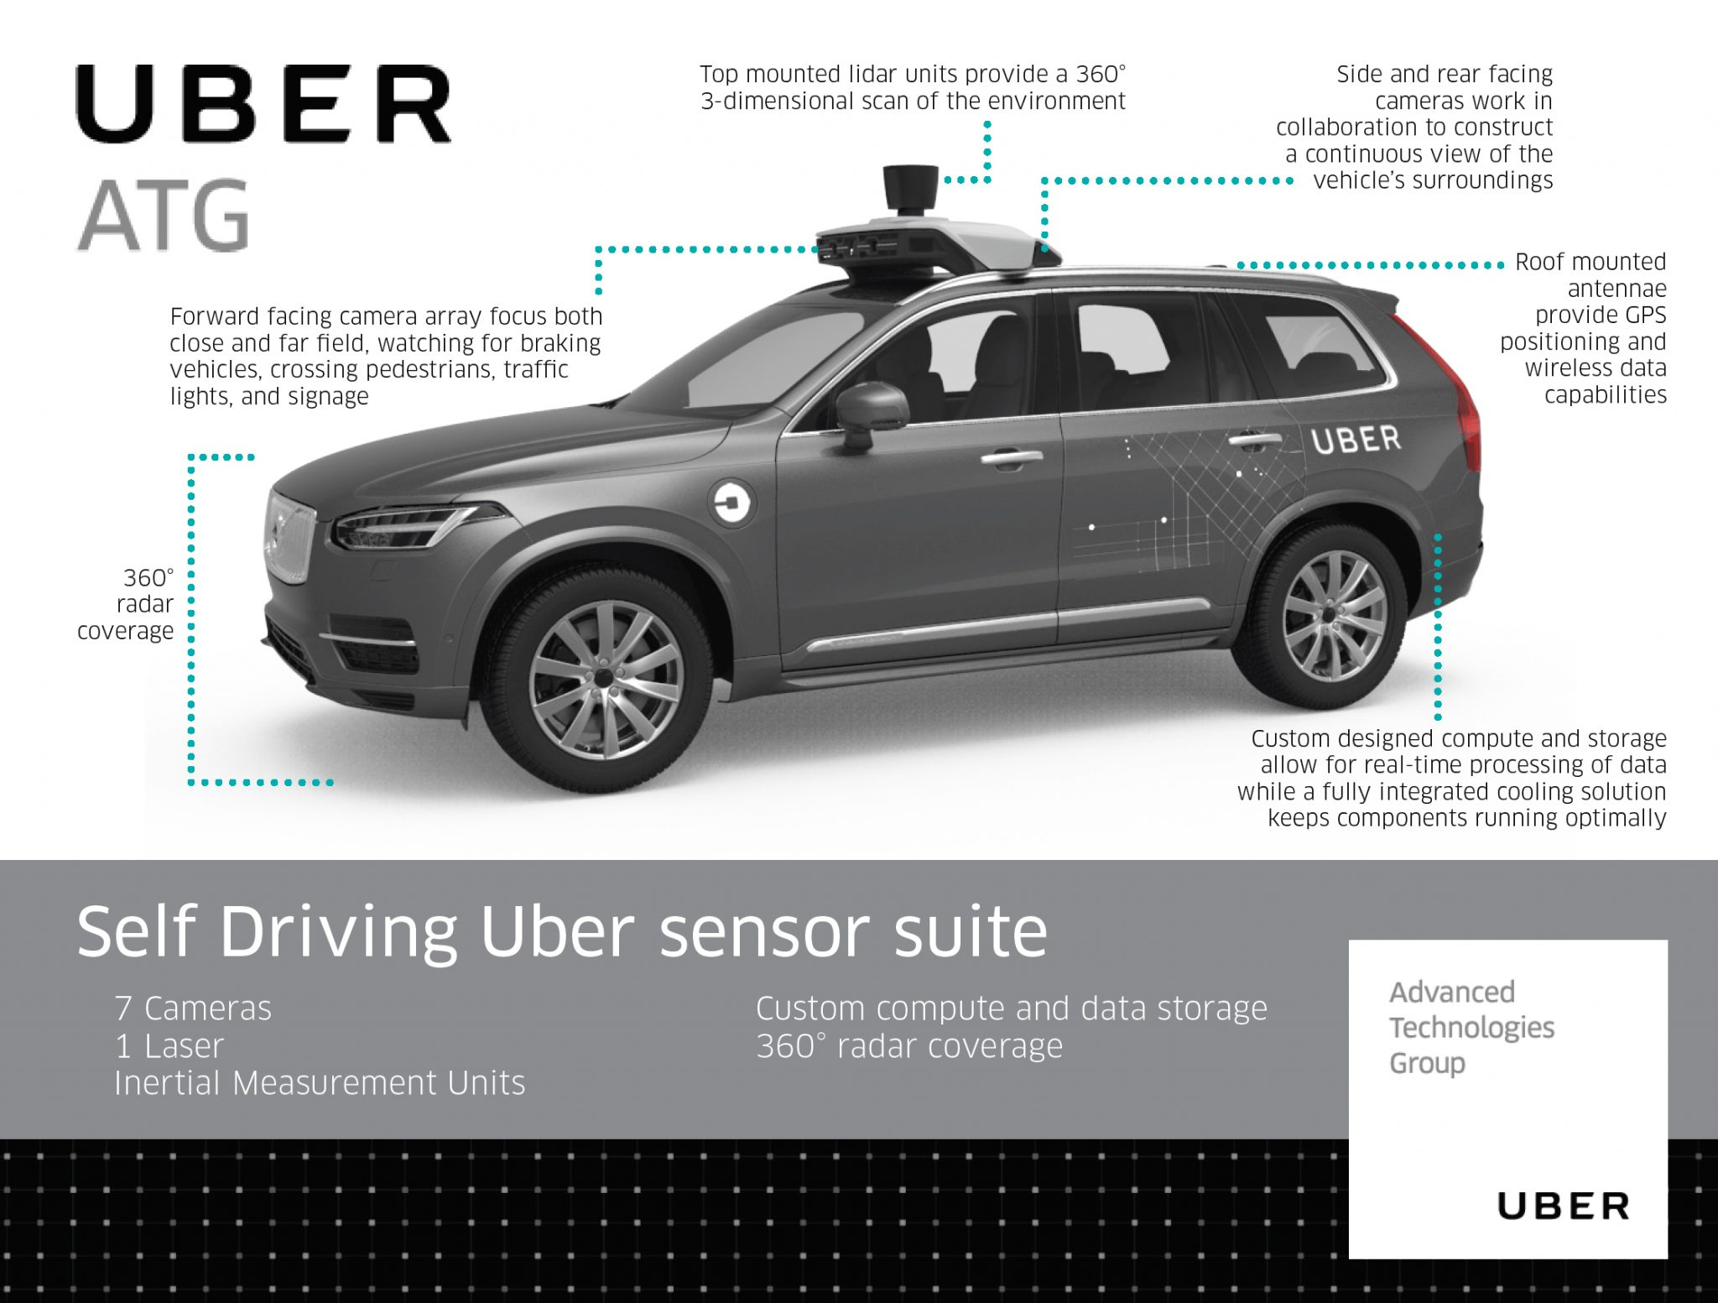

# Mercedes Benz Autonomous Prototype

Currently, German car maker Mercedes Benz is developing an autonomous vehicle prototype that is equipped with cameras, Lidar and radar sensors, similar to the Uber vehicle. Mercedes uses several cameras to scan the area around the vehicle. Of special interest is a stereo setup consisting of two synchronized cameras, which is able to measure depth by finding corresponding features in both images. The picture below shows the entire host of cameras used by the system. Mercedes states that the stereo camera alone generates a total of 100 gigabytes of data for every kilometer driven.

## The Tesla Autopilot

When the Autopilot system was first sold, it basically was a combination of adaptive cruise control and lane change assist - a set of functions which had long been available with other manufacturers around the globe. The name „Autopilot“ implied however, that the car would be truly autonomous. And indeed did many Tesla owners test the system to its limits by climbing onto the back seat , reading a book or taking a nap while being driven by the system. On the SAE scale however, the Autopilot can „only“ be classified as level 2, i.e. the driver is responsible for the driving task at all times.

In October 2016, the Tesla Model S and X sensor set was significantly upgraded and the capabilities of the Autopilot were extended by regular airborne software updates.

The image shows the interior of a Tesla with the camera views superimposed on the right side. The image shows left and right rear-facing cameras as well as a forward-facing camera for medium-range perception.

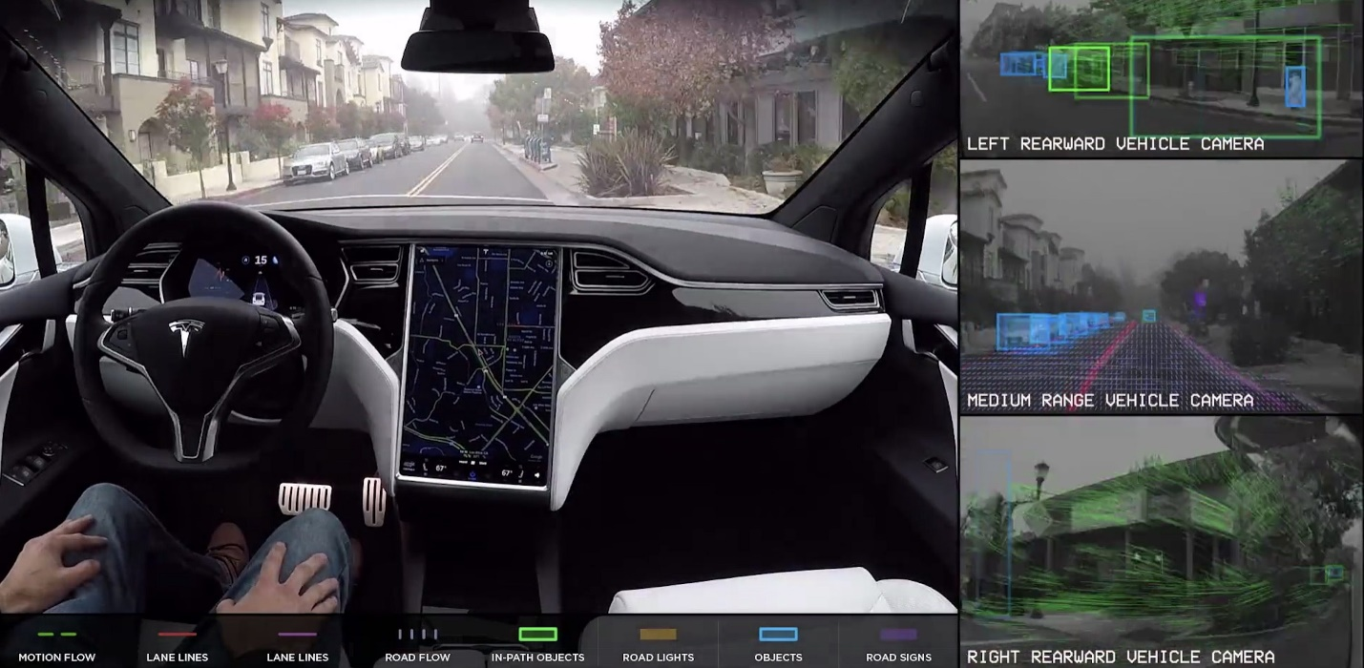As can be seen in the overview, the system combines several camera sensors with partially overlapping fields of view with a forward-facing radar sensor.

**[[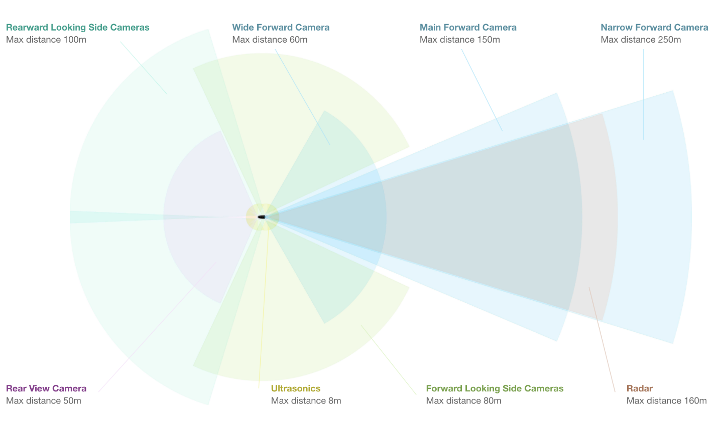](https://classroom.udacity.com/nanodegrees/nd313/parts/1971021c-523b-414c-93a3-2c6297cf4771/modules/0a71c48d-96ab-4d3a-be96-3ea1e64cf773/lessons/5996c9de-1a94-47ac-87d8-67842ad60beb/concepts/6e147e48-5f9f-4a86-b920-c07e11f67f81)](https://classroom.udacity.com/nanodegrees/nd313/parts/1971021c-523b-414c-93a3-2c6297cf4771/modules/0a71c48d-96ab-4d3a-be96-3ea1e64cf773/lessons/5996c9de-1a94-47ac-87d8-67842ad60beb/concepts/6e147e48-5f9f-4a86-b920-c07e11f67f81)**

[**https://www.tesla.com/de\_DE/autopilot**](https://www.tesla.com/de_DE/autopilot)

Let us look at each sensor type in turn:

1. *Cameras* : The forward-facing optical array consists of four cameras with differing focal lengths. The narrow-forward camera captures footage up until 250m in front, the forward camera with a slightly larger opening angle looks up until 150m in front, a wide-angle camera that captures 60m in front, and a set of forward-looking side cameras that capture footage 80m in front and to the side of the car. The wide-angle camera is designed to read road signs and traffic lights, allowing the car to react accordingly. It is debated however, wether this feature can be reliably used in traffic.
2. *Radar* : The forward-looking radar can see up to 160m ahead of the car. According to Tesla founder Elon Musk it is able to see through "sand, snow, fog—almost anything".
3. *Sonar* : A 360° ultrasonic sonar detects obstacles in an eight-meter radius around the car. The ultrasonic sensors work at any speed and are used to spot objects in close proximity of the car. The ultrasonic sensors can also be used to assist the car when automatically switching lanes. Their range however, compared to the other sensors of the set, is significantly limited and ends at about 8 meters distance.

As you may have noticed, Tesla is not using a Lidar sensor despite its plans to offer level 4 or even level 5 autonomous driving with this setup. Unlike many other manufacturers who aim at full autonomy such as Uber, Waymo and several others, Tesla is convinced that a set of high-performance cameras coupled with a powerful radar sensor will be sufficient for level 4 / level 5 autonomy. At the time of writing, there is a fierce debate going on about the best sensor set of autonomous vehicles. Tesla argues that the price and packaging disadvantage of Lidar would make the Autopilot unattractive to customers. Harsh critics such as GM's director of autonomous vehicle integration Scott Miller disagrees and argues with the highly elevated safety requirements of autonomous vehicles, which would not be met with cameras and radar alone.

Is has to be noted however that in all sensor setups, be it Uber, Tesla, Waymo or traditional manufacturers such as Mercedes or Audi, cameras are always used. Even though there is an ongoing debate on wether radar or Lidar or a combination of the two would be best, cameras are never in question. It is therefore a good idea to learn about cameras and computer vision, which we will do in great detail in this course.

**Sensor Selection Criteria**

The design of an autonomous or ADAS-equipped vehicle involves the selection of a suitable sensor set. As you have learned in the preceding section, there is a discussion going on about which combination of sensors would be necessary to reach full (or even partial) autonomy. In this section, you will learn about sensor selection criteria as well as the differences between camera, Lidar and radar with respect to each criterion.

In the following, the most typical selection criteria are briefly discussed.

1. **Range** : Lidar and radar systems can detect objects at distances ranging from a few meters to more than 200m. Many Lidar systems have difficulties detecting objects at very close distances, whereas radar can detect objects from less than a meter, depending on the system type (either long, mid or short range) . Mono cameras are not able to reliably measure metric distance to object - this is only possible by making some assumptions about the nature of the world (e.g. planar road surface). Stereo cameras on the other hand can measure distance, but only up to a distance of approx. 80m with accuracy deteriorating significantly from there.
2. **Spatial resolution** : Lidar scans have a spatial resolution in the order of 0.1° due to the short wavelength of the emitted IR laser light . This allows for high-resolution 3D scans and thus characterization of objects in a scene. Radar on the other hand can not resolve small features very well, especially as distances increase. The spatial resolution of camera systems is defined by the optics, by the pixel size on the image and by its signal-to-noise ratio. Details on small object are lost as soon as the light rays emanating from them are spread to several pixels on the image sensor (blurring). Also, when little ambient light exists to illuminate objects, spatial resolution increases as objects details are superimposed by increasing noise levels of the imager.
3. **Robustness in darkness** : Both radar and Lidar have an excellent robustness in darkness, as they are both active sensors. While daytime performance of Lidar systems is very good, they have an even better performance at night because there is no ambient sunlight that might interfere with the detection of IR laser reflections. Cameras on the other hand have a very reduced detection capability at night, as they are passive sensors that rely on ambient light. Even though there have been advances in night time performance of image sensors, they have the lowest performance among the three sensor types.
4. **Robustness in rain, snow, fog** : One of the biggest benefits of radar sensors is their performance under adverse weather conditions. They are not significantly affected by snow, heavy rain or any other obstruction in the air such as fog or sand particles. As an optical system, Lidar and camera are susceptible to adverse weather and its performance usually degrades significantly with increasing levels of adversity.
5. **Classification of objects** : Cameras excel at classifying objects such as vehicles, pedestrians, speed signs and many others. This is one of the prime advantage of camera systems and recent advances in AI emphasize this even stronger. Lidar scans with their high-density 3D point clouds also allow for a certain level of classification, albeit with less object diversity than cameras. Radar systems do not allow for much object classification.
6. **Perceiving 2D structures** : Camera systems are the only sensor able to interpret two-dimensional information such as speed signs, lane markings or traffic lights, as they are able to measure both color and light intensity. This is the primary advantage of cameras over the other sensor types.
7. **Measure speed** : Radar can directly measure the velocity of objects by exploiting the Doppler frequency shift. This is one of the primary advantages of radar sensors. Lidar can only approximate speed by using successive distance measurements, which makes it less accurate in this regard. Cameras, even though they are not able to measure distance, can measure time to collision by observing the displacement of objects on the image plane. This property will be used later in this course.
8. **System cost** : Radar systems have been widely used in the automotive industry in recent years with current systems being highly compact and affordable. The same holds for mono cameras, which have a price well below US$100 in most cases. Stereo cameras are more expensive due to the increased hardware cost and the significantly lower number of units in the market. Lidar has gained popularity over the last years, especially in the automotive industry. Due to technological advances, its cost has dropped from more than US$75,000 to below US$5,000. Many experts predict that the cost of a Lidar module might drop to less than US$500 over the next years.
9. **Package size** : Both radar and mono cameras can be integrated very well into vehicles. Stereo cameras are in some cases bulky, which makes it harder to integrate them behind the windshield as they sometimes may restrict the driver's field of vision. Lidar systems exist in various sizes. The 360° scanning Lidar is typically mounted on top of the roof and is thus very well visible. The industry shift towards much smaller solid-state Lidar systems will dramatically shrink the system size of Lidar sensors in the very near future.
10. **Computational requirements** : Lidar and radar require little back-end processing. While cameras are a cost-efficient and easily available sensor, they require significant processing to extract useful information from the images, which adds to the overall system cost.

In the following table, the different sensor types are assessed with regard to the criteria discussed above.

|  | **Range measurement** | **Robustness in darkness** | **Robustness in rain, snow, or fog** | **Classification of objects** | **Perceiving 2D Structures** | **Measure speed / TTC** | **Package size** |
| --- | --- | --- | --- | --- | --- | --- | --- |
| **Camera** | - | - | - | ++ | ++ | + | + |
| **Radar** | ++ | ++ | ++ | - | - | ++ | + |
| **Lidar** | + | ++ | + | + | - | + | - |

## The Collision Detection Problem

A collision avoidance system (CAS) is an active safety feature that warns drivers or even triggers the brake in the event of an imminent collision with an object in the path of driving. If a preceding vehicle is present, the CAS continuously estimates the time-to-collision (TTC). When the TTC falls below a lower threshold, the CAS can then decide to either warn the driver of the imminent danger or - depending on the system - apply the vehicle brakes autonomously. For the engineering task you will be completing in this course this means that you will need to find a way to compute the TTC to the vehicle in front.

Let us take a look at the following scene:

[[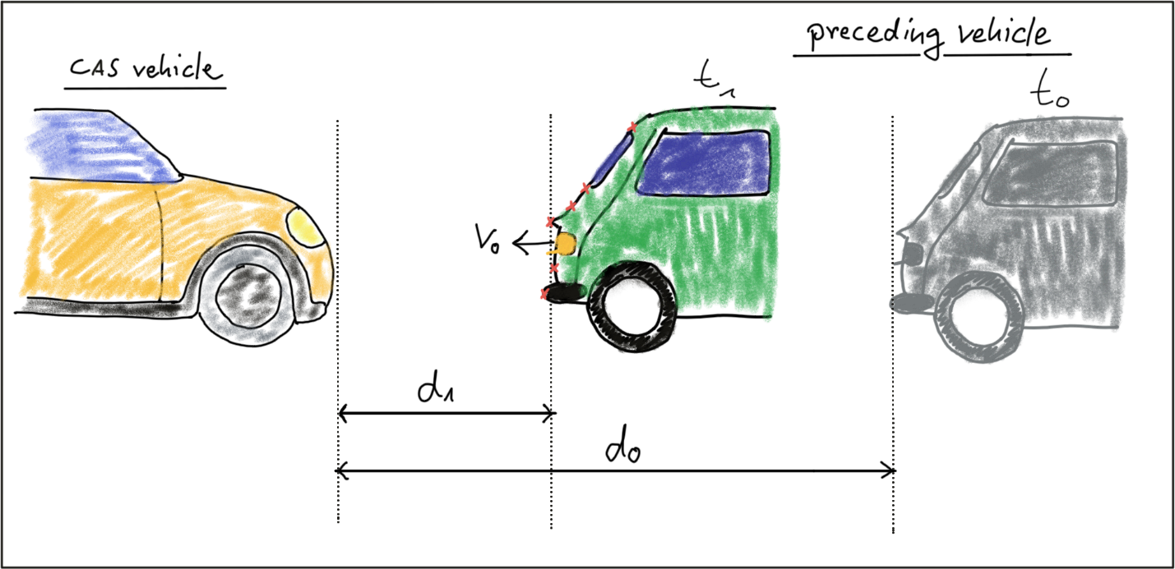](https://classroom.udacity.com/nanodegrees/nd313/parts/1971021c-523b-414c-93a3-2c6297cf4771/modules/0a71c48d-96ab-4d3a-be96-3ea1e64cf773/lessons/dfe71db5-4233-4e4f-b33f-40cb9899dc13/concepts/be934900-efc9-4f0b-83e9-aa1fcc596888)](https://classroom.udacity.com/nanodegrees/nd313/parts/1971021c-523b-414c-93a3-2c6297cf4771/modules/0a71c48d-96ab-4d3a-be96-3ea1e64cf773/lessons/dfe71db5-4233-4e4f-b33f-40cb9899dc13/concepts/be934900-efc9-4f0b-83e9-aa1fcc596888)

In this traffic scenario, the green vehicle starts to reduce its speed at time t\_0*t*0​, which is when the yellow vehicle, equipped with a collision sensor, takes the distance measurement d\_0*d*0​. A moment later, at time t\_1*t*1​, the green vehicle is considerably closer and a second measurement d\_1*d*1​ is taken. The goal now is to compute the remaining TTC so the system can warn the driver of the yellow vehicle or even trigger the brakes autonomously.

Before we can do this however, we need to find a way to describe the relative motion of the vehicles with a mathematical model.

## Constant velocity vs. constant acceleration

To compute the TTC, we need to make assumptions on the physical behavior of the preceding vehicle. One assumption could be that the relative velocity between the yellow and green vehicle in the above figure were constant. This would lead to the so-called constant velocity model (CVM) which is represented by eq. 1 in the following diagram.

[[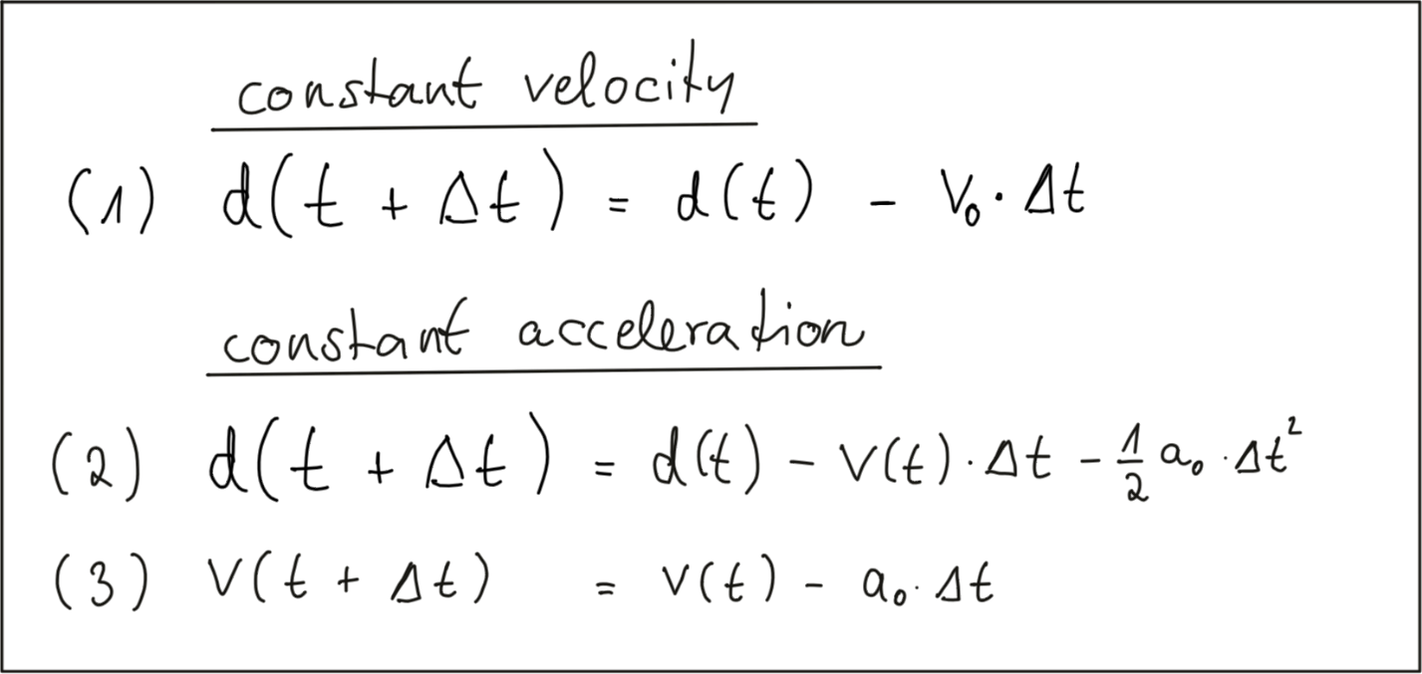](https://classroom.udacity.com/nanodegrees/nd313/parts/1971021c-523b-414c-93a3-2c6297cf4771/modules/0a71c48d-96ab-4d3a-be96-3ea1e64cf773/lessons/dfe71db5-4233-4e4f-b33f-40cb9899dc13/concepts/be934900-efc9-4f0b-83e9-aa1fcc596888)](https://classroom.udacity.com/nanodegrees/nd313/parts/1971021c-523b-414c-93a3-2c6297cf4771/modules/0a71c48d-96ab-4d3a-be96-3ea1e64cf773/lessons/dfe71db5-4233-4e4f-b33f-40cb9899dc13/concepts/be934900-efc9-4f0b-83e9-aa1fcc596888)

As you can see, the distance to the vehicle at time instant t + \Delta t*t*+Δ*t* is smaller than at time t*t*, because we subtract the product of a constant relative velocity v\_0*v*0​ and time \Delta tΔ*t*. From an engineering perspective, we would need a sensor capable of measuring the distance to the preceeding vehicle on a precisely times basis with a constant dt between measurements. This could very well be achieved with e.g. a Lidar sensor.

Especially in dynamic traffic situations where a vehicle is braking hard, the CVM is not accurate enough however, as the relative velocity between both vehicles changes between measurements. In the following figure, the approaching vehicle is shown at three time instants with increasing velocity.

[[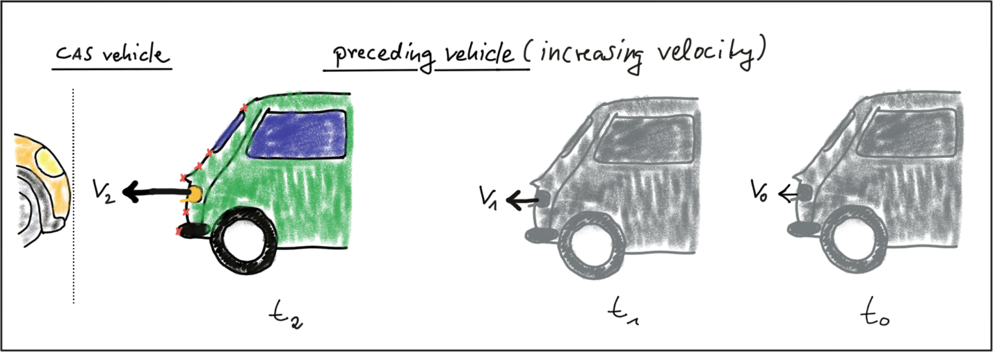](https://classroom.udacity.com/nanodegrees/nd313/parts/1971021c-523b-414c-93a3-2c6297cf4771/modules/0a71c48d-96ab-4d3a-be96-3ea1e64cf773/lessons/dfe71db5-4233-4e4f-b33f-40cb9899dc13/concepts/be934900-efc9-4f0b-83e9-aa1fcc596888)](https://classroom.udacity.com/nanodegrees/nd313/parts/1971021c-523b-414c-93a3-2c6297cf4771/modules/0a71c48d-96ab-4d3a-be96-3ea1e64cf773/lessons/dfe71db5-4233-4e4f-b33f-40cb9899dc13/concepts/be934900-efc9-4f0b-83e9-aa1fcc596888)

We can thus expand on our CVM by assuming velocity to be a function of time and subtract a second term in eq. 2 which is the product of a constant acceleration and the squared time dt between both measurements. Eq. 3 displays velocity as a function of time, which is also dependent on the constant acceleration we used in eq. 2. This model is referred to as constant acceleration model (CAM) and it is commonly used in commercially available collision detection systems. On a side note, if we were using a radar sensor instead of a Lidar, a direct measurement on velocity could be taken by exploiting a frequency shift in the returning electromagnetic wave due to the Doppler effect. This is a significant advantage over sensors such as Lidar, where velocity can only be computed based on (noisy) distance measurements.

In this course, we will be using a CVM instead of the CAM as it is much simpler to handle with regard to the math involved and with regard to the complexity of the programming task ahead of you. For small instances of dt we will assume that the CVM model is accurate enough and that it will give us a decent estimate of the TTC. Should you be involved in building a commercial version of such a system at a later stage in your career however, keep in mind that you should be using a constant acceleration model instead.

# Estimating TTC with Lidar

## The Math Behind Time-to-Collision (TTC)

In the following, let us assume that our CAS-equipped vehicle is using a Lidar sensor to take distance measurements on preceding vehicles. The sensor in this scenario will give us the distance to the closest 3D point in the path of driving. In the figure below, the closest point is indicated by a red line emanating from a Lidar sensor on top of the CAS vehicle.

**[[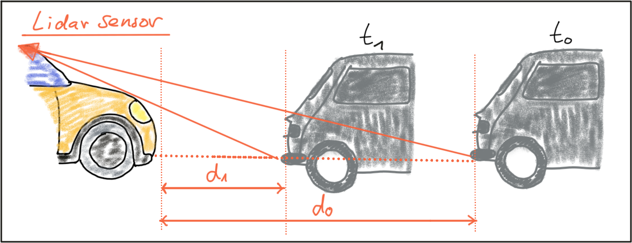](https://classroom.udacity.com/nanodegrees/nd313/parts/1971021c-523b-414c-93a3-2c6297cf4771/modules/0a71c48d-96ab-4d3a-be96-3ea1e64cf773/lessons/dfe71db5-4233-4e4f-b33f-40cb9899dc13/concepts/c78c2068-ff3b-4146-9f1f-77ea44188ef2)](https://classroom.udacity.com/nanodegrees/nd313/parts/1971021c-523b-414c-93a3-2c6297cf4771/modules/0a71c48d-96ab-4d3a-be96-3ea1e64cf773/lessons/dfe71db5-4233-4e4f-b33f-40cb9899dc13/concepts/c78c2068-ff3b-4146-9f1f-77ea44188ef2)**

Based on the model of a constant-velocity we discussed in the last section, the velocity v\_0*v*0​ can be computed from two successive Lidar measurements as follows:

**[[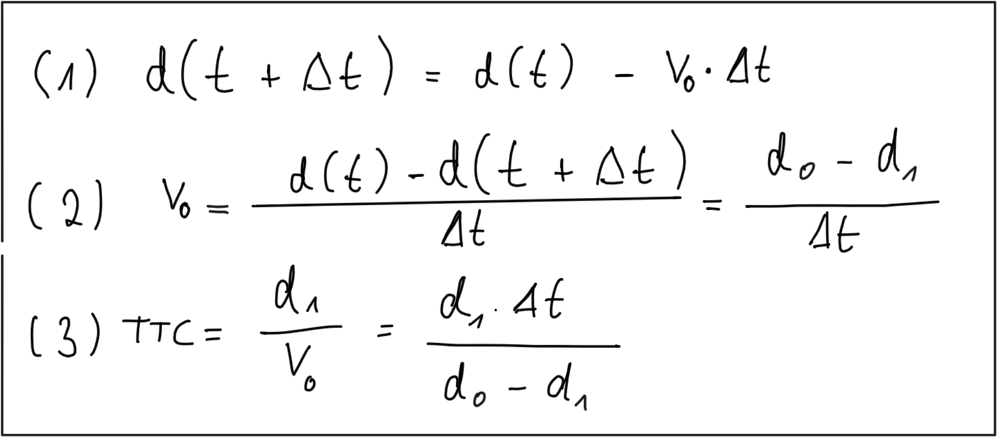](https://classroom.udacity.com/nanodegrees/nd313/parts/1971021c-523b-414c-93a3-2c6297cf4771/modules/0a71c48d-96ab-4d3a-be96-3ea1e64cf773/lessons/dfe71db5-4233-4e4f-b33f-40cb9899dc13/concepts/c78c2068-ff3b-4146-9f1f-77ea44188ef2)](https://classroom.udacity.com/nanodegrees/nd313/parts/1971021c-523b-414c-93a3-2c6297cf4771/modules/0a71c48d-96ab-4d3a-be96-3ea1e64cf773/lessons/dfe71db5-4233-4e4f-b33f-40cb9899dc13/concepts/c78c2068-ff3b-4146-9f1f-77ea44188ef2)**

Once the relative velocity v\_0*v*0​ is known, the time to collision can easily be computed by dividing the remaining distance between both vehicles by v\_0*v*0​. So given a Lidar sensor which is able to take precise distance measurements, a system for TTC estimation can be developed based based on a CVM and on the set of equations shown above. Note however that a radar sensor would be the superior solution for TTC computation as it can directly measure the relative speed, whereas with the Lidar sensor we need to compute v\_0*v*0​ from two (noisy) distance measurements.

## Preparing the Lidar Point Cloud

The following image shows a Lidar point cloud as an overlay over a camera image taken in a highway scenario with a preceding vehicle directly in the path of driving. Distance to the sensor is color-coded (green is far away, red is close). On the left side, a bird-view perspective of the Lidar points is shown as well.

**[[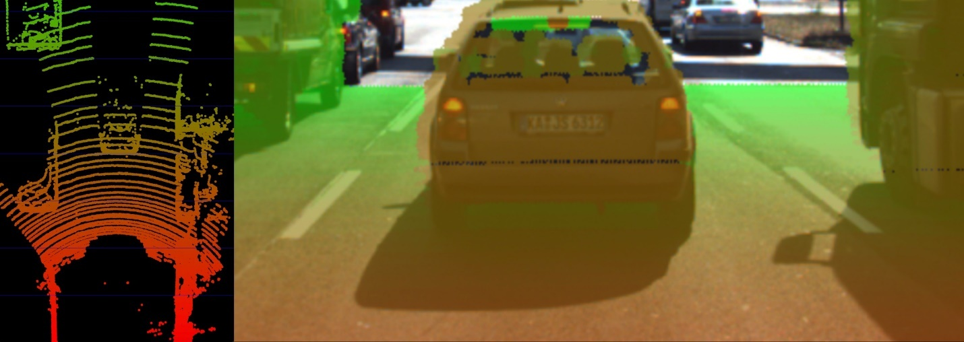](https://classroom.udacity.com/nanodegrees/nd313/parts/1971021c-523b-414c-93a3-2c6297cf4771/modules/0a71c48d-96ab-4d3a-be96-3ea1e64cf773/lessons/dfe71db5-4233-4e4f-b33f-40cb9899dc13/concepts/c78c2068-ff3b-4146-9f1f-77ea44188ef2)](https://classroom.udacity.com/nanodegrees/nd313/parts/1971021c-523b-414c-93a3-2c6297cf4771/modules/0a71c48d-96ab-4d3a-be96-3ea1e64cf773/lessons/dfe71db5-4233-4e4f-b33f-40cb9899dc13/concepts/c78c2068-ff3b-4146-9f1f-77ea44188ef2)**

As can easily be seen, the Lidar sensor provides measurements on the vehicles as well as on the road surface. Also, some 3D points in the camera image do not seem accurate when compared to their surrounding neighbors. Especially the points near the roof of the preceding vehicle differ in color from the points on the tailgate.

As measurement accuracy is correlated to the amount of light reflected from an object, it makes sense to consider the reflectiveness r of each Lidar point which we can access in addition to the x, y and z coordinates. The image below highlights high reflectiveness with green, whereas regions with low reflectiveness are shown as red. An analysis of the associated reflectivity of the point cloud shows that such deviations often occur in regions with reduced reflectiveness.

**[[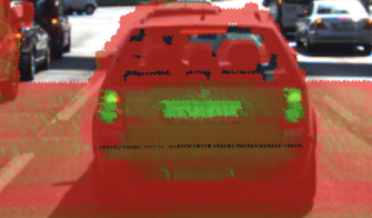](https://classroom.udacity.com/nanodegrees/nd313/parts/1971021c-523b-414c-93a3-2c6297cf4771/modules/0a71c48d-96ab-4d3a-be96-3ea1e64cf773/lessons/dfe71db5-4233-4e4f-b33f-40cb9899dc13/concepts/c78c2068-ff3b-4146-9f1f-77ea44188ef2)](https://classroom.udacity.com/nanodegrees/nd313/parts/1971021c-523b-414c-93a3-2c6297cf4771/modules/0a71c48d-96ab-4d3a-be96-3ea1e64cf773/lessons/dfe71db5-4233-4e4f-b33f-40cb9899dc13/concepts/c78c2068-ff3b-4146-9f1f-77ea44188ef2)**

In order to derive a stable TTC measurement from the given point cloud, two main steps have to be performed:

1. Remove measurements on the road surface
2. Remove measurements with low reflectivity

In the figure below, Lidar points are shown in a top-view perspective and as an image overlay after applying the filtering. After removing Lidar points in this manner, it is now much easier to derive the distance d(t) to the preceding vehicle.

**[[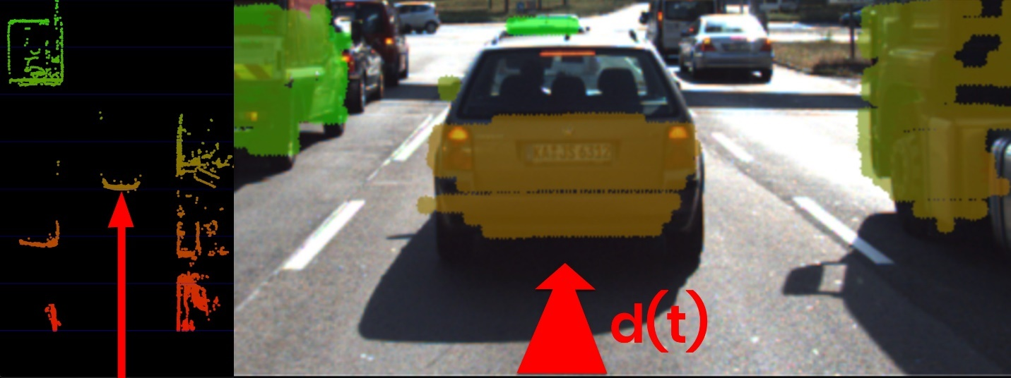](https://classroom.udacity.com/nanodegrees/nd313/parts/1971021c-523b-414c-93a3-2c6297cf4771/modules/0a71c48d-96ab-4d3a-be96-3ea1e64cf773/lessons/dfe71db5-4233-4e4f-b33f-40cb9899dc13/concepts/c78c2068-ff3b-4146-9f1f-77ea44188ef2)](https://classroom.udacity.com/nanodegrees/nd313/parts/1971021c-523b-414c-93a3-2c6297cf4771/modules/0a71c48d-96ab-4d3a-be96-3ea1e64cf773/lessons/dfe71db5-4233-4e4f-b33f-40cb9899dc13/concepts/c78c2068-ff3b-4146-9f1f-77ea44188ef2)**

In a later lesson, you will learn how to project Lidar points into the camera image and how to perform the removal procedure as seen in the above examples. For now, let us assume that for each time step dt, the Lidar sensor would return the distance d(t+dt) to the preceding vehicle.

## Computing TTC from Distance Measurements

In the code examples in this course, Lidar points are packaged into a data structure called LidarPoints. As seen below, the structure consists of the point coordinates x (forward), y (left) an z (up) in metric coordinates and of the point reflectivity r on a scale between 0 and 1 (high reflectivity).

**struct** LidarPoint { *// single lidar point in space*

**double** x, y, z; *// point position in m*

**double** r; *// point reflectivity in the range 0-1*

};

In order to compute the TTC, we need to find the distance to the closest Lidar point in the path of driving. In the figure below, Lidar measurements located on the tailgate of the preceding vehicle are measured at times t\_0*t*0​ (green) and t\_1*t*1​ (red). It can be seen, that the distance to the vehicle has decreased slightly between both time instants.

**[[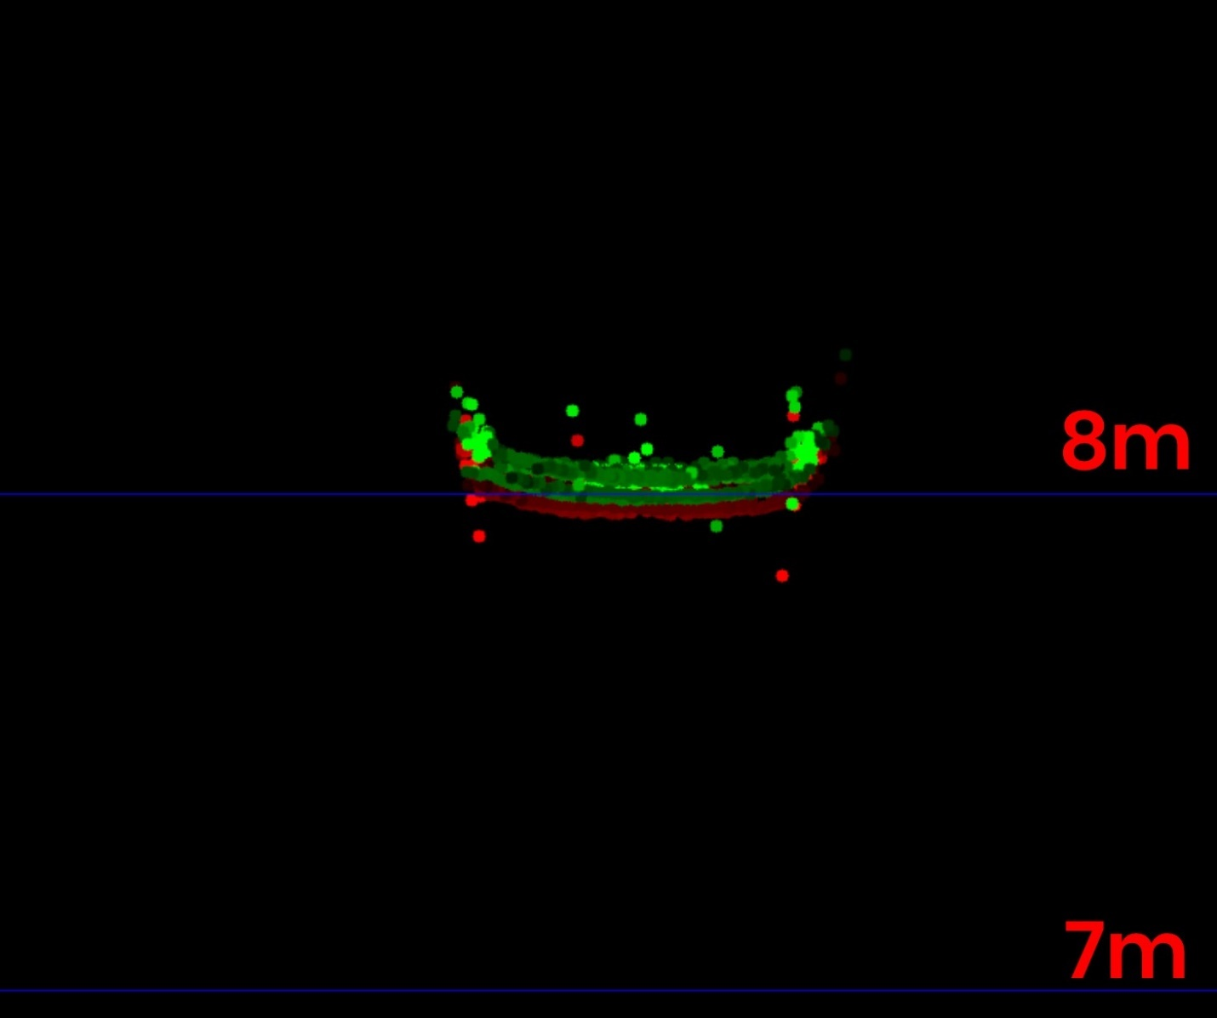](https://classroom.udacity.com/nanodegrees/nd313/parts/1971021c-523b-414c-93a3-2c6297cf4771/modules/0a71c48d-96ab-4d3a-be96-3ea1e64cf773/lessons/dfe71db5-4233-4e4f-b33f-40cb9899dc13/concepts/c78c2068-ff3b-4146-9f1f-77ea44188ef2)](https://classroom.udacity.com/nanodegrees/nd313/parts/1971021c-523b-414c-93a3-2c6297cf4771/modules/0a71c48d-96ab-4d3a-be96-3ea1e64cf773/lessons/dfe71db5-4233-4e4f-b33f-40cb9899dc13/concepts/c78c2068-ff3b-4146-9f1f-77ea44188ef2)**

The following code searches for the closest point in the point cloud associated with t\_0*t*0​ (lidarPointsPrev) and in the point cloud associated with t\_1*t*1​ (lidarPointsCurr). After finding the distance to the closest points respectively, the TTC is computed based on the formula we derived at the beginning of this section.

**void** **computeTTCLidar**(std::vector<LidarPoint> &lidarPointsPrev,

std::vector<LidarPoint> &lidarPointsCurr, **double** &TTC)

{

*// auxiliary variables*

**double** dT = 0.1; *// time between two measurements in seconds*

*// find closest distance to Lidar points*

**double** minXPrev = 1e9, minXCurr = 1e9;

**for**(**auto** it=lidarPointsPrev.begin(); it!=lidarPointsPrev.end(); ++it) {

minXPrev = minXPrev>it->x ? it->x : minXPrev;

}

**for**(**auto** it=lidarPointsCurr.begin(); it!=lidarPointsCurr.end(); ++it) {

minXCurr = minXCurr>it->x ? it->x : minXCurr;

}

*// compute TTC from both measurements*

TTC = minXCurr \* dT / (minXPrev-minXCurr);

}

Even though Lidar is a reliable sensor, erroneous measurements may still occur. As seen in the figure above, a small number of points is located behind the tailgate, seemingly without connection to the vehicle. When searching for the closest points, such measurements will pose a problem as the estimated distance will be too small. There are ways to avoid such errors by post-processing the point cloud, but there will be no guarantee that such problems will never occur in practice. It is thus a good idea to perform a more robust computation of minXCurr and minXPrev which is able to cope with a certain number of outliers (in the final project, you will do this) and also look at a second sensor which is able to compute the TTC, such as the camera.

EXERCISE

In the workspace below, extend the function computeTTCLidar shown above so that only Lidar points within a narrow corridor whose width is defined by a variable laneWidth are considered during minimum search. The width of the corridor should be set to 4 meters.

You can run your code as usual by creating a build directory in TTC\_lidar. Then use the following steps from within the build directory:

1. cmake ..
2. make
3. ./compute\_ttc\_lidar

# Estimating TTC with a Camera

## Measuring TTC without distance

Monocular cameras are not able to measure metric distances. They are passive sensors that rely on the ambient light which reflects off of objects into the camera lens. It is thus not possible to measure the runtime of light as with Lidar technology.

To measure distance, a second camera would be needed. Given two images taken by two carefully aligned cameras (also called a stereo setup) at the same time instant, one would have to locate common points of interest in both images (e.g. the tail lights of the preceding vehicle) and then triangulate their distance using camera geometry and perspective projection. For many years, automotive researchers have developed stereo cameras for the use in ADAS products and some of those have made it to market. Especially Mercedes-Benz has pioneered this technology and extensive information can be found here : [**http://www.6d-vision.com/**](http://www.6d-vision.com/). With more advanced ADAS products and with autonomous vehicles however, stereo cameras have started to disappear from the market due to their package size, the high price and the high computational load for finding corresponding features.

Despite those limitations of the mono camera, let us see if there is a way to compute TTC without the need to measure distance. Let us consider the constant velocity motion model we introduced in a previous section of this course and think about a way to replace the metric distances d with something the camera can measure reliably, such as pixel distances directly on the image plane. In the following figure, you can see how the height H*H* of the preceding vehicle can be mapped onto the image place using perspective projection. We can see that the same height H*H* maps to different heights h\_0*h*0​ and h\_1*h*1​ in the image plane, depending on the distance d\_0*d*0​ and d\_1*d*1​ of the vehicle. It is obvious that there is a geometric relation between h*h*, H*H*, d*d* and the focal length f*f* of the pinhole camera - and this is what we want to exploit in the following.

**[[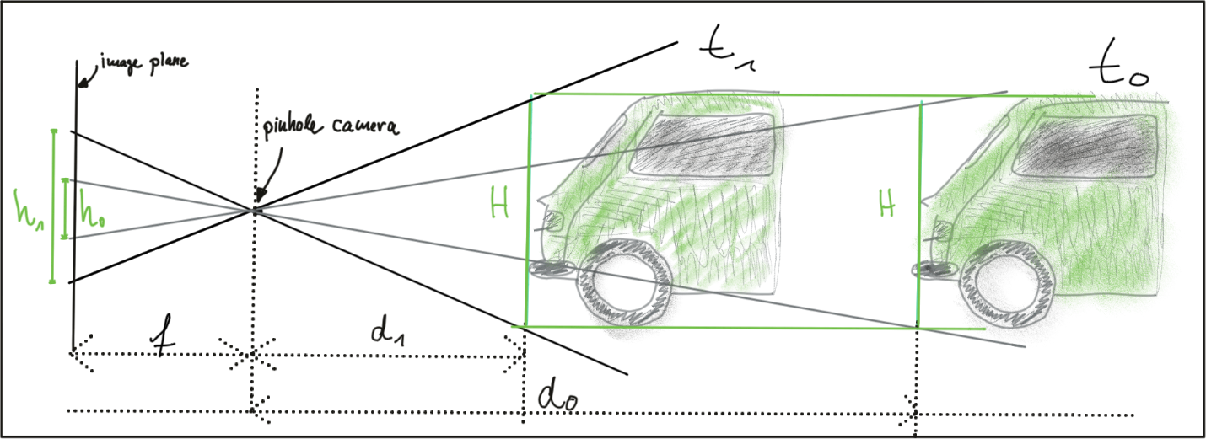](https://classroom.udacity.com/nanodegrees/nd313/parts/1971021c-523b-414c-93a3-2c6297cf4771/modules/0a71c48d-96ab-4d3a-be96-3ea1e64cf773/lessons/dfe71db5-4233-4e4f-b33f-40cb9899dc13/concepts/daceaff3-1519-4f4c-82ff-16e02b5c2e8f)](https://classroom.udacity.com/nanodegrees/nd313/parts/1971021c-523b-414c-93a3-2c6297cf4771/modules/0a71c48d-96ab-4d3a-be96-3ea1e64cf773/lessons/dfe71db5-4233-4e4f-b33f-40cb9899dc13/concepts/daceaff3-1519-4f4c-82ff-16e02b5c2e8f)**

Let us take a look at the following set of equations:

**[[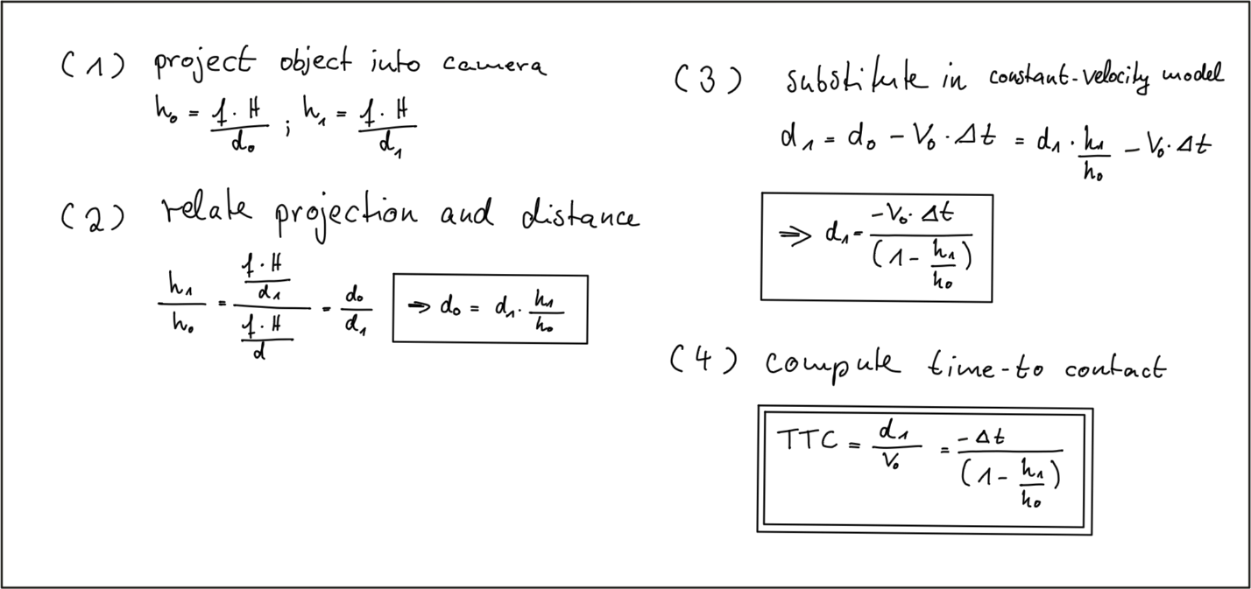](https://classroom.udacity.com/nanodegrees/nd313/parts/1971021c-523b-414c-93a3-2c6297cf4771/modules/0a71c48d-96ab-4d3a-be96-3ea1e64cf773/lessons/dfe71db5-4233-4e4f-b33f-40cb9899dc13/concepts/daceaff3-1519-4f4c-82ff-16e02b5c2e8f)](https://classroom.udacity.com/nanodegrees/nd313/parts/1971021c-523b-414c-93a3-2c6297cf4771/modules/0a71c48d-96ab-4d3a-be96-3ea1e64cf773/lessons/dfe71db5-4233-4e4f-b33f-40cb9899dc13/concepts/daceaff3-1519-4f4c-82ff-16e02b5c2e8f)**

In (1) we use the focal length of the camera and a distance measurement d\_0*d*0​ performed at time t\_0*t*0​ to project the height H*H* of the vehicle onto the image plane and thus to a height h\_0*h*0​ in pixels. The same is done at time t\_1*t*1​, leading to a projected height h\_1*h*1​.

In (2), we compute the ratio of the relative heights h\_0*h*0​ and h\_1*h*1​. As both H*H* and f*f* are cancelled out, we can observe a direct relation between relative height h*h* and absolute metric distance d*d*. We can thus express the distance to the vehicle d\_0*d*0​ as the product of d\_1*d*1​ and the ratio of relative heights on the image plane.

In (3), we substitute d\_0*d*0​ in the equation for constant velocity and solve for d\_1*d*1​, which is now dependent on the constant relative velocity v\_0*v*0​, on the time between measuring d\_0*d*0​ and d\_1*d*1​ and on the ratio of relative heights on the image plane.

In (4), the TTC is computed as the ratio of remaining distance to impact, which is d\_1*d*1​, and the constant velocity v\_0*v*0​. As we can easily see, the TTC now only consists of \Delta tΔ*t*, h\_0*h*0​ and h\_1*h*1​. Thus, it is possible to measure the time to collision by observing relative height change on the image sensor. Distance measurements are not needed and we can thus use a mono camera to estimate the time-to-collision by observing changes in relative height (also called scale change) directly in the image.

## The Problem with Bounding Box Detection

In the figure below, a neural network has been used to locate vehicles in successive images of a monocular camera. For each vehicle, the network returns a bounding box, whose width and/or height could in principal be used to compute the height ratio in the TTC equation we derived in the last section.

When observed closely however, it can be seen that the bounding boxes do not always reflect the true vehicle dimensions and the aspect ratio differs between images. Using bounding box height or width for TTC computation would thus lead to significant estimation errors.

**[[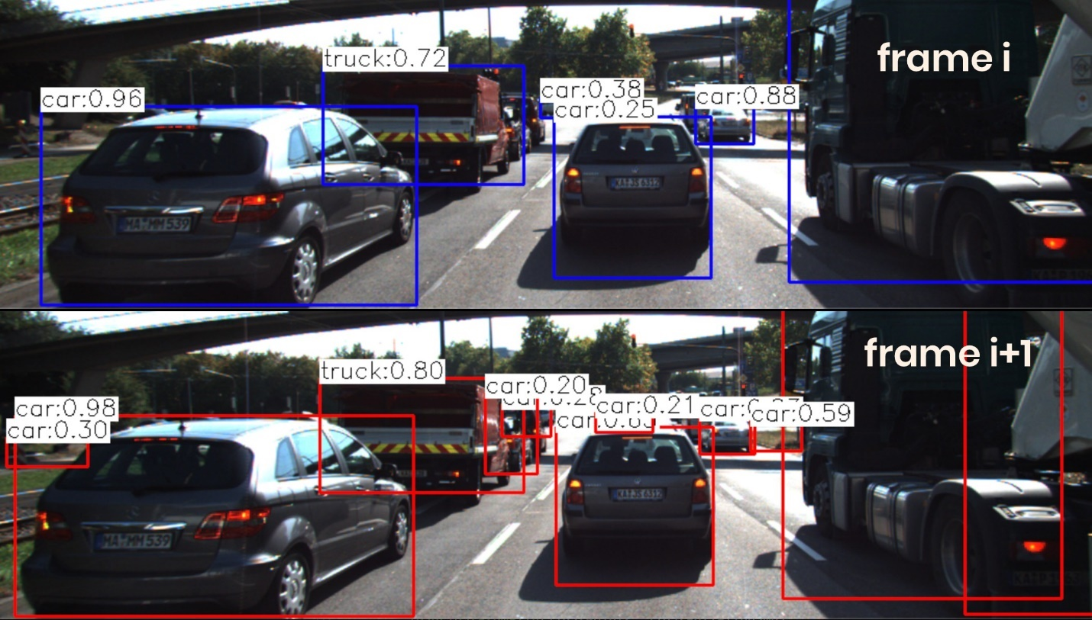](https://classroom.udacity.com/nanodegrees/nd313/parts/1971021c-523b-414c-93a3-2c6297cf4771/modules/0a71c48d-96ab-4d3a-be96-3ea1e64cf773/lessons/dfe71db5-4233-4e4f-b33f-40cb9899dc13/concepts/daceaff3-1519-4f4c-82ff-16e02b5c2e8f)](https://classroom.udacity.com/nanodegrees/nd313/parts/1971021c-523b-414c-93a3-2c6297cf4771/modules/0a71c48d-96ab-4d3a-be96-3ea1e64cf773/lessons/dfe71db5-4233-4e4f-b33f-40cb9899dc13/concepts/daceaff3-1519-4f4c-82ff-16e02b5c2e8f)**

In most engineering tasks, relying on a single measurement or property is not reliable enough. This holds especially true for safety-related products. Therefore, we want to consider wether there are further properties of vehicles and objects we can observe in an image.

## Using Texture Keypoints Instead

Instead of relying on the detection of the vehicle as a whole we now want to analyze its structure on a smaller scale. If if were possible to locate uniquely identifiable keypoints that could be tracked from one frame to the next, we could use the distance between all keypoints on the vehicle relative to each other to compute a robust estimate of the height ratio in out TTC equation. The following figure illustrates the concept.

**[[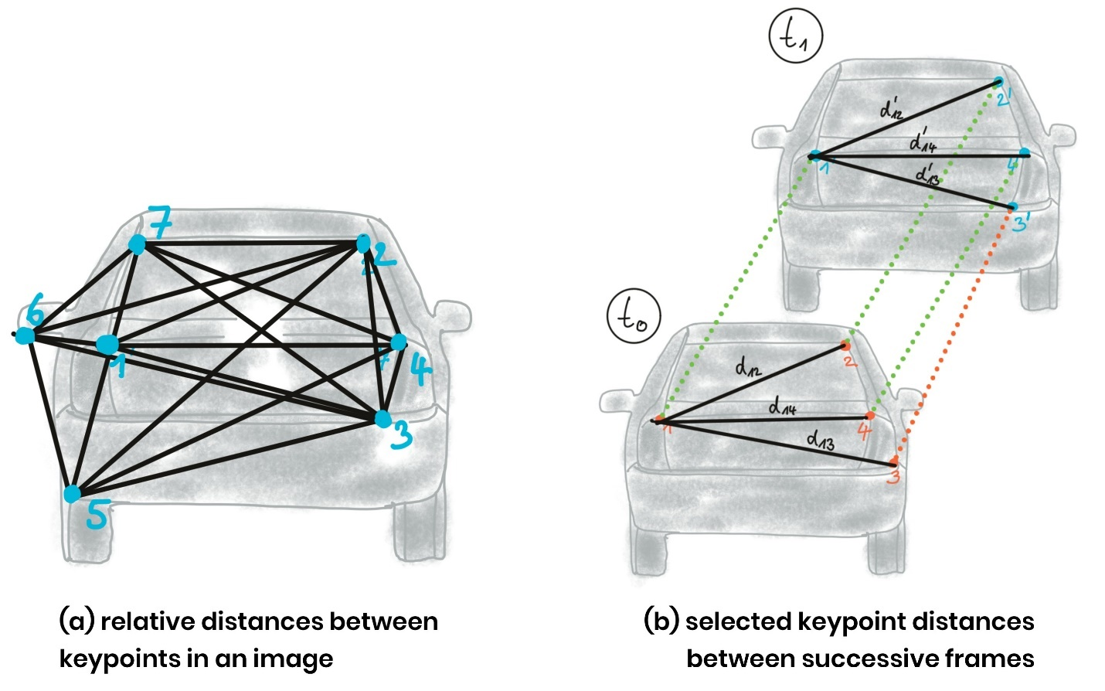](https://classroom.udacity.com/nanodegrees/nd313/parts/1971021c-523b-414c-93a3-2c6297cf4771/modules/0a71c48d-96ab-4d3a-be96-3ea1e64cf773/lessons/dfe71db5-4233-4e4f-b33f-40cb9899dc13/concepts/daceaff3-1519-4f4c-82ff-16e02b5c2e8f)](https://classroom.udacity.com/nanodegrees/nd313/parts/1971021c-523b-414c-93a3-2c6297cf4771/modules/0a71c48d-96ab-4d3a-be96-3ea1e64cf773/lessons/dfe71db5-4233-4e4f-b33f-40cb9899dc13/concepts/daceaff3-1519-4f4c-82ff-16e02b5c2e8f)**

In (a), a set of keypoints has been detected and the relative distances between keypoints 1-7 have been computed. In (b), 4 keypoints have been matched between successive images (with keypoint 3 being a mismatch) using a higher-dimensional similarity measure called descriptor (more about that in the next lesson). The ratio of all relative distances between each other can be used to compute a reliable TTC estimate by replacing the height ratio h\_1 / h\_0*h*1​/*h*0​ with the mean or median of all distance ratios d\_k / d\_k'*dk*​/*dk*′​.

The following figure shows several example of relative distances between keypoints as an overlay over a highway driving scene (only the preceding vehicle is highlighted).

**[[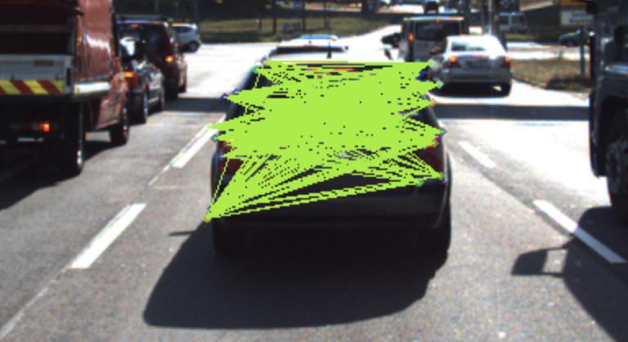](https://classroom.udacity.com/nanodegrees/nd313/parts/1971021c-523b-414c-93a3-2c6297cf4771/modules/0a71c48d-96ab-4d3a-be96-3ea1e64cf773/lessons/dfe71db5-4233-4e4f-b33f-40cb9899dc13/concepts/daceaff3-1519-4f4c-82ff-16e02b5c2e8f)](https://classroom.udacity.com/nanodegrees/nd313/parts/1971021c-523b-414c-93a3-2c6297cf4771/modules/0a71c48d-96ab-4d3a-be96-3ea1e64cf773/lessons/dfe71db5-4233-4e4f-b33f-40cb9899dc13/concepts/daceaff3-1519-4f4c-82ff-16e02b5c2e8f)**

## Computing TTC from Relative Keypoint Distances

In the code examples in this course, matching keypoints between images are packaged into an OpenCV data structure called cv::DMatch. The structure elements we will be using in this course are queryIdx, which is the index of a keypoint in the current frame, and trainIdx, which is the index of the matched keypoint in the previous frame.

All matched keypoints are stored in a dynamic list, which is then passed to a function called computeTTCCamera, which returns the time-to-collision for each object in the scene. Let us take a look at this function in the following.

EXERCISE

Imagine a set of associated keypoint between two successive frames which contain a large number of mismatches. Computing the mean distance ratio as in the function we just discussed would presumably lead to a faulty calculation of the TTC. A more robust way of computing the average of a dataset with outliers is to use the median instead. In the code below, replace meanDistRatio with a variable medianDistRatio and do not forget to consider both an even and an odd number of values in the vector distRatios.

<https://www.youtube.com/watch?v=8ViLZSG-ofg&feature=emb_logo>

## Locating Keypoints in an Image

As discussed in the previous lesson, a camera is not able to measure distance to an object directly. However, for our collision avoidance system, we can compute time-to-collision based on relative distance ratios on the image sensor instead. To do so, we need a set of locations on the image plane which can serve as stable anchors to compute relative distances between them. This section discussed how to locate such anchor locations - or keypoints in an image.

Take a look at the three patches in the following figure which have been extracted from an image of a highway driving scene. The grid shows the borders of individual pixels. How would you describe meaningful locations within those patches that could be used as keypoints?

**[[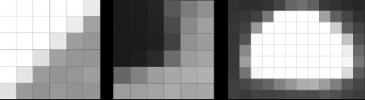](https://classroom.udacity.com/nanodegrees/nd313/parts/1971021c-523b-414c-93a3-2c6297cf4771/modules/0a71c48d-96ab-4d3a-be96-3ea1e64cf773/lessons/53855af9-95ad-41f6-bb0f-7e5464baa34b/concepts/393aeaa5-b65e-4b33-a6fc-35a6de215313)](https://classroom.udacity.com/nanodegrees/nd313/parts/1971021c-523b-414c-93a3-2c6297cf4771/modules/0a71c48d-96ab-4d3a-be96-3ea1e64cf773/lessons/53855af9-95ad-41f6-bb0f-7e5464baa34b/concepts/393aeaa5-b65e-4b33-a6fc-35a6de215313)**

In the leftmost patch, there is a distinctive contrast between bright and dark pixels which resembles a line from the bottom-left to the upper-right. The patch in the middle resembles a corner formed by a group of very dark pixels in the upper-left. The rightmost patch looks like a bright blob that might be approximated by an ellipse.

In order to precisely locate a keypoint in an image, we need a way to assign them a unique coordinate in both x an y. Not all of the above patches lend themselves to this goal. Both the corner as well as the ellipse can be positioned accurately in x and y, the line in the leftmost image can not.

**[[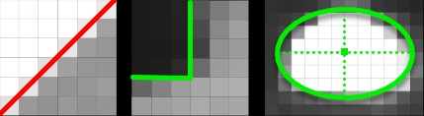](https://classroom.udacity.com/nanodegrees/nd313/parts/1971021c-523b-414c-93a3-2c6297cf4771/modules/0a71c48d-96ab-4d3a-be96-3ea1e64cf773/lessons/53855af9-95ad-41f6-bb0f-7e5464baa34b/concepts/393aeaa5-b65e-4b33-a6fc-35a6de215313)](https://classroom.udacity.com/nanodegrees/nd313/parts/1971021c-523b-414c-93a3-2c6297cf4771/modules/0a71c48d-96ab-4d3a-be96-3ea1e64cf773/lessons/53855af9-95ad-41f6-bb0f-7e5464baa34b/concepts/393aeaa5-b65e-4b33-a6fc-35a6de215313)**

In the following, we will thus concentrate on detecting corners in an image. In a later section, we will also look at detector who are optimized for blob-like structures, such as the SIFT detector.

## The Intensity Gradient

In the above examples, the contrast between neighboring pixels contains the information we need : In order to precisely locate e.g. the corner in the middle patch, we do not need to know its color but instead we require the color difference between the pixels that form the corner to be as high as possible. An ideal corner would consist of only black and white pixels.

The figure below shows the intensity profile of all pixels along the red line in the image as well as the intensity gradient, which is the derivative of image intensity.

**[[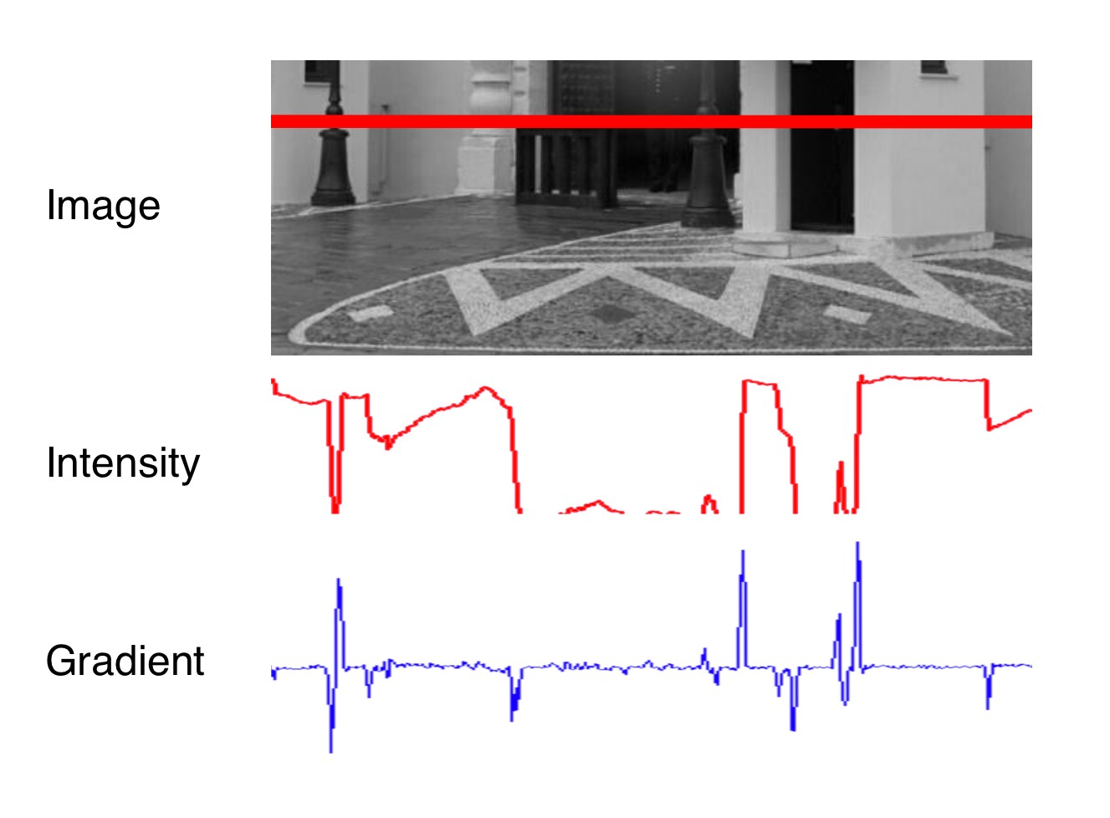](https://classroom.udacity.com/nanodegrees/nd313/parts/1971021c-523b-414c-93a3-2c6297cf4771/modules/0a71c48d-96ab-4d3a-be96-3ea1e64cf773/lessons/53855af9-95ad-41f6-bb0f-7e5464baa34b/concepts/393aeaa5-b65e-4b33-a6fc-35a6de215313)](https://classroom.udacity.com/nanodegrees/nd313/parts/1971021c-523b-414c-93a3-2c6297cf4771/modules/0a71c48d-96ab-4d3a-be96-3ea1e64cf773/lessons/53855af9-95ad-41f6-bb0f-7e5464baa34b/concepts/393aeaa5-b65e-4b33-a6fc-35a6de215313)**

**[Adapted from](https://classroom.udacity.com/nanodegrees/nd313/parts/1971021c-523b-414c-93a3-2c6297cf4771/modules/0a71c48d-96ab-4d3a-be96-3ea1e64cf773/lessons/53855af9-95ad-41f6-bb0f-7e5464baa34b/concepts/393aeaa5-b65e-4b33-a6fc-35a6de215313)**[**https://cs.brown.edu/courses/cs143/lectures\_Fall2017/07\_Fall2017\_EdgeDetection.pdf**](https://cs.brown.edu/courses/cs143/lectures_Fall2017/07_Fall2017_EdgeDetection.pdf)

It can be seen that the intensity profile increases rapidly at positions where the contrast between neighboring pixels changes significantly. The lower part of the street lamp on the left side and the dark door show a distinct intensity difference to the light wall. If we wanted to assign unique coordinates to the pixels where the change occurs, we could do so by looking at the derivative of the intensity, which is the blue gradient profile you can see below the red line. Sudden changes in image intensity are clearly visible as distinct peaks and valleys in the gradient profile. If we were to look for such peaks not only from left to right but also from top to bottom, we could look for points which show a gradient peak both in horizontal and in vertical direction and choose them as keypoints with both x and y coordinates. In the example patches above, this would work best for the corner, whereas an edge-like structure would have more or less identical gradients at all positions with no clear peak in x and y.

Based on the above observations, the first step into keypoint detection is thus the computation of a gradient image. Mathematically, the gradient is the partial derivative of the image intensity into both x and y direction. The figure below shows the intensity gradient for three example patches. The gradient direction is represented by the arrow.

**[[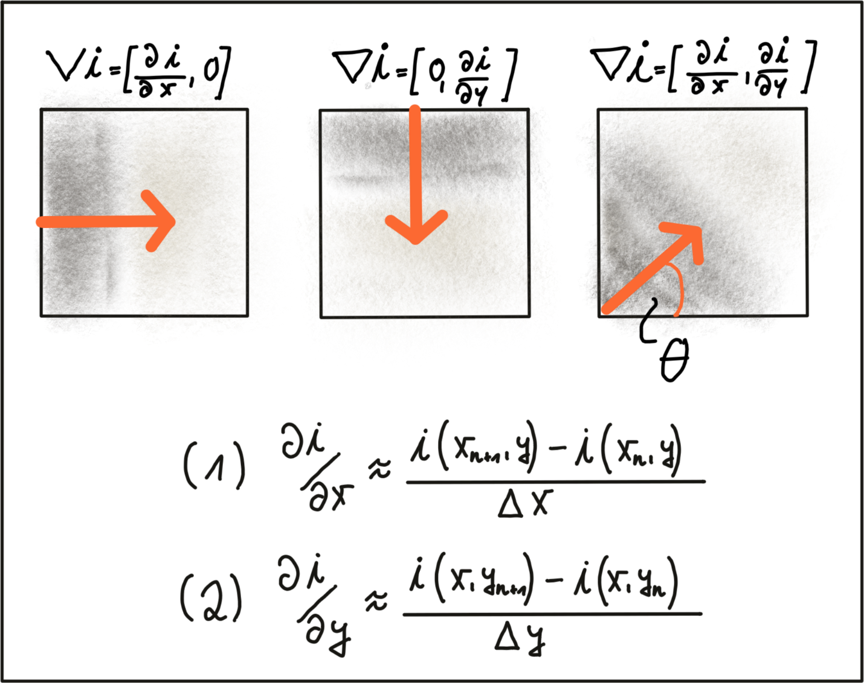](https://classroom.udacity.com/nanodegrees/nd313/parts/1971021c-523b-414c-93a3-2c6297cf4771/modules/0a71c48d-96ab-4d3a-be96-3ea1e64cf773/lessons/53855af9-95ad-41f6-bb0f-7e5464baa34b/concepts/393aeaa5-b65e-4b33-a6fc-35a6de215313)](https://classroom.udacity.com/nanodegrees/nd313/parts/1971021c-523b-414c-93a3-2c6297cf4771/modules/0a71c48d-96ab-4d3a-be96-3ea1e64cf773/lessons/53855af9-95ad-41f6-bb0f-7e5464baa34b/concepts/393aeaa5-b65e-4b33-a6fc-35a6de215313)**

In equations (1) and (2), the intensity gradient is approximated by the intensity differences between neighboring pixels, divided by the distance between those pixels in x- and y-direction. Next, based on the intensity gradient vector, we can compute both the direction as well as the magnitude as given by the following equations:

**[[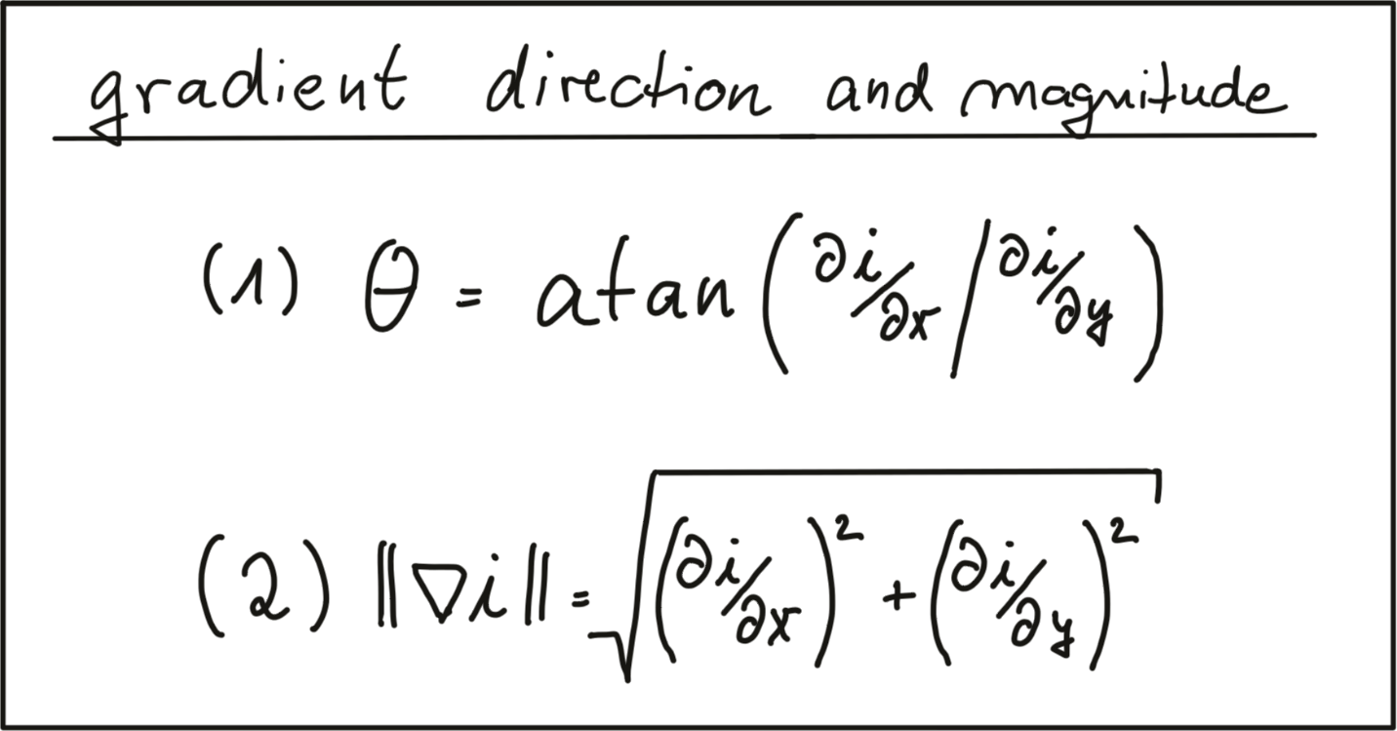](https://classroom.udacity.com/nanodegrees/nd313/parts/1971021c-523b-414c-93a3-2c6297cf4771/modules/0a71c48d-96ab-4d3a-be96-3ea1e64cf773/lessons/53855af9-95ad-41f6-bb0f-7e5464baa34b/concepts/393aeaa5-b65e-4b33-a6fc-35a6de215313)](https://classroom.udacity.com/nanodegrees/nd313/parts/1971021c-523b-414c-93a3-2c6297cf4771/modules/0a71c48d-96ab-4d3a-be96-3ea1e64cf773/lessons/53855af9-95ad-41f6-bb0f-7e5464baa34b/concepts/393aeaa5-b65e-4b33-a6fc-35a6de215313)**

There are numerous ways of computing the intensity gradient. The most straightforward approach would be to simply compute the intensity difference between neighboring pixels. This approach however is extremely sensitive to noise and should be avoided in practice. Further down in this section, we will look at a well-proven standard approach, the Sobel operator.

## Image Filters and Gaussian Smoothing

Before we further discuss gradient computation, we need to think about noise, which is present in all images (except artificial ones) and which decreases with increasing light intensity. To counteract noise, especially under low-light conditions, a smoothing operator has to be applied to the image before gradient computation. Usually, a Gaussian filter is used for this purpose which is shifted over the image and combined with the intensity values beneath it. In order to parameterize the filter properly, two parameters have to be adjusted:

1. The standard deviation, which controls the spatial extension of the filter in the image plane. The larger the standard deviation, the wider the area which is covered by the filter.
2. The kernel size, which defines how many pixels around the center location will contribute to the smoothing operation.

The following figure shows three Gaussian filter kernels with varying standard deviations.

**[[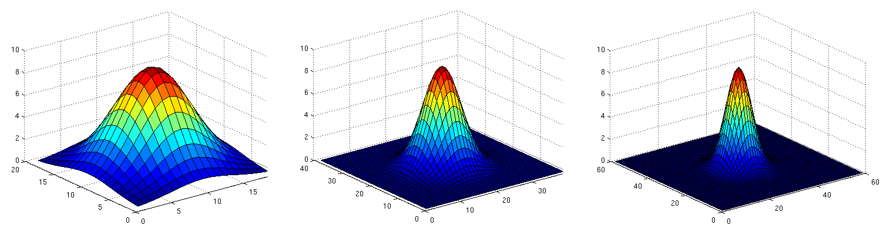](https://classroom.udacity.com/nanodegrees/nd313/parts/1971021c-523b-414c-93a3-2c6297cf4771/modules/0a71c48d-96ab-4d3a-be96-3ea1e64cf773/lessons/53855af9-95ad-41f6-bb0f-7e5464baa34b/concepts/393aeaa5-b65e-4b33-a6fc-35a6de215313)](https://classroom.udacity.com/nanodegrees/nd313/parts/1971021c-523b-414c-93a3-2c6297cf4771/modules/0a71c48d-96ab-4d3a-be96-3ea1e64cf773/lessons/53855af9-95ad-41f6-bb0f-7e5464baa34b/concepts/393aeaa5-b65e-4b33-a6fc-35a6de215313)**

Gaussian smoothing works by assigning each pixel a weighted sum of the surrounding pixels based on the height of the Gaussian curve at each point. The largest contribution will come from the center pixel itself, whereas the contribution from the pixels surroundings will decrease depending on the height of the Gaussian curve and thus its standard deviation. It can easily be seen that the contribution of the surrounding pixels around the center location increases when the standard deviation is large (left image).

Applying the Gaussian filter (or any other filter) works in four successive steps which are illustrated by the figure below:

1. Create a filter kernel with the desired properties (e.g. Gaussian smoothing or edge detection)
2. Define the anchor point within the kernel (usually the center position) and place it on top of the first pixel of the image.
3. Compute the sum of the products of kernel coefficients with the corresponding image pixel values beneath.
4. Place the result to the location of the kernel anchor in the input image.
5. Repeat the process for all pixels over the entire image.

The following figure illustrates the process of shifting the (yellow) filter kernel over the image row by row and assigning the result of the two-dimensional sum H(x,y)*H*(*x*,*y*) to every pixel location.

**[[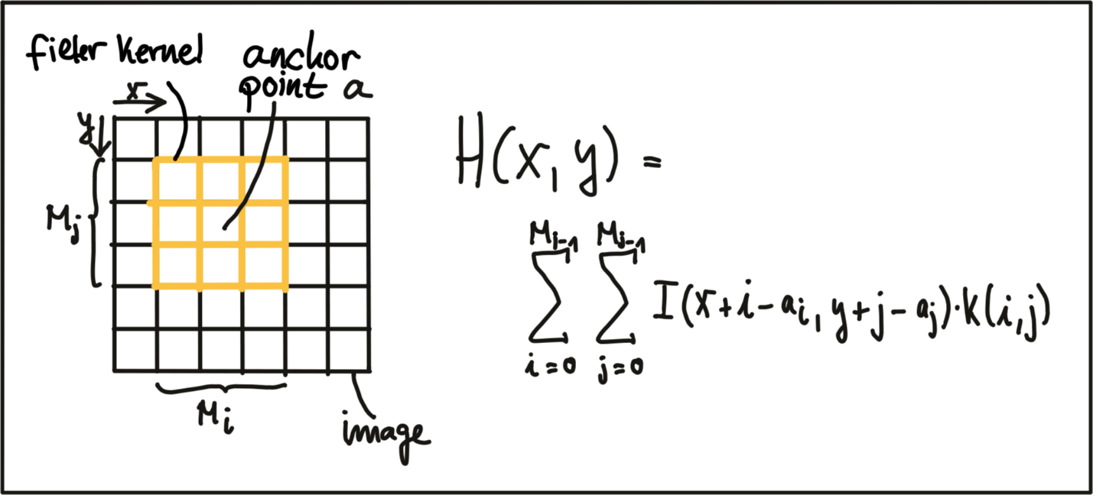](https://classroom.udacity.com/nanodegrees/nd313/parts/1971021c-523b-414c-93a3-2c6297cf4771/modules/0a71c48d-96ab-4d3a-be96-3ea1e64cf773/lessons/53855af9-95ad-41f6-bb0f-7e5464baa34b/concepts/393aeaa5-b65e-4b33-a6fc-35a6de215313)](https://classroom.udacity.com/nanodegrees/nd313/parts/1971021c-523b-414c-93a3-2c6297cf4771/modules/0a71c48d-96ab-4d3a-be96-3ea1e64cf773/lessons/53855af9-95ad-41f6-bb0f-7e5464baa34b/concepts/393aeaa5-b65e-4b33-a6fc-35a6de215313)**

A filter kernel for Gaussian smoothing is shown in the next figure. In (a), a 3D Gaussian curve is shown and in (b), the corresponding discrete filter kernel can be seen with a central anchor point (41) corresponding to the maximum of the Gaussian curve and with decreasing values towards the edges in a (approximately) circular shape.

**[[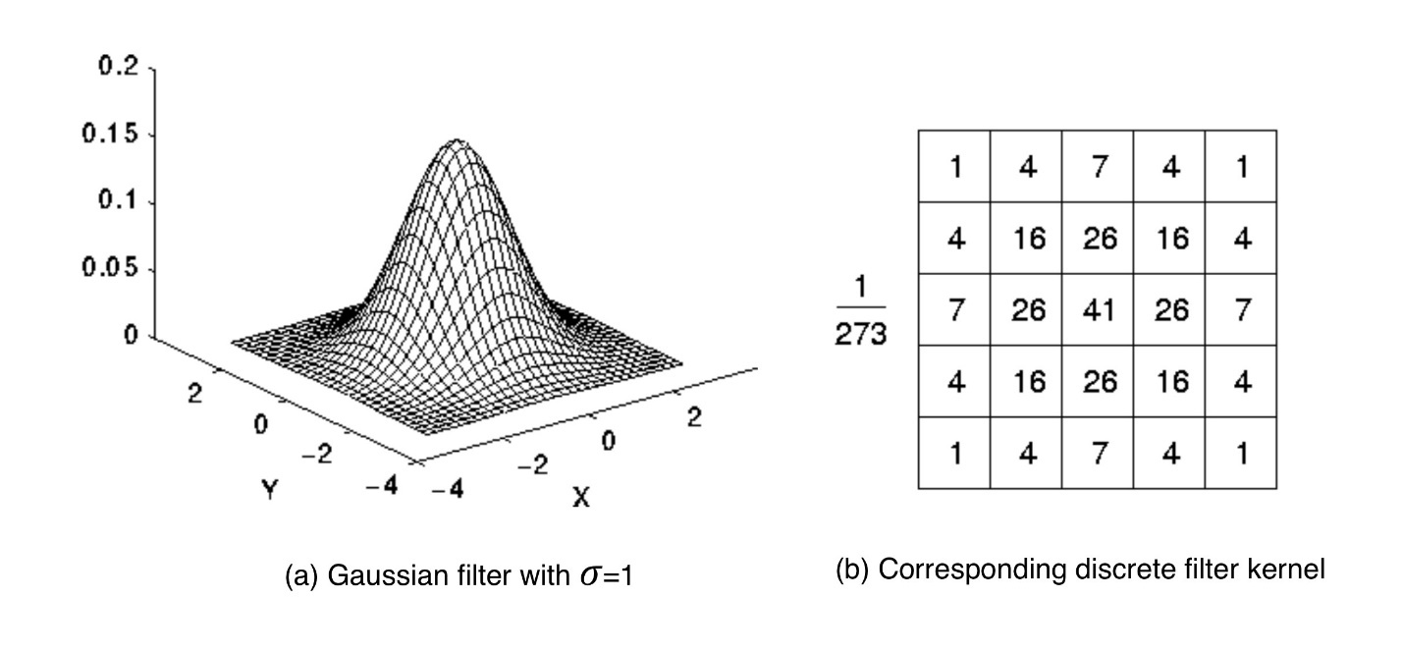](https://classroom.udacity.com/nanodegrees/nd313/parts/1971021c-523b-414c-93a3-2c6297cf4771/modules/0a71c48d-96ab-4d3a-be96-3ea1e64cf773/lessons/53855af9-95ad-41f6-bb0f-7e5464baa34b/concepts/393aeaa5-b65e-4b33-a6fc-35a6de215313)](https://classroom.udacity.com/nanodegrees/nd313/parts/1971021c-523b-414c-93a3-2c6297cf4771/modules/0a71c48d-96ab-4d3a-be96-3ea1e64cf773/lessons/53855af9-95ad-41f6-bb0f-7e5464baa34b/concepts/393aeaa5-b65e-4b33-a6fc-35a6de215313)**

[**https://homepages.inf.ed.ac.uk/rbf/HIPR2/gsmooth.htm**](https://homepages.inf.ed.ac.uk/rbf/HIPR2/gsmooth.htm)

EXERCISE

# The following code uses the function cv::filter2D to apply the filter above to an image. Run the code and figure out why the output image does not look as it is supposed to look after applying the smoothing filter. Once you know why, make the necessary changes and run the code again until you see a slightly blurred image. You can compile using cmake and make as before, and run the code using the generated gaussian\_smoothing executable. Harris Corner Detection

## Local Measures of Uniqueness

The idea of keypoint detection is to detect a unique structure in an image that can be precisely located in both coordinate directions. As discussed in the previous section, corners are ideally suited for this purpose. To illustrate this, the following figure shows an image patch which consists of line structures on a homogeneously colored background. A red arrow indicates that no unique position can be found in this direction. The green arrow expresses the opposite. As can be seen, the corner is the only local structure that can be assigned a unique coordinate in x and y.

**[[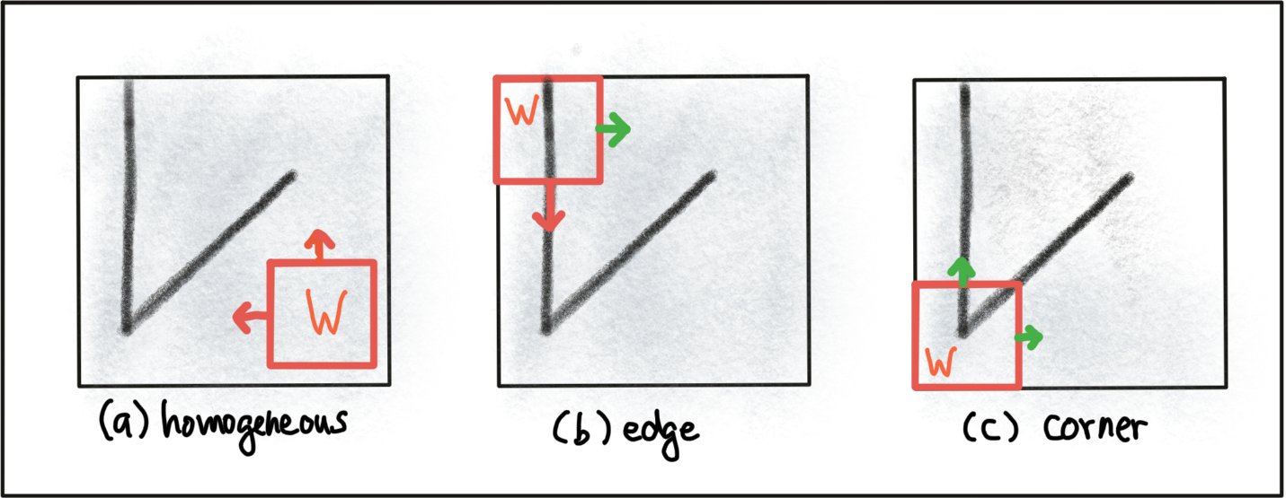](https://classroom.udacity.com/nanodegrees/nd313/parts/1971021c-523b-414c-93a3-2c6297cf4771/modules/0a71c48d-96ab-4d3a-be96-3ea1e64cf773/lessons/53855af9-95ad-41f6-bb0f-7e5464baa34b/concepts/d9b6ff38-e9d3-4723-b598-be901d061f81)](https://classroom.udacity.com/nanodegrees/nd313/parts/1971021c-523b-414c-93a3-2c6297cf4771/modules/0a71c48d-96ab-4d3a-be96-3ea1e64cf773/lessons/53855af9-95ad-41f6-bb0f-7e5464baa34b/concepts/d9b6ff38-e9d3-4723-b598-be901d061f81)**

In order to locate a corner, we consider how the content of the window would change when shifting it by a small amount. For case (a) in the figure above, there is no measurable change in any coordinate direction at the current location of the red window W whereas for (b), there will be significant change into the direction orthogonal to the edge and no change when moving into the direction of the edge. In case of (c), the window content will change in any coordinate direction.

The idea of locating corners by means of an algorithm is to find a way to detect areas with a significant change in the image structure based on a displacement of a local window W. Generally, a suitable measure for describing change mathematically is the sum of squared differences (SSD), which looks at the deviations of all pixels in a local neighborhood before and after performing a coordinate shift. The equation below illustrates the concept.

**[[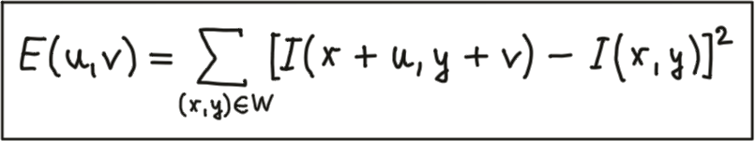](https://classroom.udacity.com/nanodegrees/nd313/parts/1971021c-523b-414c-93a3-2c6297cf4771/modules/0a71c48d-96ab-4d3a-be96-3ea1e64cf773/lessons/53855af9-95ad-41f6-bb0f-7e5464baa34b/concepts/d9b6ff38-e9d3-4723-b598-be901d061f81)](https://classroom.udacity.com/nanodegrees/nd313/parts/1971021c-523b-414c-93a3-2c6297cf4771/modules/0a71c48d-96ab-4d3a-be96-3ea1e64cf773/lessons/53855af9-95ad-41f6-bb0f-7e5464baa34b/concepts/d9b6ff38-e9d3-4723-b598-be901d061f81)**

After shifting the Window W by an amount u in x-direction and v in y-direction the equation sums up the squared differences of all pixels within W at the old and at the new window position. In the following we will use some mathematical transformations to derive a measure for the change of the local environment around a pixel from the general definition of the SSD.

In the first step, based on the definition of E(u,v)*E*(*u*,*v*) above, we will at first make a Taylor series expansion of I(x+u, y+u)*I*(*x*+*u*,*y*+*u*). For small values of u and v, the first-order approximation is sufficient, which leads to the following expression.

**[[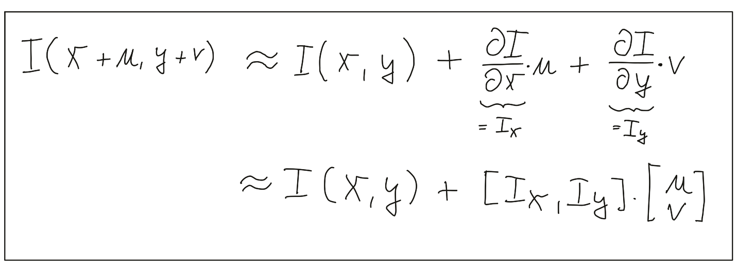](https://classroom.udacity.com/nanodegrees/nd313/parts/1971021c-523b-414c-93a3-2c6297cf4771/modules/0a71c48d-96ab-4d3a-be96-3ea1e64cf773/lessons/53855af9-95ad-41f6-bb0f-7e5464baa34b/concepts/d9b6ff38-e9d3-4723-b598-be901d061f81)](https://classroom.udacity.com/nanodegrees/nd313/parts/1971021c-523b-414c-93a3-2c6297cf4771/modules/0a71c48d-96ab-4d3a-be96-3ea1e64cf773/lessons/53855af9-95ad-41f6-bb0f-7e5464baa34b/concepts/d9b6ff38-e9d3-4723-b598-be901d061f81)**

The derivation of the image intensity I*I* both in x- and y-direction is something you have learned in the previous section already - this is simply the intensity gradient . From this point on, we will use the shorthand notation shown above to express the gradient.

In the second step, we will now insert the approximated expression of I(x+u, y+v)*I*(*x*+*u*,*y*+*v*) into the SSD equation above, which simplifies to the following form:

**[[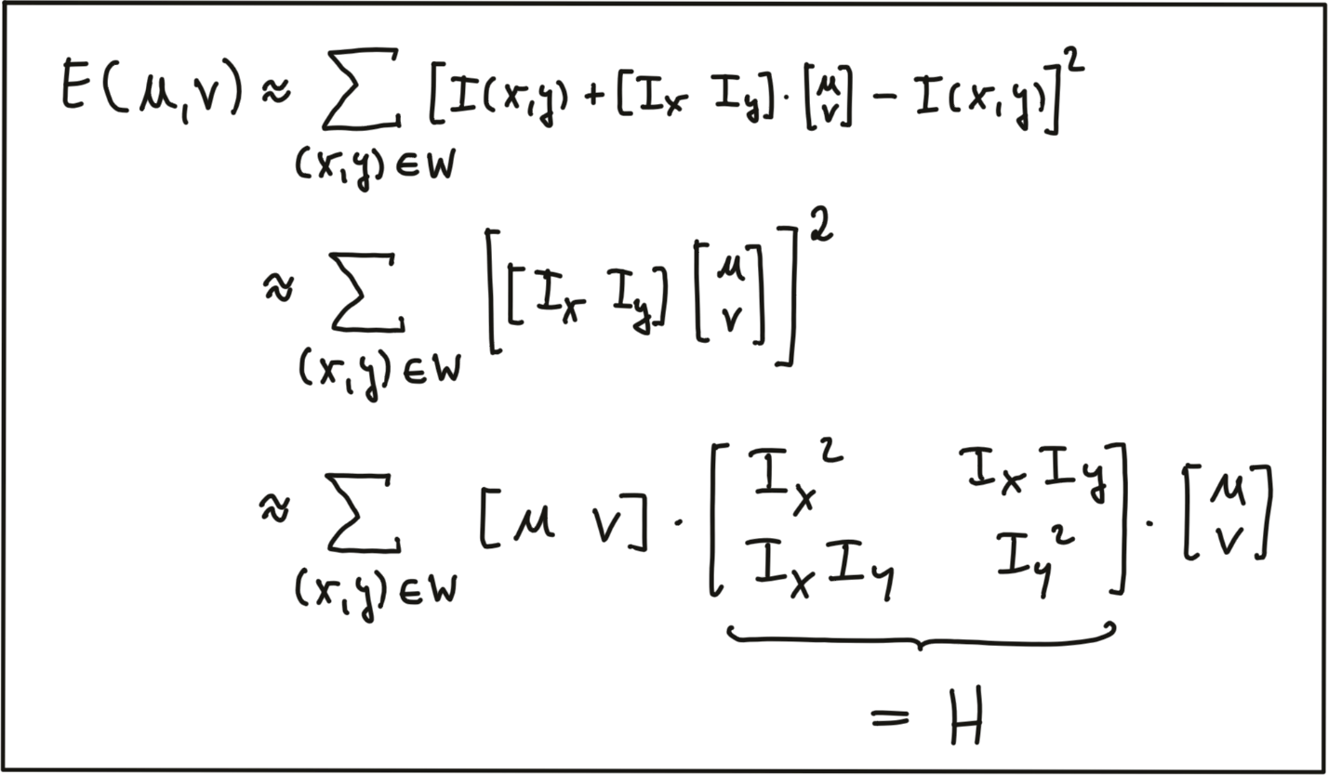](https://classroom.udacity.com/nanodegrees/nd313/parts/1971021c-523b-414c-93a3-2c6297cf4771/modules/0a71c48d-96ab-4d3a-be96-3ea1e64cf773/lessons/53855af9-95ad-41f6-bb0f-7e5464baa34b/concepts/d9b6ff38-e9d3-4723-b598-be901d061f81)](https://classroom.udacity.com/nanodegrees/nd313/parts/1971021c-523b-414c-93a3-2c6297cf4771/modules/0a71c48d-96ab-4d3a-be96-3ea1e64cf773/lessons/53855af9-95ad-41f6-bb0f-7e5464baa34b/concepts/d9b6ff38-e9d3-4723-b598-be901d061f81)**

The result of our mathematical transformations is a matrix H*H*, which can now be conveniently analyzed to locate structural change in a local window W*W* around every pixel position u,v*u*,*v* in an image. In the literature, the matrix H*H* is often referred to as covariance matrix.

To do this, it helps to visualize the matrix H*H* as an ellipse, whose axis length and directions are given by its eigenvalues and eigenvectors. As can be seen in the following figure, the larger eigenvector points into the direction of maximal intensity change, whereas the smaller eigenvector points into the direction of minimal change. So in order to identify corners, we need to find positions in the image which have two significantly large eigenvalues of H*H*.

**[[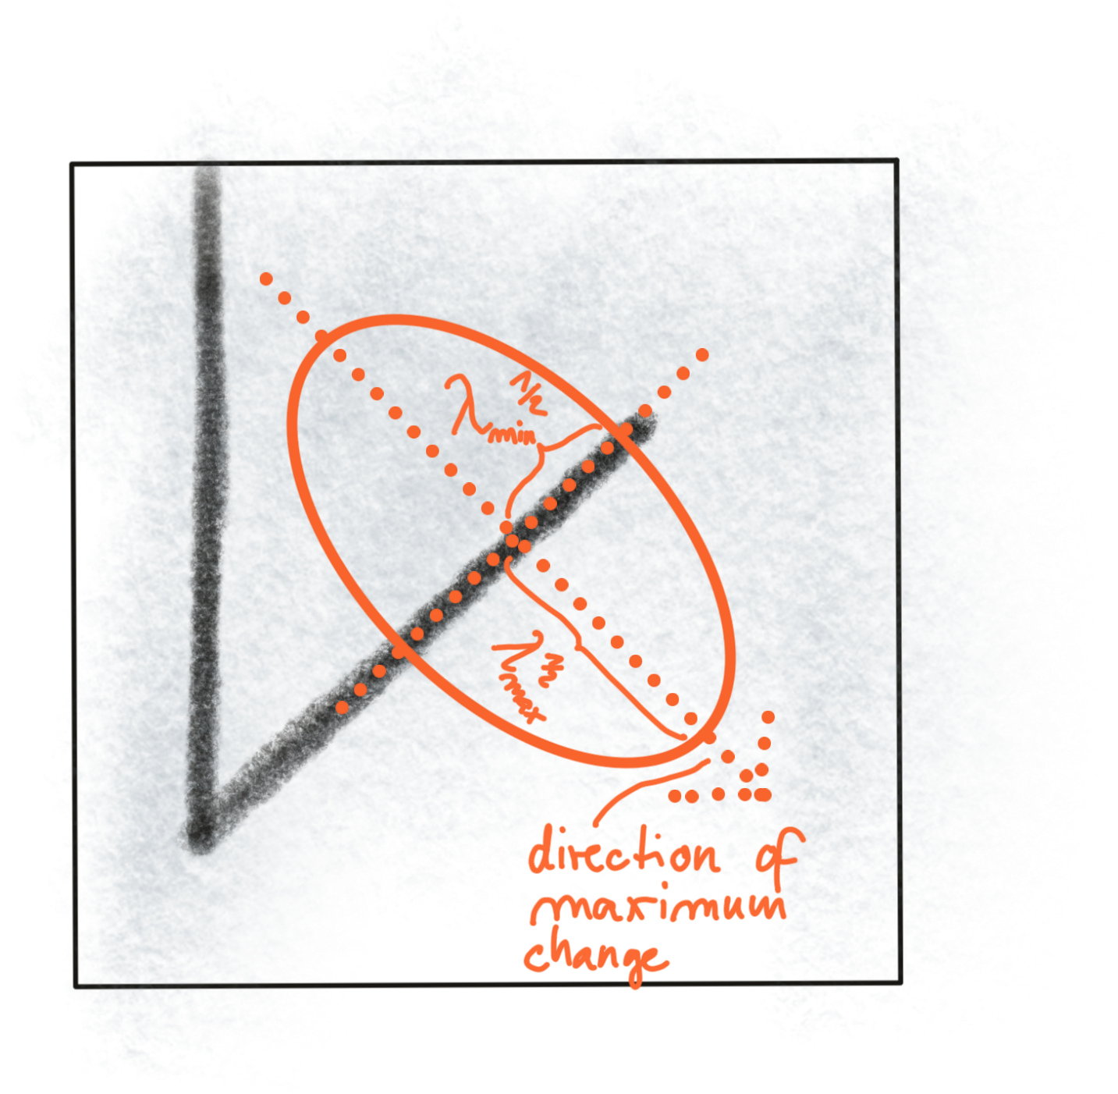](https://classroom.udacity.com/nanodegrees/nd313/parts/1971021c-523b-414c-93a3-2c6297cf4771/modules/0a71c48d-96ab-4d3a-be96-3ea1e64cf773/lessons/53855af9-95ad-41f6-bb0f-7e5464baa34b/concepts/d9b6ff38-e9d3-4723-b598-be901d061f81)](https://classroom.udacity.com/nanodegrees/nd313/parts/1971021c-523b-414c-93a3-2c6297cf4771/modules/0a71c48d-96ab-4d3a-be96-3ea1e64cf773/lessons/53855af9-95ad-41f6-bb0f-7e5464baa34b/concepts/d9b6ff38-e9d3-4723-b598-be901d061f81)**

Without going into details on eigenvalues in this course, we will look at a simple formula of how they can be computed from H*H*:

**[[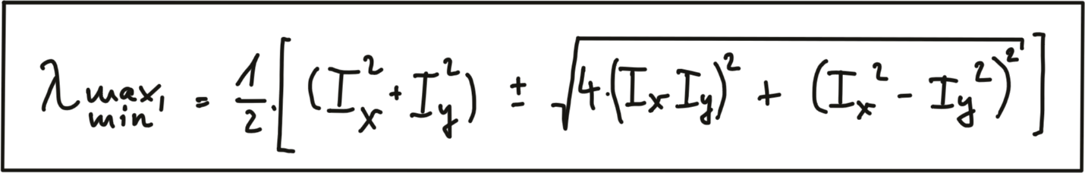](https://classroom.udacity.com/nanodegrees/nd313/parts/1971021c-523b-414c-93a3-2c6297cf4771/modules/0a71c48d-96ab-4d3a-be96-3ea1e64cf773/lessons/53855af9-95ad-41f6-bb0f-7e5464baa34b/concepts/d9b6ff38-e9d3-4723-b598-be901d061f81)](https://classroom.udacity.com/nanodegrees/nd313/parts/1971021c-523b-414c-93a3-2c6297cf4771/modules/0a71c48d-96ab-4d3a-be96-3ea1e64cf773/lessons/53855af9-95ad-41f6-bb0f-7e5464baa34b/concepts/d9b6ff38-e9d3-4723-b598-be901d061f81)**

In addition to the smoothing of the image before gradient computation, the Harris detector uses a Gaussian window w(x,y)*w*(*x*,*y*) to compute a weighted sum of the intensity gradients around a local neighborhood. The size of this neighborhood is called scale in the context of feature detection and it is controlled by the standard deviation of the Gaussian distribution.

**[[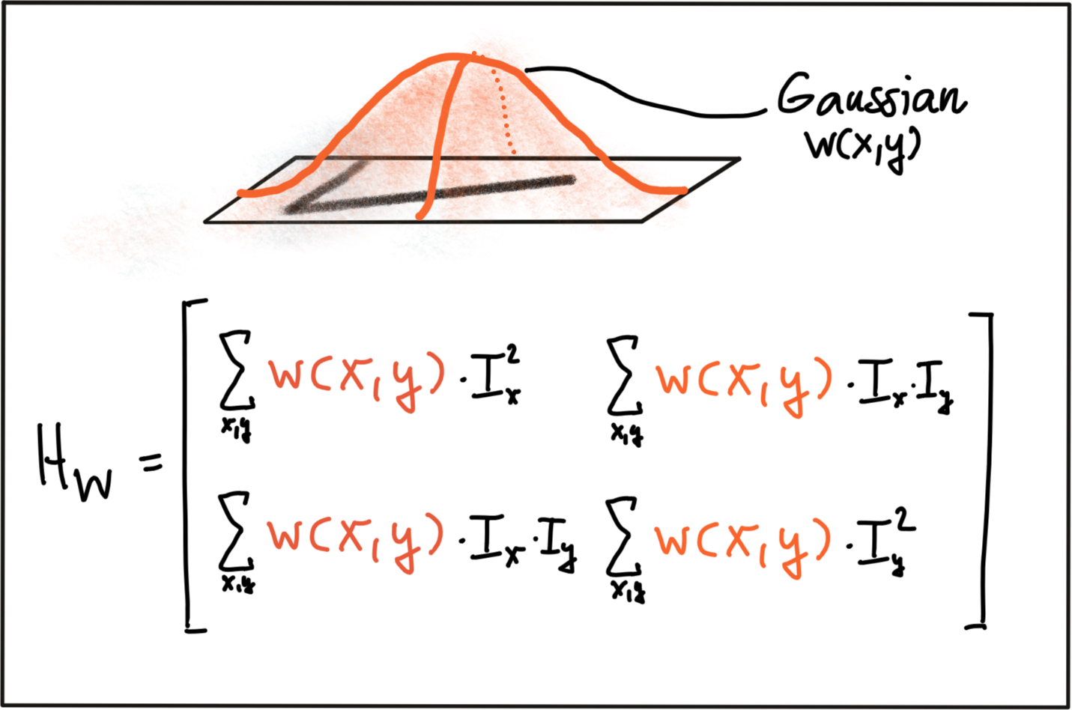](https://classroom.udacity.com/nanodegrees/nd313/parts/1971021c-523b-414c-93a3-2c6297cf4771/modules/0a71c48d-96ab-4d3a-be96-3ea1e64cf773/lessons/53855af9-95ad-41f6-bb0f-7e5464baa34b/concepts/d9b6ff38-e9d3-4723-b598-be901d061f81)](https://classroom.udacity.com/nanodegrees/nd313/parts/1971021c-523b-414c-93a3-2c6297cf4771/modules/0a71c48d-96ab-4d3a-be96-3ea1e64cf773/lessons/53855af9-95ad-41f6-bb0f-7e5464baa34b/concepts/d9b6ff38-e9d3-4723-b598-be901d061f81)**

As can be seen, the larger the scale of the Gaussian window, the larger the feature below that contributes to the sum of gradients. By adjusting scale, we can thus control the keypoints we are able to detect.

## The Harris Corner Detector

Based on the eigenvalues of H*H*, one of the most famous corner detectors is the Harris detector. This method evaluates the following expression to derive a corner response measure at every pixel location with the factor k being an empirical constant which is usually in the range between k = 0.04 - 0.06.

**[[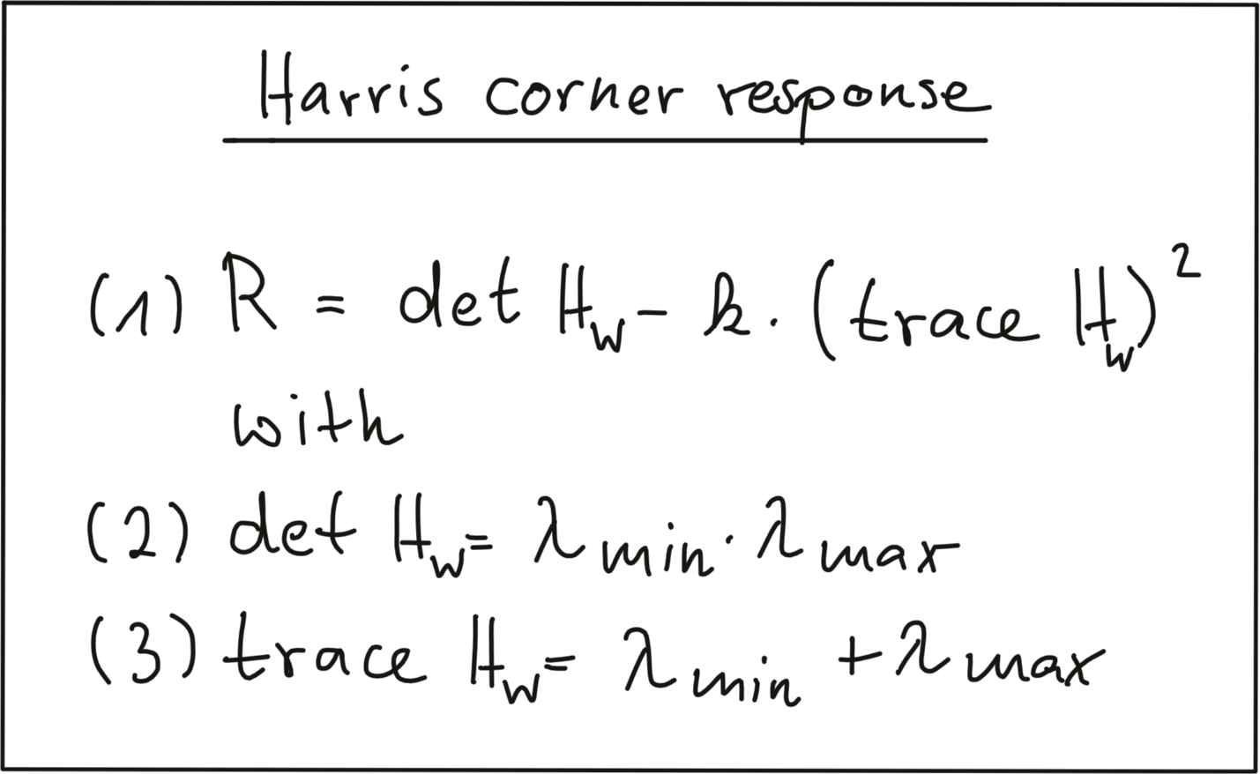](https://classroom.udacity.com/nanodegrees/nd313/parts/1971021c-523b-414c-93a3-2c6297cf4771/modules/0a71c48d-96ab-4d3a-be96-3ea1e64cf773/lessons/53855af9-95ad-41f6-bb0f-7e5464baa34b/concepts/d9b6ff38-e9d3-4723-b598-be901d061f81)](https://classroom.udacity.com/nanodegrees/nd313/parts/1971021c-523b-414c-93a3-2c6297cf4771/modules/0a71c48d-96ab-4d3a-be96-3ea1e64cf773/lessons/53855af9-95ad-41f6-bb0f-7e5464baa34b/concepts/d9b6ff38-e9d3-4723-b598-be901d061f81)**

Based on the concepts presented in this section, the following code computes the corner response for a given image and displays the result.

*// load image from file*

cv::Mat img;

img = cv::imread("./img1.png");

*// convert image to grayscale*

cv::Mat imgGray;

cv::cvtColor(img, imgGray, cv::COLOR\_BGR2GRAY);

*// Detector parameters*

**int** blockSize = 2; *// for every pixel, a blockSize × blockSize neighborhood is considered*

**int** apertureSize = 3; *// aperture parameter for Sobel operator (must be odd)*

**int** minResponse = 100; *// minimum value for a corner in the 8bit scaled response matrix*

**double** k = 0.04; *// Harris parameter (see equation for details)*

*// Detect Harris corners and normalize output*

cv::Mat dst, dst\_norm, dst\_norm\_scaled;

dst = cv::Mat::zeros(imgGray.size(), CV\_32FC1 );

cv::cornerHarris( imgGray, dst, blockSize, apertureSize, k, cv::BORDER\_DEFAULT );

cv::normalize( dst, dst\_norm, 0, 255, cv::NORM\_MINMAX, CV\_32FC1, cv::Mat() );

cv::convertScaleAbs( dst\_norm, dst\_norm\_scaled );

*// visualize results*

string windowName = "Harris Corner Detector Response Matrix";

cv::namedWindow( windowName, 4 );

cv::imshow( windowName, dst\_norm\_scaled );

cv::waitKey(0);

The result can be seen below : The brighter a pixel, the higher the Harris corner response.

**[[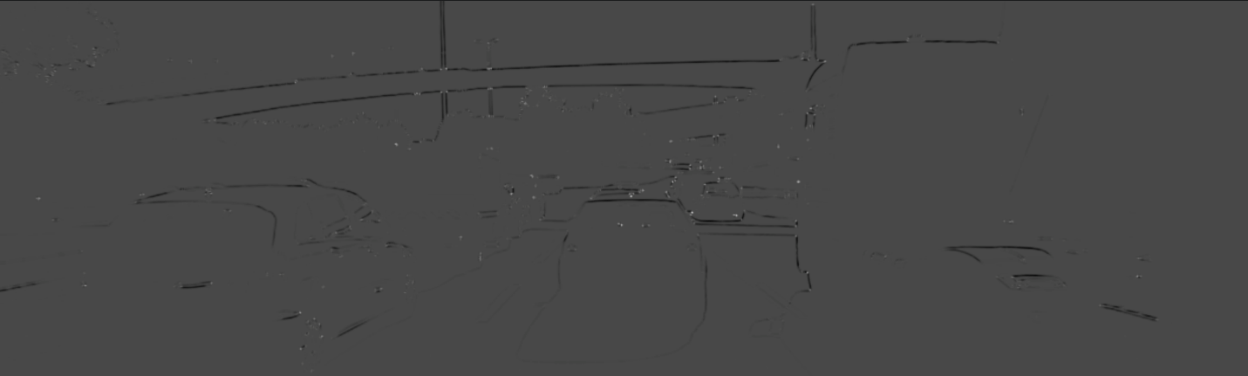](https://classroom.udacity.com/nanodegrees/nd313/parts/1971021c-523b-414c-93a3-2c6297cf4771/modules/0a71c48d-96ab-4d3a-be96-3ea1e64cf773/lessons/53855af9-95ad-41f6-bb0f-7e5464baa34b/concepts/d9b6ff38-e9d3-4723-b598-be901d061f81)](https://classroom.udacity.com/nanodegrees/nd313/parts/1971021c-523b-414c-93a3-2c6297cf4771/modules/0a71c48d-96ab-4d3a-be96-3ea1e64cf773/lessons/53855af9-95ad-41f6-bb0f-7e5464baa34b/concepts/d9b6ff38-e9d3-4723-b598-be901d061f81)**

## Exercise

In order to locate corners, we now have to perform a non-maxima suppression to (a) ensure that we get the pixel with maximum cornerness in a local neighborhood and (b) to prevent corners from being too close to each other as we prefer an even spread of corners throughout the image.

Your task is to locate local maxima in the Harris response matrix and perform a non-maximum suppression (NMS) in a local neighborhood around each maximum. The resulting coordinates shall be stored in a list of keypoints of the type vector<cv::KeyPoint>. The result should look like this, with each circle denoting the position of a Harris corner.

**[[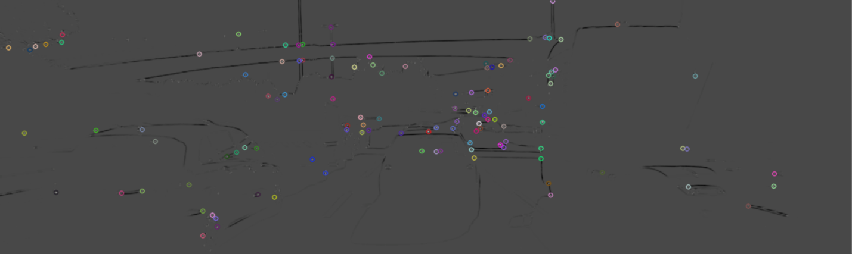](https://classroom.udacity.com/nanodegrees/nd313/parts/1971021c-523b-414c-93a3-2c6297cf4771/modules/0a71c48d-96ab-4d3a-be96-3ea1e64cf773/lessons/53855af9-95ad-41f6-bb0f-7e5464baa34b/concepts/d9b6ff38-e9d3-4723-b598-be901d061f81)](https://classroom.udacity.com/nanodegrees/nd313/parts/1971021c-523b-414c-93a3-2c6297cf4771/modules/0a71c48d-96ab-4d3a-be96-3ea1e64cf773/lessons/53855af9-95ad-41f6-bb0f-7e5464baa34b/concepts/d9b6ff38-e9d3-4723-b598-be901d061f81)**

You can write your code in the cornerness\_harris.cpp file in the desktop workspace below. After building, you can run the code using the generated cornerness\_harris executable.

# Overview of Popular Keypoint Detectors

## Invariance to Photometric and Geometric Changes

In the literature (and in the OpenCV library), there is a large number of feature detectors (including the Harris detector), we can choose from. Depending on the type of keypoint that shall be detected and based on the properties of the images, the robustness of the respective detector with regard to both photometric and geometric transformations needs to be considered.

There are four basic transformation types we need to think about when selecting a suitable keypoint detector:

1. Rotation
2. Scale change
3. Intensity change
4. Affine transformation

The following figure shows two images in frame i of a video sequence (a) who have been subjected to several transformations in frame i + n (b).

**[[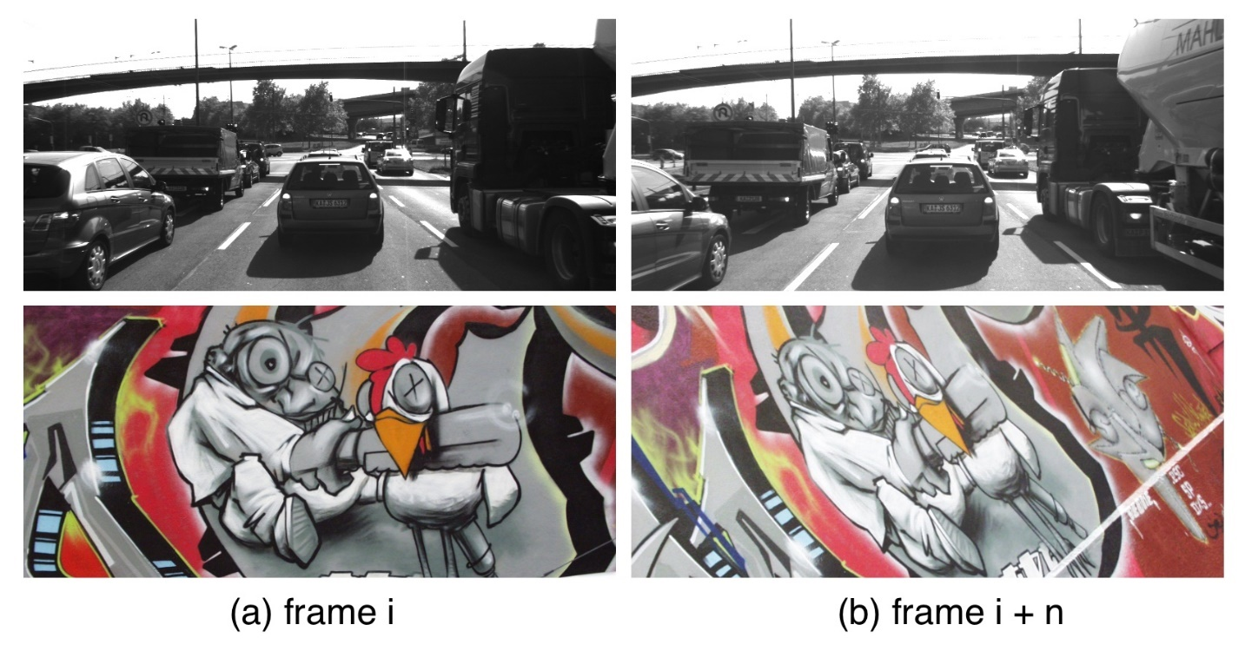](https://classroom.udacity.com/nanodegrees/nd313/parts/1971021c-523b-414c-93a3-2c6297cf4771/modules/0a71c48d-96ab-4d3a-be96-3ea1e64cf773/lessons/53855af9-95ad-41f6-bb0f-7e5464baa34b/concepts/e76a7615-5e3a-441d-a015-b7190ce1b621)](https://classroom.udacity.com/nanodegrees/nd313/parts/1971021c-523b-414c-93a3-2c6297cf4771/modules/0a71c48d-96ab-4d3a-be96-3ea1e64cf773/lessons/53855af9-95ad-41f6-bb0f-7e5464baa34b/concepts/e76a7615-5e3a-441d-a015-b7190ce1b621)**

For the graffiti sequence, which is one of the standard image sets used in computer vision (also see [**http://www.robots.ox.ac.uk/~vgg/research/affine/)**](http://www.robots.ox.ac.uk/~vgg/research/affine/)), we can observe all of the transformations listed above whereas for the highway sequence, when focussing on the preceding vehicle, there is only a scale change as well as an intensity change between frames i and i+n.

In the following, the above criteria are used to briefly assess the Harris corner detector.

Rotation R :

**[[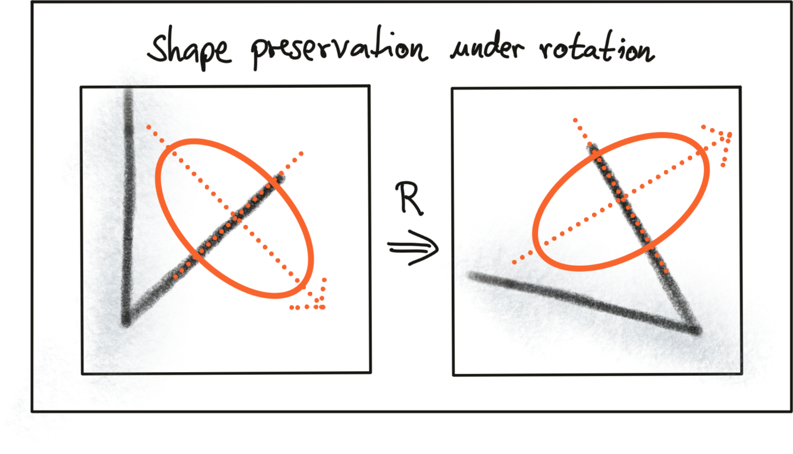](https://classroom.udacity.com/nanodegrees/nd313/parts/1971021c-523b-414c-93a3-2c6297cf4771/modules/0a71c48d-96ab-4d3a-be96-3ea1e64cf773/lessons/53855af9-95ad-41f6-bb0f-7e5464baa34b/concepts/e76a7615-5e3a-441d-a015-b7190ce1b621)](https://classroom.udacity.com/nanodegrees/nd313/parts/1971021c-523b-414c-93a3-2c6297cf4771/modules/0a71c48d-96ab-4d3a-be96-3ea1e64cf773/lessons/53855af9-95ad-41f6-bb0f-7e5464baa34b/concepts/e76a7615-5e3a-441d-a015-b7190ce1b621)**

Intensity change:

**[[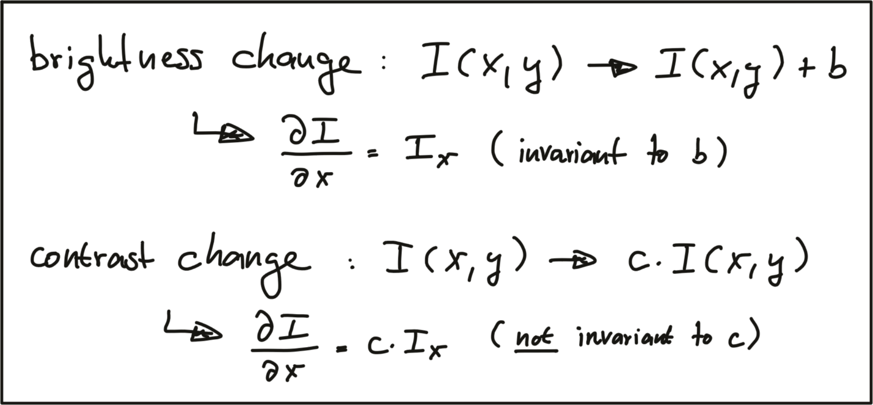](https://classroom.udacity.com/nanodegrees/nd313/parts/1971021c-523b-414c-93a3-2c6297cf4771/modules/0a71c48d-96ab-4d3a-be96-3ea1e64cf773/lessons/53855af9-95ad-41f6-bb0f-7e5464baa34b/concepts/e76a7615-5e3a-441d-a015-b7190ce1b621)](https://classroom.udacity.com/nanodegrees/nd313/parts/1971021c-523b-414c-93a3-2c6297cf4771/modules/0a71c48d-96ab-4d3a-be96-3ea1e64cf773/lessons/53855af9-95ad-41f6-bb0f-7e5464baa34b/concepts/e76a7615-5e3a-441d-a015-b7190ce1b621)**

Scale change:

**[[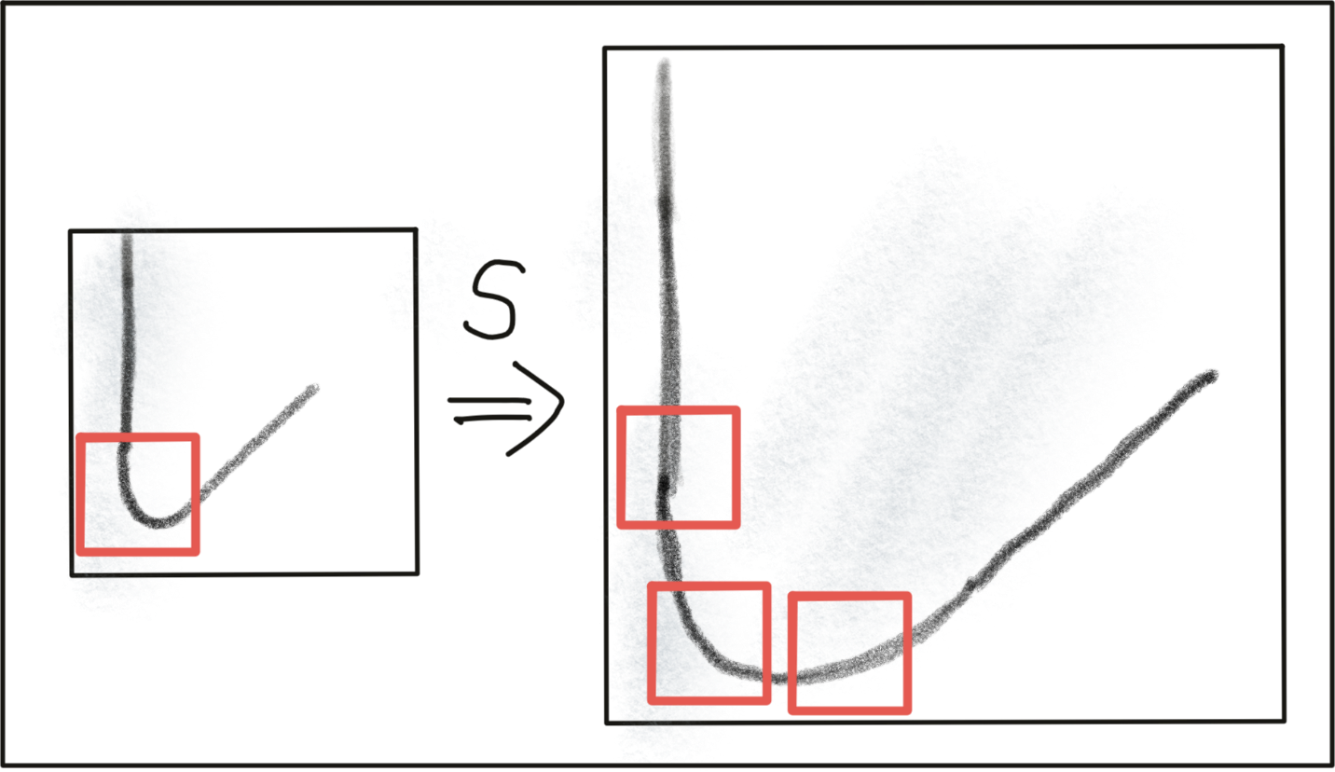](https://classroom.udacity.com/nanodegrees/nd313/parts/1971021c-523b-414c-93a3-2c6297cf4771/modules/0a71c48d-96ab-4d3a-be96-3ea1e64cf773/lessons/53855af9-95ad-41f6-bb0f-7e5464baa34b/concepts/e76a7615-5e3a-441d-a015-b7190ce1b621)](https://classroom.udacity.com/nanodegrees/nd313/parts/1971021c-523b-414c-93a3-2c6297cf4771/modules/0a71c48d-96ab-4d3a-be96-3ea1e64cf773/lessons/53855af9-95ad-41f6-bb0f-7e5464baa34b/concepts/e76a7615-5e3a-441d-a015-b7190ce1b621)**

Summarizing, the Harris detector is robust under rotation and additive intensity shifts, but sensitive to scale change, multiplicative intensity shifts (i.e. changes in contrast) and affine transformations. However, if it were possible to modify the Harris detector in a way such that it were able to account for changes of the object scale, e.g. when the preceding vehicle approaches, it might be (despite its age), a suitable detector for our purposes.

## Automatic Scale Selection

In order to detect keypoints at their ideal scale, we must know (or find) their respective dimensions in the image and adapt the size of the Gaussian window w(x,y)*w*(*x*,*y*) as introduced earlier in this section. If the keypoint scale is unknown or if keypoints with varying size exist in the image, detection must be performed successively at multiple scale levels.

**[[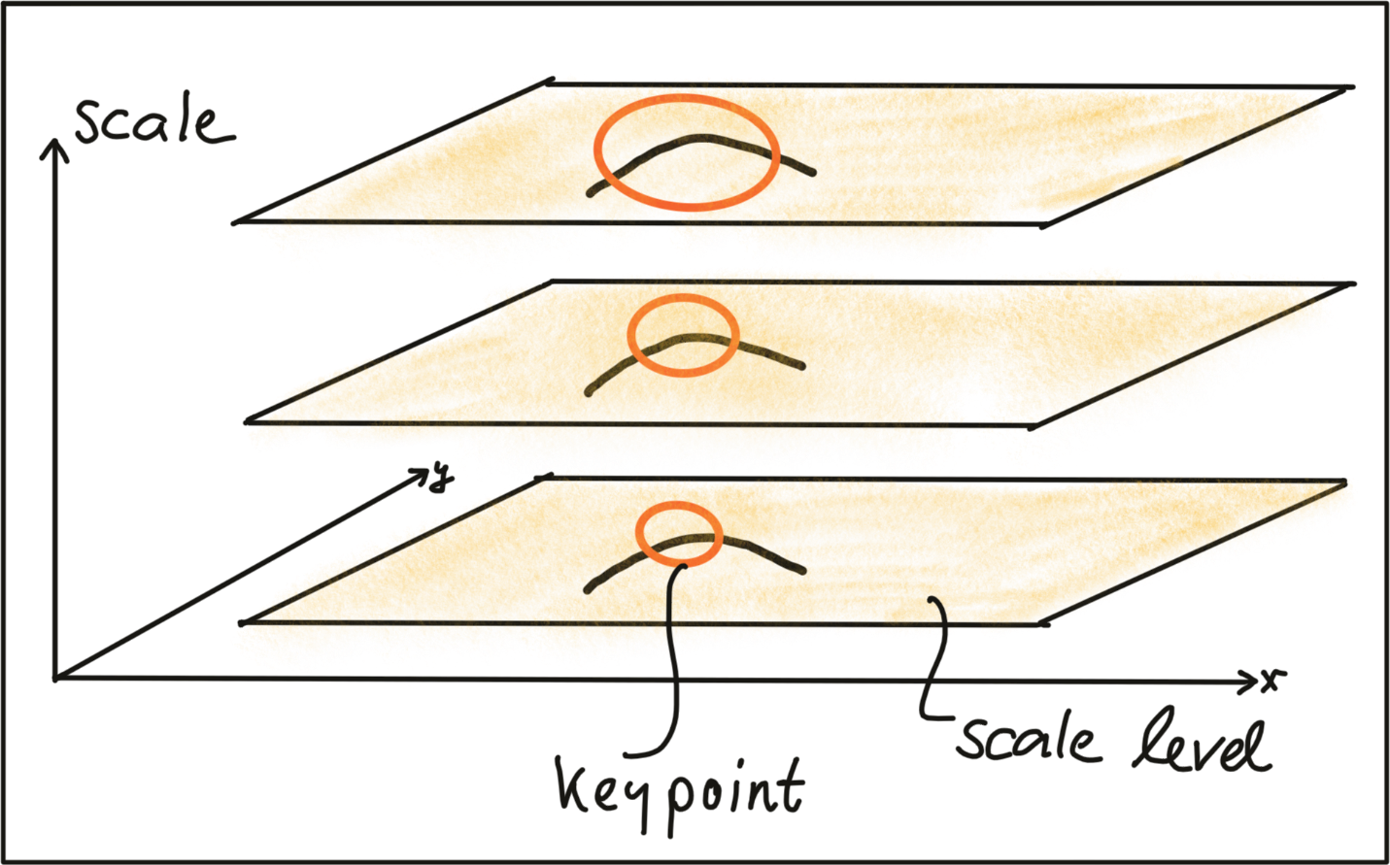](https://classroom.udacity.com/nanodegrees/nd313/parts/1971021c-523b-414c-93a3-2c6297cf4771/modules/0a71c48d-96ab-4d3a-be96-3ea1e64cf773/lessons/53855af9-95ad-41f6-bb0f-7e5464baa34b/concepts/e76a7615-5e3a-441d-a015-b7190ce1b621)](https://classroom.udacity.com/nanodegrees/nd313/parts/1971021c-523b-414c-93a3-2c6297cf4771/modules/0a71c48d-96ab-4d3a-be96-3ea1e64cf773/lessons/53855af9-95ad-41f6-bb0f-7e5464baa34b/concepts/e76a7615-5e3a-441d-a015-b7190ce1b621)**

Based on the increment of the standard deviation between two neighboring levels, the same keypoint might be detected multiple times. This poses the problem of choosing the „correct“ scale which best represents the keypoint.

In a landmark paper from 1998, Tony Lindeberg published a method for "Feature detection with automatic scale selection". In this paper, he proposed a function F(x,y,scale)*F*(*x*,*y*,*scale*), which could be used to select those keypoints that showed a stable maximum of F*F* over scale. The scale for which F*F* was maximized was termed the "characteristic scale“ of the respective keypoint.

The following image shows such a function F*F* which has been evaluated for several scale levels and exhibits a clear maximum that can be seen as the characteristic scale of the image content within the circular region.

**[[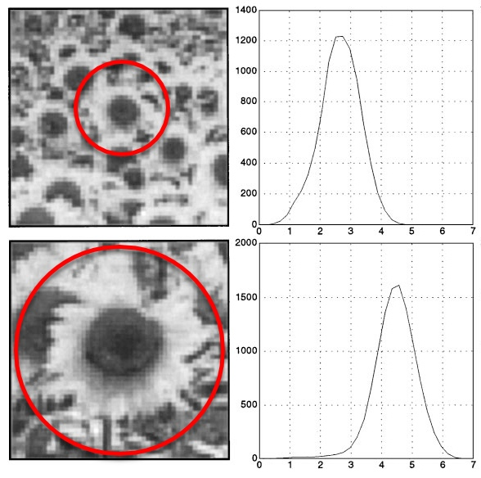](https://classroom.udacity.com/nanodegrees/nd313/parts/1971021c-523b-414c-93a3-2c6297cf4771/modules/0a71c48d-96ab-4d3a-be96-3ea1e64cf773/lessons/53855af9-95ad-41f6-bb0f-7e5464baa34b/concepts/e76a7615-5e3a-441d-a015-b7190ce1b621)](https://classroom.udacity.com/nanodegrees/nd313/parts/1971021c-523b-414c-93a3-2c6297cf4771/modules/0a71c48d-96ab-4d3a-be96-3ea1e64cf773/lessons/53855af9-95ad-41f6-bb0f-7e5464baa34b/concepts/e76a7615-5e3a-441d-a015-b7190ce1b621)**

**[Adapted from](https://classroom.udacity.com/nanodegrees/nd313/parts/1971021c-523b-414c-93a3-2c6297cf4771/modules/0a71c48d-96ab-4d3a-be96-3ea1e64cf773/lessons/53855af9-95ad-41f6-bb0f-7e5464baa34b/concepts/e76a7615-5e3a-441d-a015-b7190ce1b621)**[**Feature Detection with Automatic Scale Selection**](https://people.kth.se/~tony/papers/cvap198.pdf).

Details of how to properly design a suitable function F*F* are not in the focus of this course however. The major take-away is the knowledge that a good detector is able to automatically select the characteristic scale of a keypoint based on structural properties of its local neighborhood. Modern keypoint detectors usually possess this ability and are thus robust under changes of the image scale.

## Overview of Popular Keypoint Detectors

Keypoint detectors are a very popular research area and thus a large number of powerful algorithms have been developed over the years. Applications of keypoint detection include such things as object recognition and tracking, image matching and panoramic stitching as well as robotic mapping and 3D modeling. In addition to invariance under the transformations mentioned above, detectors can be compared for their detection performance and their processing speed.

The Harris detector along with several other "classics" belongs to a group of traditional detectors, which aim at maximizing detection accuracy. In this group, computational complexity is not a primary concern. The following list shows a number of popular classic detectors :

* 1988 Harris Corner Detector (Harris, Stephens)
* 1996 Good Features to Track (Shi, Tomasi)
* 1999 Scale Invariant Feature Transform (Lowe)
* 2006 Speeded Up Robust Features (Bay, Tuytelaars, Van Gool)

In recent years, a number of faster detectors has been developed which aims at real-time applications on smartphones and other portable devices. The following list shows the most popular detectors belonging to this group:

* 2006 Features from Accelerated Segment Test (FAST) (Rosten, Drummond)
* 2010 Binary Robust Independent Elementary Features (BRIEF) (Calonder, et al.)
* 2011 Oriented FAST and Rotated BRIEF (ORB) (Rublee et al.)
* 2011 Binary Robust Invariant Scalable Keypoints (BRISK) (Leutenegger, Chli, Siegwart)
* 2012 Fast Retina Keypoint (FREAK) (Alahi, Ortiz, Vandergheynst)
* 2012 KAZE (Alcantarilla, Bartoli, Davidson)

In this course, we will be using the Harris detector as well as the Shi-Tomasi detector (which is very similar to Harris) as representatives from the first group of "classic“ detectors. From the second group, we will be leveraging the OpenCV to implement the entire list of detectors.

<https://www.youtube.com/watch?v=ybf16ErRqVg&feature=emb_logo>

<https://www.youtube.com/watch?v=Hel5bW4bD4w&feature=emb_logo>

## Exercise

Before we go into details on the above-mentioned detectors in the next section, use the OpenCV library to add the FAST detector in addition to the already implemented Shi-Tomasi detector and compare both algorithms with regard to (a) number of keypoints, (b) distribution of keypoints over the image and (c) processing speed. Describe your observations with a special focus on the preceding vehicle.

• •

# Gradient-based vs. Binary Descriptors

## Detectors and Descriptors

Before we go into details on how some of the keypoint detectors discussed in the previous section work, let us take a look at the problem ahead of us. Our task is to find corresponding keypoints in a sequence of images that we can use to compute the TTC to a preceding object, e.g. a vehicle. We therefore need a way to robustly assign keypoints to each other based on some measure of similarity. In the literature, a large variety of similarity measures (called descriptors) have been proposed and in many cases, authors have published both a new method for keypoint detection as well as similarity measure which has been optimized for their type of keypoints.

Let us refine our terminology at this point :

* A keypoint (sometimes also interest point or salient point) detector is an algorithm that chooses points from an image based on a local maximum of a function, such as the "cornerness" metric we saw with the Harris detector.
* A descriptor is a vector of values, which describes the image patch around a keypoint. There are various techniques ranging from comparing raw pixel values to much more sophisticated approaches such as histograms of gradient orientations.

Descriptors help us to assign similar keypoints in different images to each other. As shown in the figure below, a set of keypoints in one frame is assigned keypoints in another frame such that the similarity of their respective descriptors is maximized and (ideally) the keypoints represent the same object in the image. In addition to maximizing similarity, a good descriptor should also be able to minimize the number of mismatches, i.e. avoid assigning keypoints to each other that do not correspond to the same object.

**[[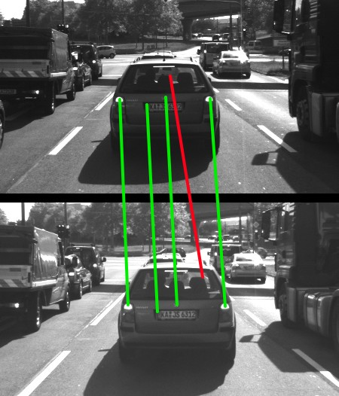](https://classroom.udacity.com/nanodegrees/nd313/parts/1971021c-523b-414c-93a3-2c6297cf4771/modules/0a71c48d-96ab-4d3a-be96-3ea1e64cf773/lessons/53855af9-95ad-41f6-bb0f-7e5464baa34b/concepts/6958e5a8-7ef9-4417-b522-3add2c626513)](https://classroom.udacity.com/nanodegrees/nd313/parts/1971021c-523b-414c-93a3-2c6297cf4771/modules/0a71c48d-96ab-4d3a-be96-3ea1e64cf773/lessons/53855af9-95ad-41f6-bb0f-7e5464baa34b/concepts/6958e5a8-7ef9-4417-b522-3add2c626513)**

Before we go into details on a powerful class of detector / descriptor combinations (i.e. binary descriptors such as BRISK), let us briefly revisit one of the most famous descriptors of all time - the Scale Invariant Feature Transform. The reason we are doing this is two-fold : First, this method is still relevant and being used in a large number of applications. And second, we need to lay some foundations so that you will be able to better understand and appreciate the contributions of binary descriptors.

# HOG Descriptors and SIFT

In the following, we will take a brief look at the family of descriptors based on Histograms of Oriented Gradients (HOG). The basic idea behind HOG is to describe the structure of an object by the distribution its intensity gradients in a local neighborhood. To achieve this, an image is divided into cells in which gradients are computed and collected in a histogram. The set of histogram from all cells is then used as a similarity measure to uniquely identify an image patch or object.

One of the best-known examples of the HOG family is the Scale-Invariant Feature Transform (SIFT), introduced in 1999 by David Lowe. The SIFT method includes both a keypoint detector as well as a descriptor and it follows a five-step process, which is briefly outlined in the following.

1. First, keypoints are detected in the image using an approach called „Laplacian-Of-Gaussian (LoG)“, which is based on second-degree intensity derivatives. The LoG is applied to various scale levels of the image and tends to detect blobs instead of corners. In addition to a unique scale level, keypoints are also assigned an orientation based on the intensity gradients in a local neighborhood around the keypoint.
2. Second, for every keypoint, its surrounding area is transformed by removing the orientation and thus ensuring a canonical orientation. Also, the size of the area is resized to 16 x 16 pixels, providing a normalized patch.

**[[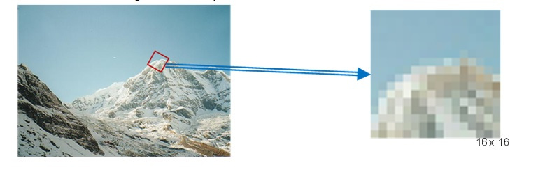](https://classroom.udacity.com/nanodegrees/nd313/parts/1971021c-523b-414c-93a3-2c6297cf4771/modules/0a71c48d-96ab-4d3a-be96-3ea1e64cf773/lessons/53855af9-95ad-41f6-bb0f-7e5464baa34b/concepts/6958e5a8-7ef9-4417-b522-3add2c626513)](https://classroom.udacity.com/nanodegrees/nd313/parts/1971021c-523b-414c-93a3-2c6297cf4771/modules/0a71c48d-96ab-4d3a-be96-3ea1e64cf773/lessons/53855af9-95ad-41f6-bb0f-7e5464baa34b/concepts/6958e5a8-7ef9-4417-b522-3add2c626513)**

**[The mountain scenery image material has been taken from the original publication by D. Lowe.](https://classroom.udacity.com/nanodegrees/nd313/parts/1971021c-523b-414c-93a3-2c6297cf4771/modules/0a71c48d-96ab-4d3a-be96-3ea1e64cf773/lessons/53855af9-95ad-41f6-bb0f-7e5464baa34b/concepts/6958e5a8-7ef9-4417-b522-3add2c626513)**

1. Third, the orientation and magnitude of each pixel within the normalized patch are computed based on the intensity gradients Ix and Iy.
2. Fourth, the normalized patch is divided into a grid of 4 x 4 cells. Within each cell, the orientations of pixels which exceed a threshold on magnitude are collected in a histogram consisting of 8 bins.

**[[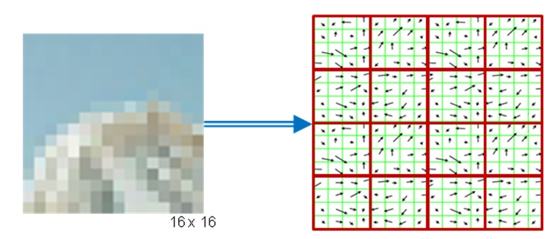](https://classroom.udacity.com/nanodegrees/nd313/parts/1971021c-523b-414c-93a3-2c6297cf4771/modules/0a71c48d-96ab-4d3a-be96-3ea1e64cf773/lessons/53855af9-95ad-41f6-bb0f-7e5464baa34b/concepts/6958e5a8-7ef9-4417-b522-3add2c626513)](https://classroom.udacity.com/nanodegrees/nd313/parts/1971021c-523b-414c-93a3-2c6297cf4771/modules/0a71c48d-96ab-4d3a-be96-3ea1e64cf773/lessons/53855af9-95ad-41f6-bb0f-7e5464baa34b/concepts/6958e5a8-7ef9-4417-b522-3add2c626513)**

**[[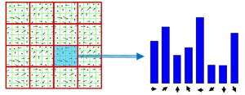](https://classroom.udacity.com/nanodegrees/nd313/parts/1971021c-523b-414c-93a3-2c6297cf4771/modules/0a71c48d-96ab-4d3a-be96-3ea1e64cf773/lessons/53855af9-95ad-41f6-bb0f-7e5464baa34b/concepts/6958e5a8-7ef9-4417-b522-3add2c626513)](https://classroom.udacity.com/nanodegrees/nd313/parts/1971021c-523b-414c-93a3-2c6297cf4771/modules/0a71c48d-96ab-4d3a-be96-3ea1e64cf773/lessons/53855af9-95ad-41f6-bb0f-7e5464baa34b/concepts/6958e5a8-7ef9-4417-b522-3add2c626513)**

1. Last, the 8-bin histograms of all 16 cells are concatenated into a 128-dimensional vector (the descriptor) which is used to uniquely represent the keypoint.

The SIFT detector / descriptor is able to robustly identify objects even among clutter and under partial occlusion. It is invariant to uniform changes in scale, to rotation, to changes in both brightness and contrast and it is even partially invariant to affine distortions.

The downside of SIFT is its low speed, which prevents it from being used in real-time applications on e.g. smartphones. Other members of the HOG family (such as SURF and GLOH), have been optimized for speed. However, they are still too computationally expensive and should not be used in real-time applications. Also, SIFT and SURF are heavily patented, so they can’t be freely used in a commercial context. In order to use SIFT in the OpenCV, you have to #include <opencv2/xfeatures2d/nonfree.hpp>, which further emphasizes this issue.

A much faster (and free) alternative to HOG-based methods is the family of binary descriptors, which provide a fast alternative at only slightly worse accuracy and performance. Let us take a look at those in the next section.

## Binary Descriptors and BRISK

The problem with HOG-based descriptors is that they are based on computing the intensity gradients, which is a very costly operation. Even though there have been some improvements such as SURF, which uses the integral image instead, these methods do not lend themselves to real-time applications on devices with limited processing capabilities (such as smartphones).

The central idea of binary descriptors is to rely solely on the intensity information (i.e. the image itself) and to encode the information around a keypoint in a string of binary numbers, which can be compared very efficiently in the matching step, when corresponding keypoints are searched. Currently, the most popular binary descriptors are BRIEF, BRISK, ORB, FREAK and KAZE (all available in the OpenCV library).

From a high-level perspective, binary descriptors consist of three major parts:

1. A **sampling pattern** which describes where sample points are located around the location of a keypoint.
2. A method for **orientation compensation**, which removes the influence of rotation of the image patch around a keypoint location.
3. A method for **sample-pair selection**, which generates pairs of sample points which are compared against each other with regard to their intensity values. If the first value is larger than the second, we write a '1' into the binary string, otherwise we write a '0'. After performing this for all point pairs in the sampling pattern, a long binary chain (or ‚string‘) is created (hence the family name of this descriptor class).

In the following, the "Binary Robust Invariant Scalable Keypoints (BRISK)" keypoint detector / descriptor is used as a representative for the binary descriptor family. Proposed in 2011 by Stefan Leutenegger et al., BRISK is a FAST-based detector in combination with a binary descriptor created from intensity comparisons retrieved by dedicated sampling of each keypoint neighborhood.

The sampling pattern of BRISK is composed out of a number of sample points (blue), where a concentric ring (red) around each sample point denotes an area where Gaussian smoothing is applied. As opposed to some other binary descriptors such as ORB or BRIEF, the BRISK sampling pattern is fixed. The smoothing is important to avoid aliasing (an effect that causes different signals to become indistinguishable - or aliases of one another - when sampled).

**[[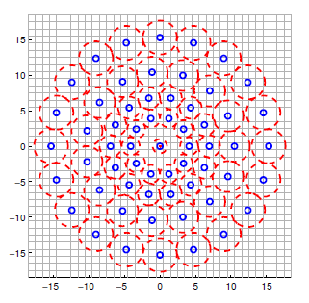](https://classroom.udacity.com/nanodegrees/nd313/parts/1971021c-523b-414c-93a3-2c6297cf4771/modules/0a71c48d-96ab-4d3a-be96-3ea1e64cf773/lessons/53855af9-95ad-41f6-bb0f-7e5464baa34b/concepts/6958e5a8-7ef9-4417-b522-3add2c626513)](https://classroom.udacity.com/nanodegrees/nd313/parts/1971021c-523b-414c-93a3-2c6297cf4771/modules/0a71c48d-96ab-4d3a-be96-3ea1e64cf773/lessons/53855af9-95ad-41f6-bb0f-7e5464baa34b/concepts/6958e5a8-7ef9-4417-b522-3add2c626513)**

During sample pair selection, the BRISK algorithm differentiates between long- and short-distance pairs. The long-distance pairs (i.e. sample points with a minimal distance between each other on the sample pattern) are used for estimating the orientation of the image patch from intensity gradients, whereas the short-distance pairs are used for the intensity comparisons from which the descriptor string is assembled. Mathematically, the pairs are expressed as follows:

**[[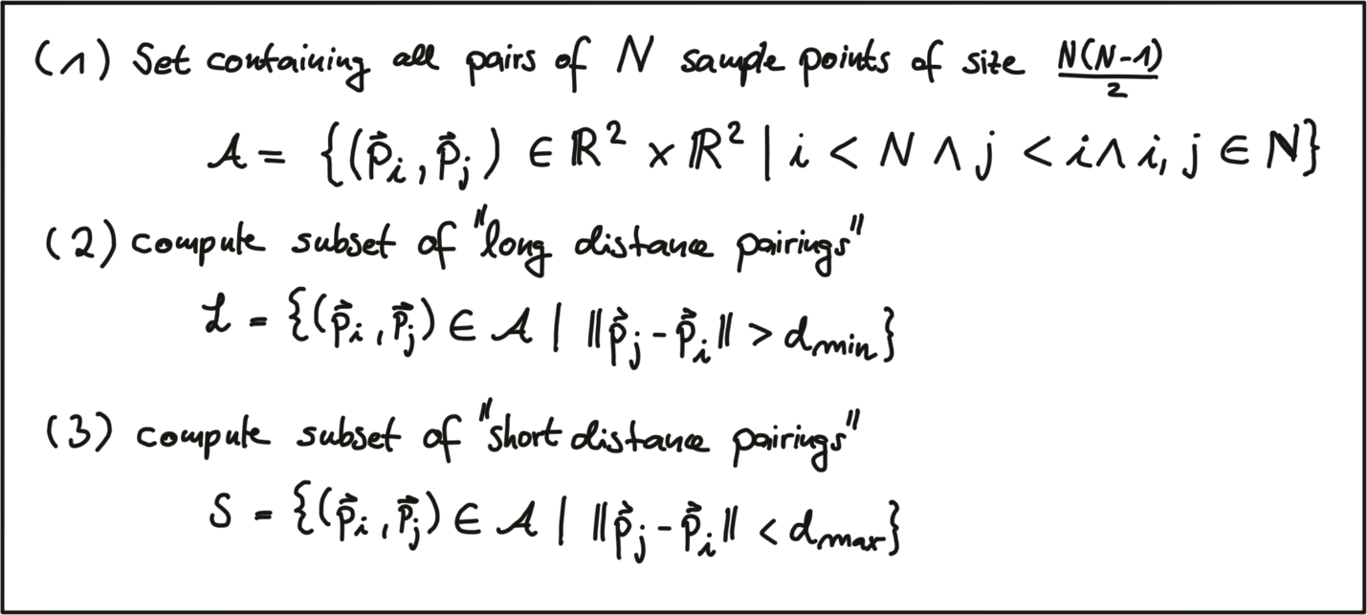](https://classroom.udacity.com/nanodegrees/nd313/parts/1971021c-523b-414c-93a3-2c6297cf4771/modules/0a71c48d-96ab-4d3a-be96-3ea1e64cf773/lessons/53855af9-95ad-41f6-bb0f-7e5464baa34b/concepts/6958e5a8-7ef9-4417-b522-3add2c626513)](https://classroom.udacity.com/nanodegrees/nd313/parts/1971021c-523b-414c-93a3-2c6297cf4771/modules/0a71c48d-96ab-4d3a-be96-3ea1e64cf773/lessons/53855af9-95ad-41f6-bb0f-7e5464baa34b/concepts/6958e5a8-7ef9-4417-b522-3add2c626513)**

First, we define the set A of all possible pairings of sample points. Then, we extract the subset L from A for which the euclidean distance is above a pre-defined upper threshold. This set are the long-distance pairs used for orientation estimation. Lastly, we extract those pairs from A whose euclidean distance is below a lower threshold. This set S contains the short-distance pairs for assembling the binary descriptor string.

The following figure shows the two types of distance pairs on the sampling pattern for short pairs (left) and long pairs (right).

**[[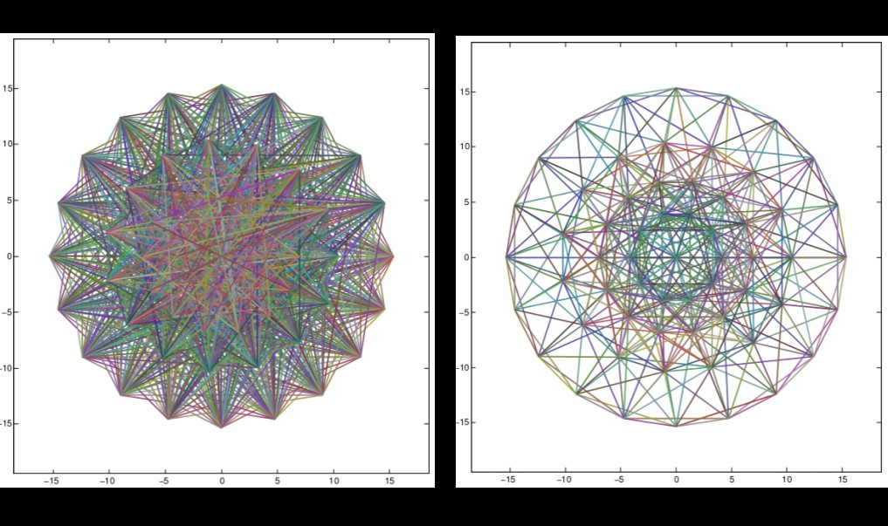](https://classroom.udacity.com/nanodegrees/nd313/parts/1971021c-523b-414c-93a3-2c6297cf4771/modules/0a71c48d-96ab-4d3a-be96-3ea1e64cf773/lessons/53855af9-95ad-41f6-bb0f-7e5464baa34b/concepts/6958e5a8-7ef9-4417-b522-3add2c626513)](https://classroom.udacity.com/nanodegrees/nd313/parts/1971021c-523b-414c-93a3-2c6297cf4771/modules/0a71c48d-96ab-4d3a-be96-3ea1e64cf773/lessons/53855af9-95ad-41f6-bb0f-7e5464baa34b/concepts/6958e5a8-7ef9-4417-b522-3add2c626513)**

**[[based on this](https://classroom.udacity.com/nanodegrees/nd313/parts/1971021c-523b-414c-93a3-2c6297cf4771/modules/0a71c48d-96ab-4d3a-be96-3ea1e64cf773/lessons/53855af9-95ad-41f6-bb0f-7e5464baa34b/concepts/6958e5a8-7ef9-4417-b522-3add2c626513)**[**source**](https://classroom.udacity.com/nanodegrees/nd313/parts/1971021c-523b-414c-93a3-2c6297cf4771/modules/0a71c48d-96ab-4d3a-be96-3ea1e64cf773/lessons/53855af9-95ad-41f6-bb0f-7e5464baa34b/concepts/based%20on%20https:/www.cse.unr.edu/~bebis/CS491Y/Lectures/BRISK.pptx) ]

From the long pairs, the keypoint direction vector \vec{g}*g*⃗​ is computed as follows:

**[[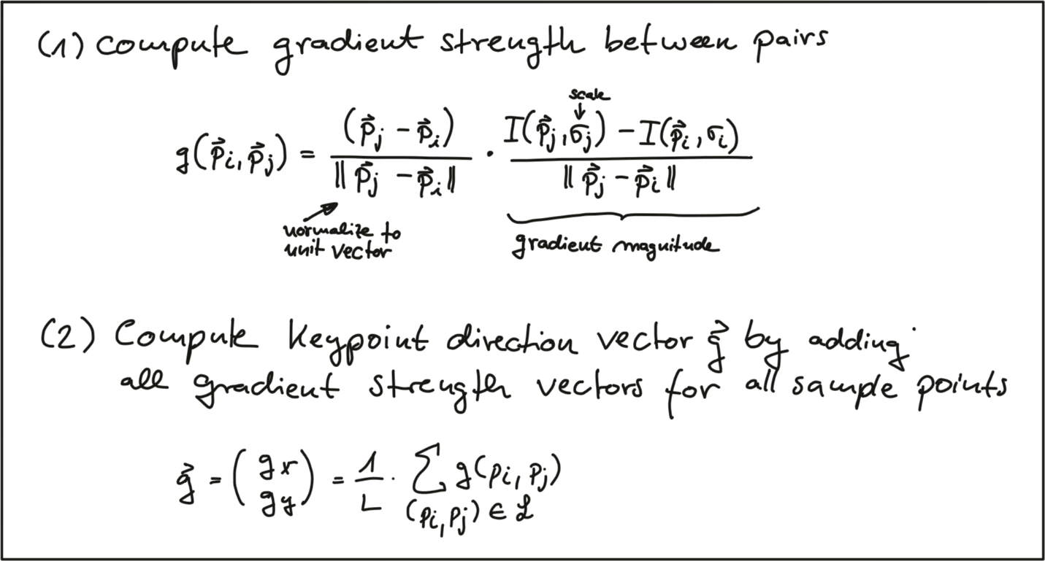](https://classroom.udacity.com/nanodegrees/nd313/parts/1971021c-523b-414c-93a3-2c6297cf4771/modules/0a71c48d-96ab-4d3a-be96-3ea1e64cf773/lessons/53855af9-95ad-41f6-bb0f-7e5464baa34b/concepts/6958e5a8-7ef9-4417-b522-3add2c626513)](https://classroom.udacity.com/nanodegrees/nd313/parts/1971021c-523b-414c-93a3-2c6297cf4771/modules/0a71c48d-96ab-4d3a-be96-3ea1e64cf773/lessons/53855af9-95ad-41f6-bb0f-7e5464baa34b/concepts/6958e5a8-7ef9-4417-b522-3add2c626513)**

First, the gradient strength between two sample points is computed based on the normalized unit vector that gives the direction between both points multiplied with the intensity difference of both points at their respective scales. In (2), the keypoint direction vector \vec{g}*g*⃗​ is then computed from the sum of all gradient strengths.

Based on \vec{g}*g*⃗​, we can use the direction of the sample pattern to rearrange the short-distance pairings and thus ensure rotation invariance. Based on the rotation-invariant short-distance pairings, the final binary descriptor can be constructed as follows:

**[[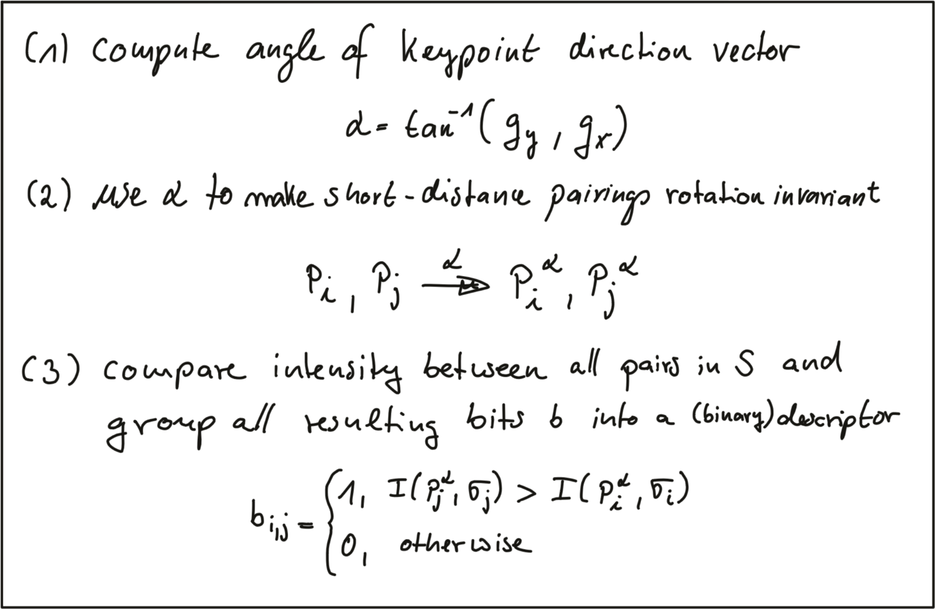](https://classroom.udacity.com/nanodegrees/nd313/parts/1971021c-523b-414c-93a3-2c6297cf4771/modules/0a71c48d-96ab-4d3a-be96-3ea1e64cf773/lessons/53855af9-95ad-41f6-bb0f-7e5464baa34b/concepts/6958e5a8-7ef9-4417-b522-3add2c626513)](https://classroom.udacity.com/nanodegrees/nd313/parts/1971021c-523b-414c-93a3-2c6297cf4771/modules/0a71c48d-96ab-4d3a-be96-3ea1e64cf773/lessons/53855af9-95ad-41f6-bb0f-7e5464baa34b/concepts/6958e5a8-7ef9-4417-b522-3add2c626513)**

After computing the orientation angle of the keypoint from g, we use it to make the short-distance pairings invariant to rotation. Then, the intensity between all pairs in S*S* is compared and used to assemble the binary descriptor we can use for matching.

## HOG vs. Binary Exercise

<https://www.youtube.com/watch?v=69oJ9Jx2DPE&feature=emb_logo>

In the code at the end of this section, keypoints and descriptors are computed using the BRISK method. The time for both keypoint detection and descriptor computation is printed to the console. For the BRISK detector, the keypoints can be seen in the following figure with the center of a circle denoting its location and the size of the circle reflecting the characteristic scale.

**[[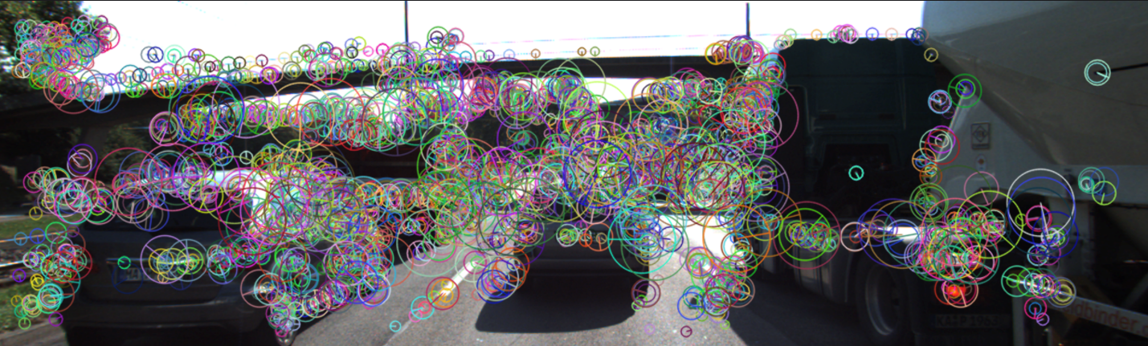](https://classroom.udacity.com/nanodegrees/nd313/parts/1971021c-523b-414c-93a3-2c6297cf4771/modules/0a71c48d-96ab-4d3a-be96-3ea1e64cf773/lessons/53855af9-95ad-41f6-bb0f-7e5464baa34b/concepts/6958e5a8-7ef9-4417-b522-3add2c626513)](https://classroom.udacity.com/nanodegrees/nd313/parts/1971021c-523b-414c-93a3-2c6297cf4771/modules/0a71c48d-96ab-4d3a-be96-3ea1e64cf773/lessons/53855af9-95ad-41f6-bb0f-7e5464baa34b/concepts/6958e5a8-7ef9-4417-b522-3add2c626513)**

Given the code in describe\_keypoints.cpp of the workspace below, add the SIFT detector / descriptor, compute the time for both steps and compare both BRISK and SIFT with regard to processing speed and the number and visual appearance of keypoints.

After building your code with cmake and make, you can run the code from the virtual desktop using the describe\_keypoints executable.

<https://www.youtube.com/watch?v=69oJ9Jx2DPE&feature=emb_logo>

# Descriptor Matching

## Distance between descriptors

In the last section, you have learned that keypoints can be described by transforming their local neighborhood into a high-dimensional vector that captures the unique characteristics of the gradient or intensity distribution. In this section, we want to look at several ways to compute the distance between two descriptors such that the differences between them are transformed into a single number which we can use as a simple measure of similarity.

The first distance function is the "Sum of Absolute Differences (SAD)". As you can see in the equation below, the SAD takes as input two descriptor vectors d\_a*da*​ and d\_b*db*​. The SAD is computed by subtracting from every component in d\_a*da*​ the corresponding component at the same position in d\_b*db*​. Then, the absolute value of the respective result is summed up. The SAD norm is also referred to as L1-norm in the literature.

The second distance function is the "Sum of Squared Differences (SSD)", which is similar to the SAD in the sense that differences between individual components of two descriptor vectors are computed. However, the key difference between SAD and SSD is that the latter sums the squared differences instead of the absolute differences. In the literature, the SSD norm is also referred to as L2-norm. Both norms are given in the following figure.

**[[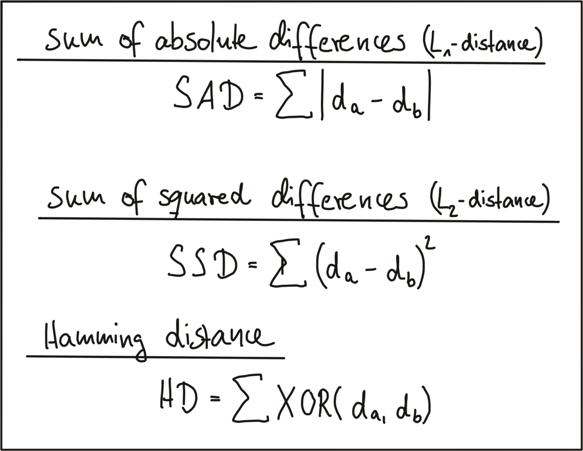](https://classroom.udacity.com/nanodegrees/nd313/parts/1971021c-523b-414c-93a3-2c6297cf4771/modules/0a71c48d-96ab-4d3a-be96-3ea1e64cf773/lessons/53855af9-95ad-41f6-bb0f-7e5464baa34b/concepts/ccc26fbd-896a-443e-a381-a1ea53695a84)](https://classroom.udacity.com/nanodegrees/nd313/parts/1971021c-523b-414c-93a3-2c6297cf4771/modules/0a71c48d-96ab-4d3a-be96-3ea1e64cf773/lessons/53855af9-95ad-41f6-bb0f-7e5464baa34b/concepts/ccc26fbd-896a-443e-a381-a1ea53695a84)**

There are several ways of explaining the differences between SAD and SSD. One helpful approach, as we want to keep this aspect short, is to look at both norms from a geometrical perspective. In the following figure, a two-dimensional feature space is considered. In it, there are two feature vectors d1 and d2, each of which consists of an (a,b) coordinate pair.

**[[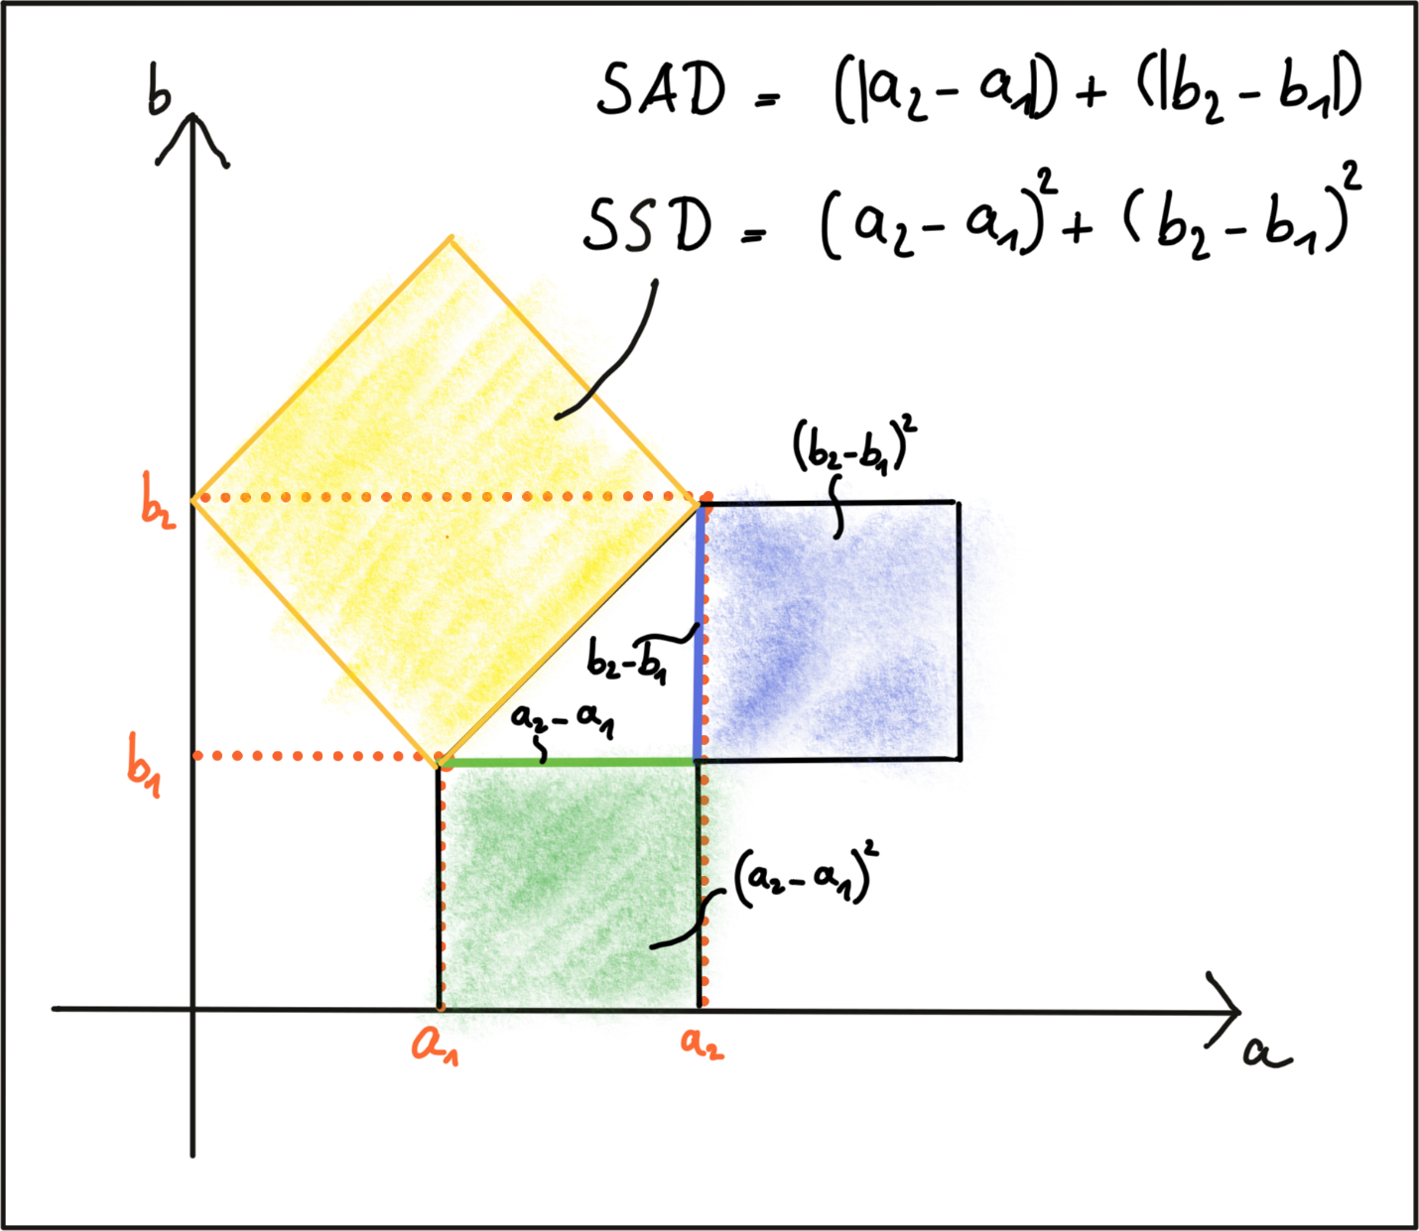](https://classroom.udacity.com/nanodegrees/nd313/parts/1971021c-523b-414c-93a3-2c6297cf4771/modules/0a71c48d-96ab-4d3a-be96-3ea1e64cf773/lessons/53855af9-95ad-41f6-bb0f-7e5464baa34b/concepts/ccc26fbd-896a-443e-a381-a1ea53695a84)](https://classroom.udacity.com/nanodegrees/nd313/parts/1971021c-523b-414c-93a3-2c6297cf4771/modules/0a71c48d-96ab-4d3a-be96-3ea1e64cf773/lessons/53855af9-95ad-41f6-bb0f-7e5464baa34b/concepts/ccc26fbd-896a-443e-a381-a1ea53695a84)**

The shortest distance between both is a straight line. Given the two components of each vector, the SAD computes the sum of the length differences, which is a one-dimensional process. The SSD on the other hand, computes the sum of squares, which obeys the law of Pythagoras. This law says that In a rectangular triangle, the sum of the cathete squares is equal to the square of the hypotenuse. So in terms of the geometric distance between both vectors, the L2-norm is a more accurate measure. Note that the same rationale applies to higher-dimensional descriptors in the same manner.

In the case of a binary descriptor who consists only of ones and zeros, the best (and fastest) measure to use is the Hamming distance, which computes the difference between both vectors by using an XOR function, which returns zero if two bits are identical and one if two bits are different. So the sum of all XOR operations is simply the number of differing bits between both descriptors.

The key takeaway here is that you have to adapt the distance measure to the type of descriptor you are using. In case of gradient-based methods such as SIFT, the L2-norm would be most appropriate. In case of all binary descriptors, the Hamming distance should be used.

## Finding matches

Let us assume we have N keypoints and their associated descriptors in one image and M keypoints in another image. The most obvious method to look for corresponding pairs would be to compare all features with each other, i.e. perform N x M comparisons. For a given keypoint from the first image, it takes every keypoint in the second image and calculates the distance. The keypoint with the smallest distance will be considered its pair. This approach is referred to as Brute Force Matching or Nearest Neighbor Matching and is available in the OpenCV under the name BFMatcher. The output of brute force matching in OpenCV is a list of keypoint pairs sorted by the distance of their descriptors under the chosen distance function. Brute force matching works well for small keypoint numbers but can be computationally expensive as the number of keypoints increases.

In 2014, David Lowe (the father of SIFT) and Marius Muja released an open-source library called "fast library for approximate nearest neighbors" (FLANN). FLANN trains an indexing structure for walking through potential matching candidates that is created using concepts from machine learning. The library builds a very efficient data structure (a KD-tree) to search for matching pairs and avoids the exhaustive search of the brute force approach. It is therefore faster while the results are still very good, depending on the matching parameters. As FLANN-based matching entails a whole new body of knowledge with several concepts that have limited relevancy for this course, there is no detailed description of the method given here. The FLANN-based matching is available in the OpenCV and you will see it again in the code example below. At the time of writing (May 2019), there is a potential bug in the current implementation of the OpenCV, which requires a conversion of the binary descriptors into floating point vectors, which is inefficient. Yet still there is an improvement in speed, albeit not as large as it potentially could be.

Both BFMatching and FLANN accept a descriptor distance threshold T which is used to limit the number of matches to the ‚good‘ ones and discard matches where the respective pairs are no correspondences. Corresponding ‚good‘ pairs are termed ‚True Positives (TP)‘ whereas mismatches are called ‚False Positives (FP)‘. The task of selecting a suitable value for T is to allow for as many TP matches as possible while FP matches should be avoided as far as possible. Depending on the image content and on the respective detector / descriptor combination, a trade-off between TP and FP has to be found that reasonably balances the ratio between TP and FP. The following figure shows two distributions of TP and of FP over the SSD to illustrate threshold selection.

**[[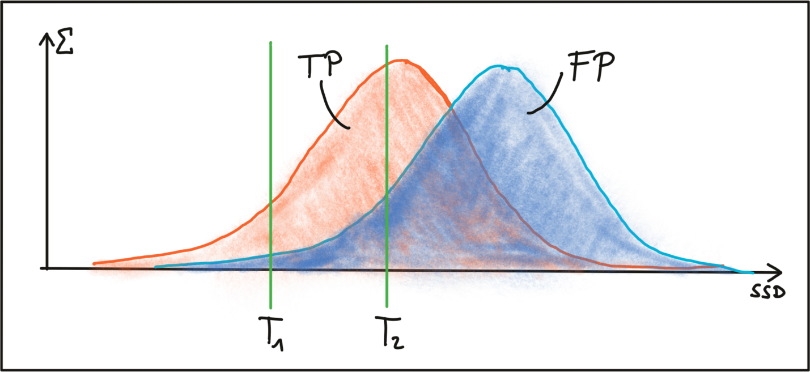](https://classroom.udacity.com/nanodegrees/nd313/parts/1971021c-523b-414c-93a3-2c6297cf4771/modules/0a71c48d-96ab-4d3a-be96-3ea1e64cf773/lessons/53855af9-95ad-41f6-bb0f-7e5464baa34b/concepts/ccc26fbd-896a-443e-a381-a1ea53695a84)](https://classroom.udacity.com/nanodegrees/nd313/parts/1971021c-523b-414c-93a3-2c6297cf4771/modules/0a71c48d-96ab-4d3a-be96-3ea1e64cf773/lessons/53855af9-95ad-41f6-bb0f-7e5464baa34b/concepts/ccc26fbd-896a-443e-a381-a1ea53695a84)**

The first threshold T1 is set to a maximally permissible SSD between two features in a way that some true positive matches are selected, while false positive matches are almost entirely avoided . However, most TP matches are also discarded with this setting. By increasing the matching threshold to T2, more TP matches are selected but the number of FP matches also increases significantly. In practice, a clear and concise separation of TP and FP is almost never found and therefore, setting a matching threshold is always a compromise between balancing 'good' vs. 'bad' matches. While FP matches can not be avoided in most cases, the goal always is to lower their number as much as possible. In the following, two strategies to achieve this are presented.

## Selecting Matches

As long as the selected threshold T is not exceeded, brute force matching will always return a match for a keypoint in the first image, even if the keypoint is not present in the second image. This inevitably leads to a number of false matches. A strategy to counteract this is called cross check matching, which works by applying the matching procedure in both directions and keeping only those matches whose best match in one direction equals the best match in the other direction. The steps of the cross check approach are:

1. For each descriptor in the source image, find one or more best matches in the reference image.
2. Switch the order of source and reference image.
3. Repeat the matching procedure between source and reference image from step 1.
4. Select those keypoint pairs whose descriptors are best matches in both directions.

Although cross check matching increases the processing time, it usually removes a significant number of false matches and should thus always be performed when accuracy is preferred over speed.

A very efficient way of lowering the number of false positives is to compute the nearest neighbor distance ratio for each keypoint. This method has been originally proposed by D. Lowe in the 1999 paper on SIFT. The main idea is to not apply the threshold on the SSD directly. Instead, for each keypoint in the source image, the two best matches are located in the reference image and the ratio between the descriptor distances is computed. Then, a threshold is applied to the ratio to sort out ambiguous matches. The figure below illustrates the principle.

**[[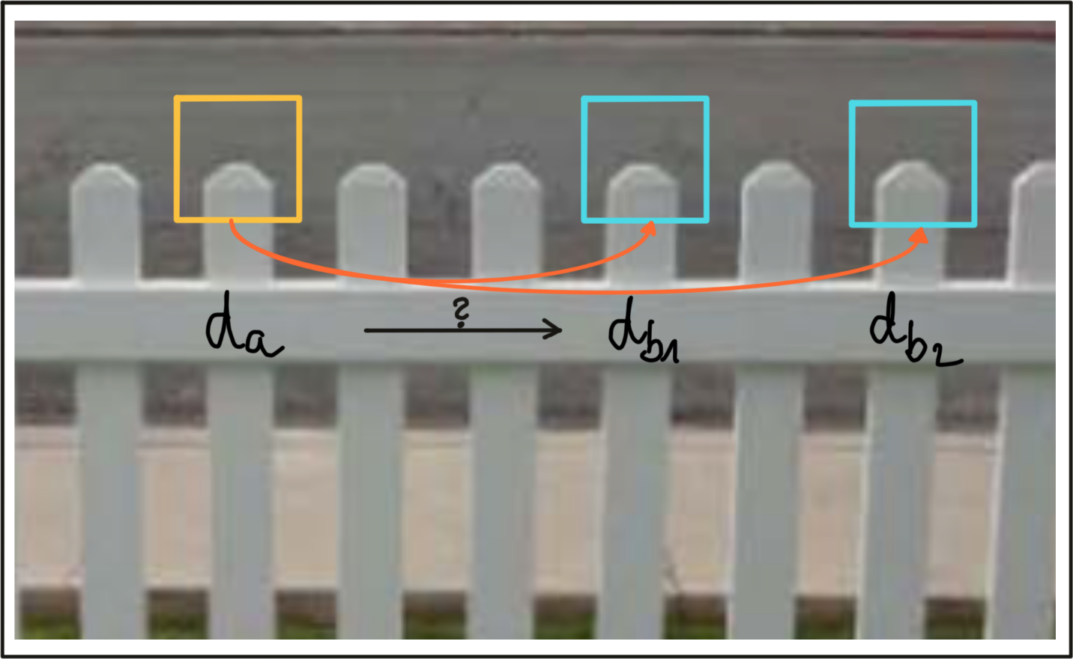](https://classroom.udacity.com/nanodegrees/nd313/parts/1971021c-523b-414c-93a3-2c6297cf4771/modules/0a71c48d-96ab-4d3a-be96-3ea1e64cf773/lessons/53855af9-95ad-41f6-bb0f-7e5464baa34b/concepts/ccc26fbd-896a-443e-a381-a1ea53695a84)](https://classroom.udacity.com/nanodegrees/nd313/parts/1971021c-523b-414c-93a3-2c6297cf4771/modules/0a71c48d-96ab-4d3a-be96-3ea1e64cf773/lessons/53855af9-95ad-41f6-bb0f-7e5464baa34b/concepts/ccc26fbd-896a-443e-a381-a1ea53695a84)**

In the example, an image patch with an associated descriptor da is compared to two other image patches with descriptors d\_{b\_1}*db*1​​ and d\_{b\_2}*db*2​​. As can be seen, the patches look very similar and would result in ambiguous and thus unreliable matches. By computing the SSD ratio between best and second-best match, such weak candidates can be filtered out.

In practice, a threshold value of 0.8 has proven to provide a good balance between TP and FP. In the image sequences examined in the original SIFT paper, 90% of the false matches were eliminated with this setting while less than 5% of correct matches were lost.

## Exercise: Distance between descriptors

<https://www.youtube.com/watch?v=nawEaRwnu2c&feature=emb_logo>

<https://www.youtube.com/watch?v=IGa4AUyl7YQ&feature=emb_logo>

In the following code example, a set of binary BRISK descriptors is pre-loaded and matched using the brute force approach described earlier in this section. Note that the number of matches has been limited to the 100 best candidates for educational purposes, as it is much easier to visually spot mismatches when drawing a reduced number of keypoint pairs as an overlay. Note that once the matches have been computed, the function can be set to either nearest-neighbor (keeping only the best match) or k-nearest-neighbor selection (keeping the best k matches per keypoint).

Before we take a look at how to estimate the performance of keypoints and descriptors further down below in this section, please complete the following tasks using the desktop workspace below:

1. Load the 'BRISK\_small' dataset with cross-check first turned off, then on. Look at the visualized keypoint matches and at the number of matched pairs and describe your results.
2. Add the k-nearest-neighbor matching (using cv::knnMatch) with k=2 and implement the above-described descriptor distance ratio to filter out ambiguous matches with the threshold set to 0.8. Visualize the results, count the percentage of discarded matches (for both the 'BRISK\_small' and the 'BRISK\_large' dataset) and describe your observations.
3. Use both BF matching and FLANN matching on the 'BRISK\_large' dataset and on the SIFT dataset and describe your observations.

The code for this exercise is in the descriptor\_matching.cpp file, and after building with cmake and make, you can run the code using the descriptor\_matching executable.

# Mid-Term Project Introduction

### Code Walkthrough

The next video is a detailed walkthrough of the source code for the project. You can find the Github Repo for the code [**here**](https://github.com/udacity/SFND_2D_Feature_Tracking) to follow along, or you can find the project code in the workspace at the end of this lesson.

Just as with the exercises in this course, you can compile and run the project from the top-level directory using cmake and make:

* mkdir build && cd build
* cmake ..
* make
* ./2D\_feature\_tracking

Also, you can find the project rubric [**here**](https://review.udacity.com/#!/rubrics/2549/view) to follow along with the project tasks that are described in the next classroom concepts.

<https://www.youtube.com/watch?v=LmTtSYRfi7g&feature=emb_logo>

# The Data Buffer

<https://www.youtube.com/watch?v=9ndzOpPHxA4&feature=emb_logo>

## Task MP.1

Your first task is to set up the loading procedure for the images, which is currently not optimal. In the student version of the code, we push all images into a vector inside a for-loop and with every new image, the data structure grows. Now imagine you want to process a large image sequence with several thousand images and Lidar point clouds over night - in the current implementation this would push the memory of your computer to its limit and eventually slow down the entire program. So in order to prevent this, we only want to hold a certain number of images in memory so that when a new one arrives, the oldest one is deleted from one end of the vector and the new one is added to the other end. The following figure illustrates the principle.

**[[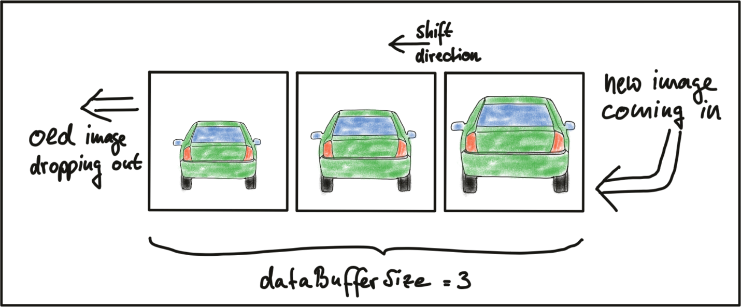](https://classroom.udacity.com/nanodegrees/nd313/parts/1971021c-523b-414c-93a3-2c6297cf4771/modules/0a71c48d-96ab-4d3a-be96-3ea1e64cf773/lessons/4b340bfe-c1be-400d-b64f-ecbaf51c6fb8/concepts/141829c4-dec6-4694-afa9-c7de75f734d3)](https://classroom.udacity.com/nanodegrees/nd313/parts/1971021c-523b-414c-93a3-2c6297cf4771/modules/0a71c48d-96ab-4d3a-be96-3ea1e64cf773/lessons/4b340bfe-c1be-400d-b64f-ecbaf51c6fb8/concepts/141829c4-dec6-4694-afa9-c7de75f734d3)**

Please replace the code in section 'TASK MP.1' with an implementation of this principle.

# Keypoint Detection

<https://www.youtube.com/watch?time_continue=145&v=CVXysH5gHUQ&feature=emb_logo>

## TASK MP.2

Your second task is to focus on keypoint detection. In the student version of the code you will find an existing implementation of the Shi-Tomasi detector. Please implement a selection of alternative detectors, which are HARRIS, FAST, BRISK, ORB, AKAZE, and SIFT. The following figure shows keypoints detected with the SIFT method.

**[[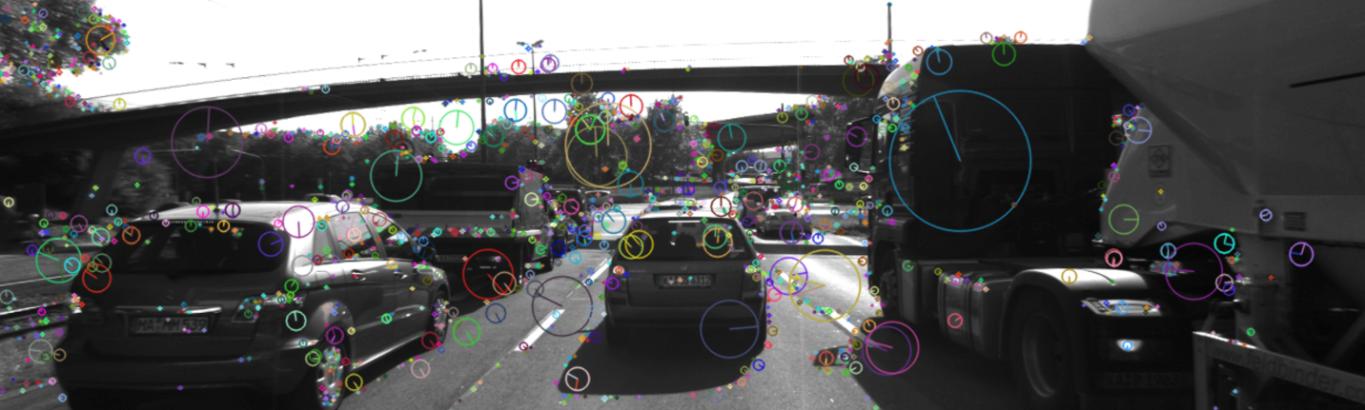](https://classroom.udacity.com/nanodegrees/nd313/parts/1971021c-523b-414c-93a3-2c6297cf4771/modules/0a71c48d-96ab-4d3a-be96-3ea1e64cf773/lessons/4b340bfe-c1be-400d-b64f-ecbaf51c6fb8/concepts/cf9dd808-3d9c-4895-9c1b-64d02a625023)](https://classroom.udacity.com/nanodegrees/nd313/parts/1971021c-523b-414c-93a3-2c6297cf4771/modules/0a71c48d-96ab-4d3a-be96-3ea1e64cf773/lessons/4b340bfe-c1be-400d-b64f-ecbaf51c6fb8/concepts/cf9dd808-3d9c-4895-9c1b-64d02a625023)**

The Harris detector is already familiar to you from a previous exercise and the other methods are available in the OpenCV. Also, please adjust the project code in a way that each detector can be selected by setting the string 'detectorType' to the respective name. Please note that all detectors should be added to the file 'matching2D\_student.cpp'. Take a look at the header file 'matching2D.hpp' for details on the call parameters for the functions you need to implement.

### TASK MP.3

In a later part of the mid-term project, you will be evaluating the various detectors and descriptors with regard to a set of performance metrics. As we are focussing on a collision detection system in this course, keypoints on the preceding vehicle are of special interest to us. Therefore, in order to enable a more targeted evaluation, we want to discard feature points that are not located on the preceding vehicle.

Your third task therefore is to remove all keypoints outside of a bounding box around the preceding vehicle. Box parameters you should use are : cx = 535, cy = 180, w = 180, h = 150.

Please note that this cropping of feature points should only be used for evaluation purposes in the mid-term project. For later sections of this course, especially in the final project, please disable keypoint cropping using this method. Also, there will be keypoints within the box that are e.g. on the road surface or on other vehicles. Please keep an eye on their number in relation to keypoints on the actual vehicle and discuss this later in the evaluation part of the mid-term project.

# Descriptor Extraction & Matching

<https://www.youtube.com/watch?v=w-0hSIMq32o&feature=emb_logo>

## Descriptor Code Walkthrough

<https://www.youtube.com/watch?v=Ap6uNX95Ewc&feature=emb_logo>

### TASK MP.4

Your fourth task is to implement a variety of keypoint descriptors to the already implemented BRISK method and make them selectable using the string 'descriptorType'. The methods you must integrate are BRIEF, ORB, FREAK, AKAZE and SIFT.

### TASK MP.5

Your fifth task will focus on the matching part. The current implementation uses Brute Force matching combined with Nearest-Neighbor selection. You must now add FLANN as an alternative to brute-force as well as the K-Nearest-Neighbor approach.

### TASK MP.6

As your sixth task, you will then implement the descriptor distance ratio test as a filtering method to remove bad keypoint matches.

# Performance Evaluation

<https://www.youtube.com/watch?time_continue=6&v=OMqg22EGssM&feature=emb_logo>In this last part of the mid-term project you will document speed and number of matched keypoints for all detector / descriptor combinations with a focus on the preceding vehicle over a sequence of ten images.

## TASK MP.7

Your seventh task is to count the number of keypoints on the preceding vehicle for all 10 images and take note of the distribution of their neighborhood size. Do this for all the detectors you have implemented.

## TASK MP.8

Your eighth task is to count the number of matched keypoints for all 10 images using all possible combinations of detectors and descriptors. In the matching step, use the BF approach with the descriptor distance ratio set to 0.8.

## TASK MP.9

Your ninth task is to log the time it takes for keypoint detection and descriptor extraction. The results must be entered into a spreadsheet and based on this information you will then suggest the TOP3 detector / descriptor combinations as the best choice for our purpose of detecting keypoints on vehicles. Finally, in a short text, please justify your recommendation based on your observations and on the data you collected.

# Lidar-to-Camera Point Projection

<https://www.youtube.com/watch?time_continue=44&v=mru6Yrt2Ufo&feature=emb_logo>

## Displaying and Cropping Lidar Points

In this section, we will load a set of Lidar points from file and display it from a top view perspective. Also, we will manually remove points that are located in the road surface. This is an important step which is needed to correctly compute the time-to-collision in the final project. The Lidar points have been obtained using a Velodyne HDL-64E sensor spinning at a frequency of 10Hz and capturing approximately 100k points per cycle. Further information on the KITTI sensor setup can be found here : [**http://www.cvlibs.net/datasets/kitti/setup.php**](http://www.cvlibs.net/datasets/kitti/setup.php)

**[[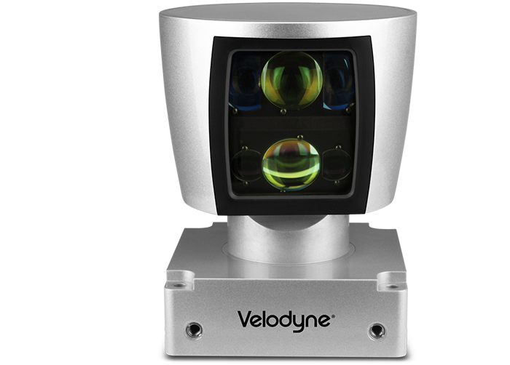](https://classroom.udacity.com/nanodegrees/nd313/parts/1971021c-523b-414c-93a3-2c6297cf4771/modules/0a71c48d-96ab-4d3a-be96-3ea1e64cf773/lessons/fb74bfb2-bfe1-4d86-a997-320ab71c0dbd/concepts/93e3b893-f874-477f-8f02-1ff465c160de)](https://classroom.udacity.com/nanodegrees/nd313/parts/1971021c-523b-414c-93a3-2c6297cf4771/modules/0a71c48d-96ab-4d3a-be96-3ea1e64cf773/lessons/fb74bfb2-bfe1-4d86-a997-320ab71c0dbd/concepts/93e3b893-f874-477f-8f02-1ff465c160de)**

As will be detailed later, the Velodyne sensor has been synchronized with a forward-looking camera, which, at the time of capturing the Lidar data used in this section, was showing the following (by now very familiar) scene.

**[[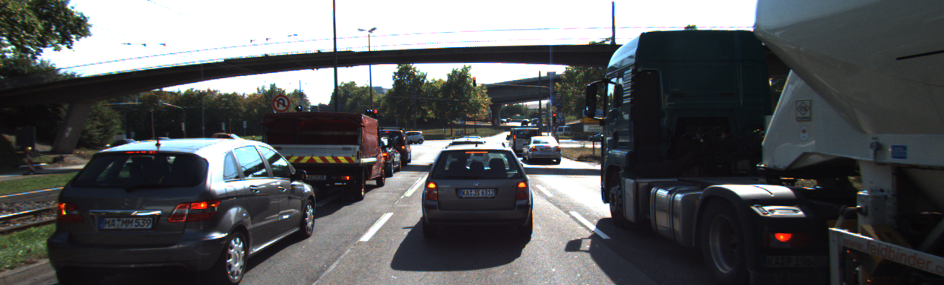](https://classroom.udacity.com/nanodegrees/nd313/parts/1971021c-523b-414c-93a3-2c6297cf4771/modules/0a71c48d-96ab-4d3a-be96-3ea1e64cf773/lessons/fb74bfb2-bfe1-4d86-a997-320ab71c0dbd/concepts/93e3b893-f874-477f-8f02-1ff465c160de)](https://classroom.udacity.com/nanodegrees/nd313/parts/1971021c-523b-414c-93a3-2c6297cf4771/modules/0a71c48d-96ab-4d3a-be96-3ea1e64cf773/lessons/fb74bfb2-bfe1-4d86-a997-320ab71c0dbd/concepts/93e3b893-f874-477f-8f02-1ff465c160de)**

The Lidar points corresponding to the scene are displayed in the following figure, together with the Velodyne coordinate system and a set of distance markers. While the top view image has been cropped at 20m, the farthest point for this scene in the original dataset is at ~78m.

**[[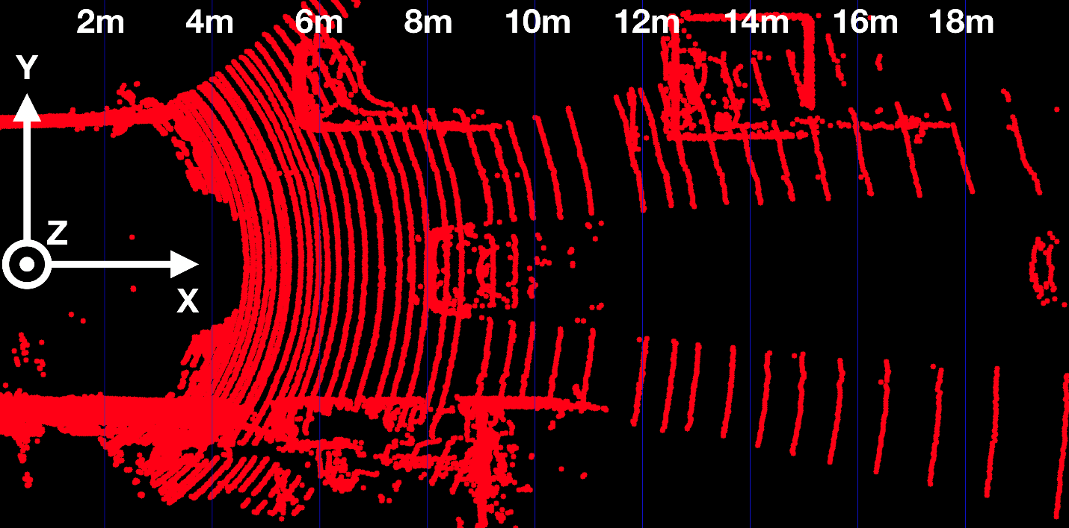](https://classroom.udacity.com/nanodegrees/nd313/parts/1971021c-523b-414c-93a3-2c6297cf4771/modules/0a71c48d-96ab-4d3a-be96-3ea1e64cf773/lessons/fb74bfb2-bfe1-4d86-a997-320ab71c0dbd/concepts/93e3b893-f874-477f-8f02-1ff465c160de)](https://classroom.udacity.com/nanodegrees/nd313/parts/1971021c-523b-414c-93a3-2c6297cf4771/modules/0a71c48d-96ab-4d3a-be96-3ea1e64cf773/lessons/fb74bfb2-bfe1-4d86-a997-320ab71c0dbd/concepts/93e3b893-f874-477f-8f02-1ff465c160de)**

## Exercise

The following code in show\_lidar\_top\_view.cpp loads and displays the Lidar points in a top view perspective. When you run the code example, you will see that all Lidar points are displayed, including the ones on the road surface. Please complete the following exercises before continuing:

1. Change the color of the Lidar points such that X=0.0m corresponds to red while X=20.0m is shown as green with a gradual transition in between. The output of the Lidar point cloud should look like this:

**[[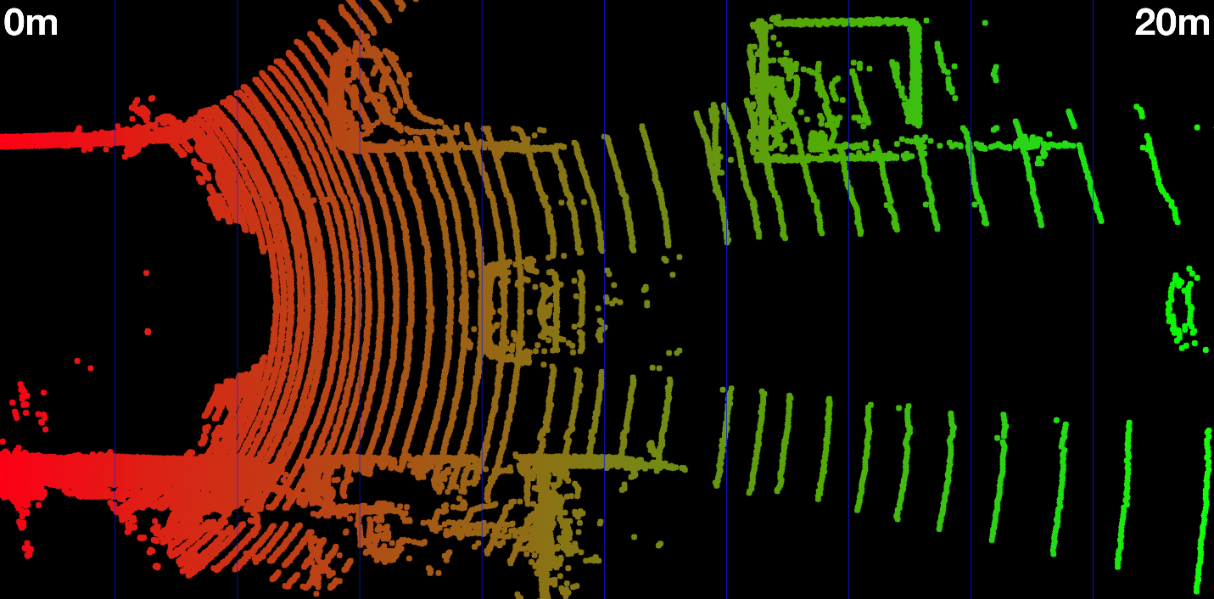](https://classroom.udacity.com/nanodegrees/nd313/parts/1971021c-523b-414c-93a3-2c6297cf4771/modules/0a71c48d-96ab-4d3a-be96-3ea1e64cf773/lessons/fb74bfb2-bfe1-4d86-a997-320ab71c0dbd/concepts/93e3b893-f874-477f-8f02-1ff465c160de)](https://classroom.udacity.com/nanodegrees/nd313/parts/1971021c-523b-414c-93a3-2c6297cf4771/modules/0a71c48d-96ab-4d3a-be96-3ea1e64cf773/lessons/fb74bfb2-bfe1-4d86-a997-320ab71c0dbd/concepts/93e3b893-f874-477f-8f02-1ff465c160de)**

1. Remove all Lidar points on the road surface while preserving measurements on the obstacles in the scene. Your final result should look something like this:

**[[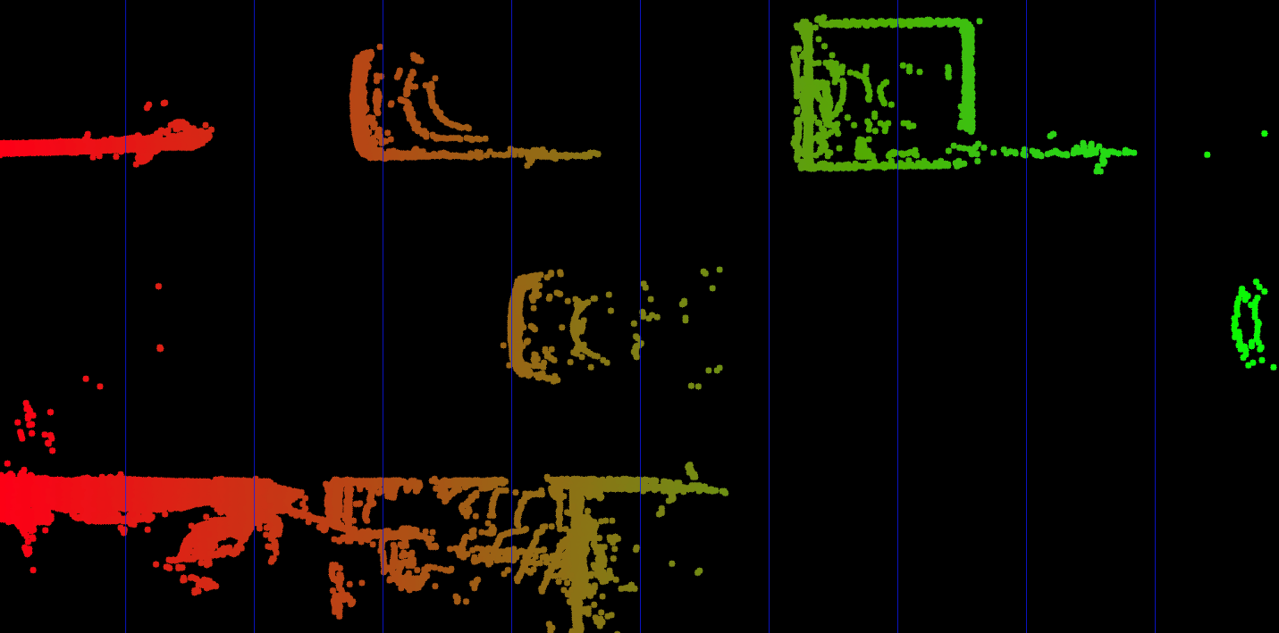](https://classroom.udacity.com/nanodegrees/nd313/parts/1971021c-523b-414c-93a3-2c6297cf4771/modules/0a71c48d-96ab-4d3a-be96-3ea1e64cf773/lessons/fb74bfb2-bfe1-4d86-a997-320ab71c0dbd/concepts/93e3b893-f874-477f-8f02-1ff465c160de)](https://classroom.udacity.com/nanodegrees/nd313/parts/1971021c-523b-414c-93a3-2c6297cf4771/modules/0a71c48d-96ab-4d3a-be96-3ea1e64cf773/lessons/fb74bfb2-bfe1-4d86-a997-320ab71c0dbd/concepts/93e3b893-f874-477f-8f02-1ff465c160de)**

<https://www.youtube.com/watch?v=pzYFO12BiE0&feature=emb_logo>

Now that we can display Lidar data as 3D points in the sensor coordinate system, let us move on to the next section, where we want to start working on a way to project these points into the camera image.

## Homogeneous coordinates

In this section, our goal is to project points from 3D space onto the image plane. In order to do this, we can use the equations discussed in lesson 1 of this course:

**[[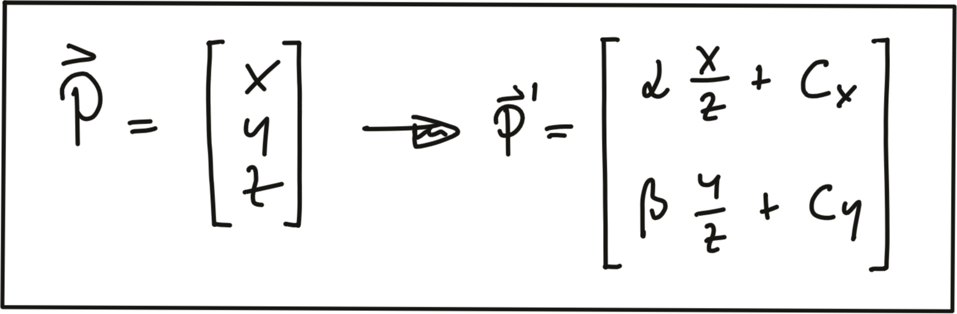](https://classroom.udacity.com/nanodegrees/nd313/parts/1971021c-523b-414c-93a3-2c6297cf4771/modules/0a71c48d-96ab-4d3a-be96-3ea1e64cf773/lessons/fb74bfb2-bfe1-4d86-a997-320ab71c0dbd/concepts/93e3b893-f874-477f-8f02-1ff465c160de)](https://classroom.udacity.com/nanodegrees/nd313/parts/1971021c-523b-414c-93a3-2c6297cf4771/modules/0a71c48d-96ab-4d3a-be96-3ea1e64cf773/lessons/fb74bfb2-bfe1-4d86-a997-320ab71c0dbd/concepts/93e3b893-f874-477f-8f02-1ff465c160de)**

In addition to the intrinsic camera parameters which make up the geometry of the projection, we need additional information about the position and alignment of both camera and Lidar in a common reference coordinate system. To move from Lidar to camera involves translation and rotation operations, which we need to apply to every 3D point. So our goal here is to simplify the notation with which we can express the projection. Using a linear transformation (or mapping), 3D points could be represented by a vector and operations such as translation, rotation, scaling and perspective projection could be represented as matrices by which the vector is multiplied. The problem with the projection equations we have so far is that they involve a division by Z, which makes them non-linear and thus prevents us from transforming them into the much more convenient matrix-vector form.

A way to avoid this problem is to change the coordinate system and go from the original Euclidean coordinate system to a form called the Homogenous coordinate system. Moving back and forth between both coordinate systems is a non-linear operation, but once we are in the homogenous coordinate system, projective transformations such as the one given above become linear and can thus be expressed as simple matrix-vector multiplications. Transformations between both coordinate systems work as shown in the following figure.

**[[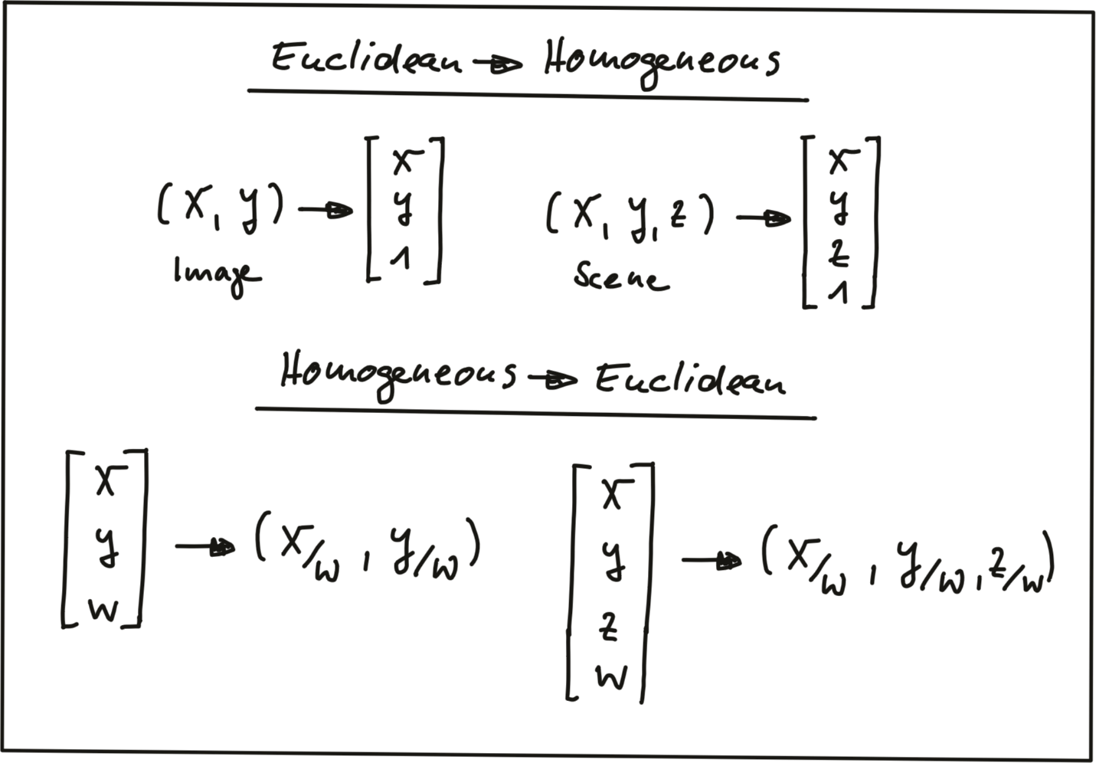](https://classroom.udacity.com/nanodegrees/nd313/parts/1971021c-523b-414c-93a3-2c6297cf4771/modules/0a71c48d-96ab-4d3a-be96-3ea1e64cf773/lessons/fb74bfb2-bfe1-4d86-a997-320ab71c0dbd/concepts/93e3b893-f874-477f-8f02-1ff465c160de)](https://classroom.udacity.com/nanodegrees/nd313/parts/1971021c-523b-414c-93a3-2c6297cf4771/modules/0a71c48d-96ab-4d3a-be96-3ea1e64cf773/lessons/fb74bfb2-bfe1-4d86-a997-320ab71c0dbd/concepts/93e3b893-f874-477f-8f02-1ff465c160de)**

A point in the n-dimensional euclidian coordinate system is represented by a vector with n components. The transformation into (n+1)-dimensional homogeneous coordinates can be achieved by simply adding the number 1 as an additional component. The transformation can be applied to both image coordinates as well as scene coordinates.

Converting back from homogeneous coordinates to Euclidean then works by suppressing the last coordinate and dividing the first n coordinates by the (n+1)-th coordinate as shown in the figure above. As discussed earlier in this section, this is a non-linear operation and once we are back in Euclidean space, the neat separation of the different parameters into individual matrix components is lost. In the following, we will take a look at those matrix components.

## Intrinsic Parameters

Now we are ready to express the projection equations in matrix-vector form:

**[[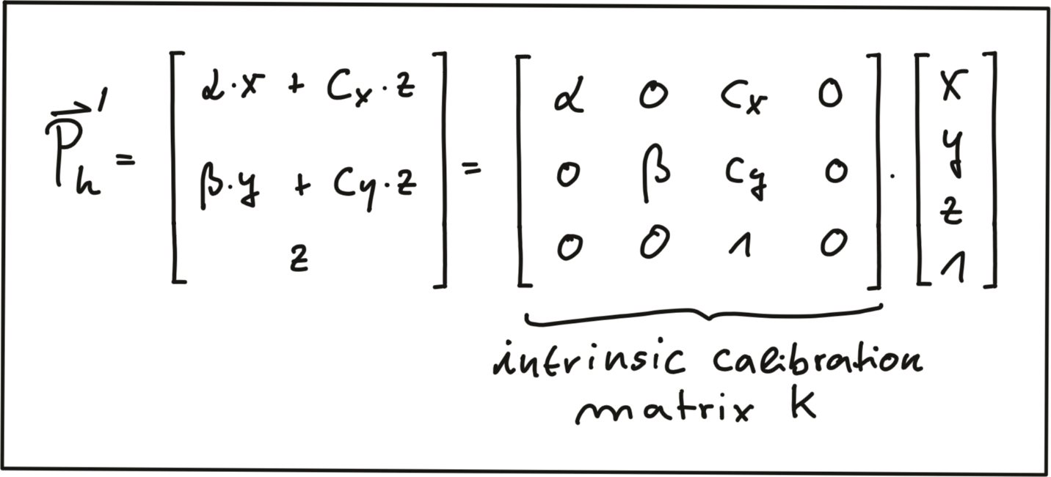](https://classroom.udacity.com/nanodegrees/nd313/parts/1971021c-523b-414c-93a3-2c6297cf4771/modules/0a71c48d-96ab-4d3a-be96-3ea1e64cf773/lessons/fb74bfb2-bfe1-4d86-a997-320ab71c0dbd/concepts/93e3b893-f874-477f-8f02-1ff465c160de)](https://classroom.udacity.com/nanodegrees/nd313/parts/1971021c-523b-414c-93a3-2c6297cf4771/modules/0a71c48d-96ab-4d3a-be96-3ea1e64cf773/lessons/fb74bfb2-bfe1-4d86-a997-320ab71c0dbd/concepts/93e3b893-f874-477f-8f02-1ff465c160de)**

As can be seen, the camera parameters are arranged in a matrix, which conveniently expresses the properties of our pinhole camera model in a compact way. Additional properties of a more complex camera model such as skewness or shear can easily be added. The following video animation shows the effect of the individual intrinsic parameters of the camera on the appearance of objects on the image plane. [**source**: [**http://ksimek.github.io/2013/08/13/intrinsic**](http://ksimek.github.io/2013/08/13/intrinsic)]

## <https://www.youtube.com/watch?v=Cu-VRkG1sY4&feature=emb_logo> Extrinsic Parameters

The mapping between a point P in 3D space to a point P’ in the 2D image plane has so far been described in the camera coordinate system with the pinhole as its center . But what if the information we have about points in 3D (or in general about any physical object) is available in another coordinate system, such as the vehicle coordinate system common in many automotive applications? As shown in the figure below, the origin of the vehicle coordinate system is placed directly on the ground below the midpoint of the rear axle with the x-axis pointing into driving direction. In addition to the axis naming convention, the figure also shows the typically used names for rotation around X, Y and Z which are 'roll', 'pitch' and 'yaw'.

**[[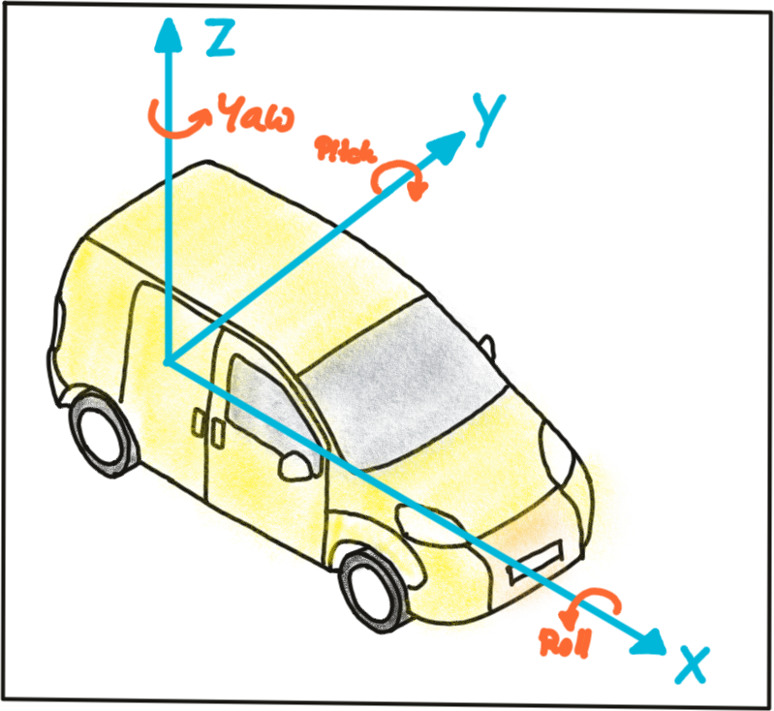](https://classroom.udacity.com/nanodegrees/nd313/parts/1971021c-523b-414c-93a3-2c6297cf4771/modules/0a71c48d-96ab-4d3a-be96-3ea1e64cf773/lessons/fb74bfb2-bfe1-4d86-a997-320ab71c0dbd/concepts/93e3b893-f874-477f-8f02-1ff465c160de)](https://classroom.udacity.com/nanodegrees/nd313/parts/1971021c-523b-414c-93a3-2c6297cf4771/modules/0a71c48d-96ab-4d3a-be96-3ea1e64cf773/lessons/fb74bfb2-bfe1-4d86-a997-320ab71c0dbd/concepts/93e3b893-f874-477f-8f02-1ff465c160de)**

Let us assume the vehicle were equipped with a Lidar sensor and a camera, who would both be calibrated in the vehicle coordinate system. In order to project points measured in the Lidar sensor coordinate system into the camera, we need to add an additional transformation to our mapping operation that allows us to relate points from the vehicle coordinate system to the camera coordinate system and vice versa. Generally, such a mapping operation can be broken down into three components: translation, rotation and scaling. Let’s look at each of them in turn:

Translation : As seen in the following figure, translation describes the linear shift of a point \vec{P}*P*⃗ to a new location \vec{P'}*P*′⃗ by adding the components of a translation vector \vec{t}*t*⃗ to the components of \vec{P}*P*⃗.

**[[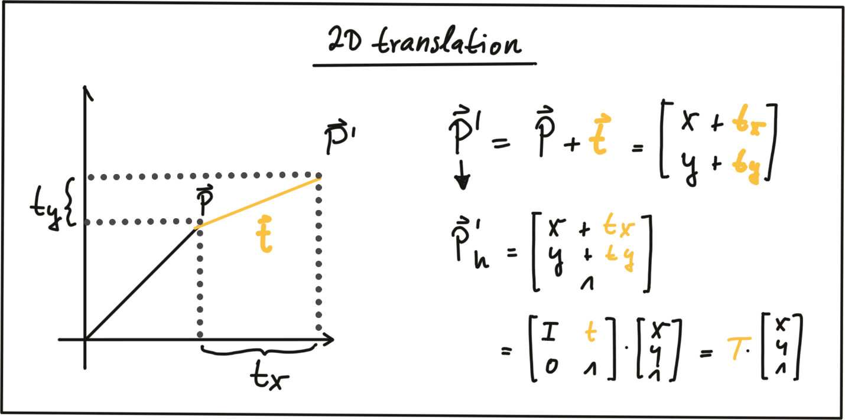](https://classroom.udacity.com/nanodegrees/nd313/parts/1971021c-523b-414c-93a3-2c6297cf4771/modules/0a71c48d-96ab-4d3a-be96-3ea1e64cf773/lessons/fb74bfb2-bfe1-4d86-a997-320ab71c0dbd/concepts/93e3b893-f874-477f-8f02-1ff465c160de)](https://classroom.udacity.com/nanodegrees/nd313/parts/1971021c-523b-414c-93a3-2c6297cf4771/modules/0a71c48d-96ab-4d3a-be96-3ea1e64cf773/lessons/fb74bfb2-bfe1-4d86-a997-320ab71c0dbd/concepts/93e3b893-f874-477f-8f02-1ff465c160de)**

In homogeneous coordinates, this can be expressed by concatenating an identity matrix I*I* of size N*N* (where span class="mathquill">N is the number of components in \vec{P}*P*⃗) and the translation vector \vec{t}*t*⃗. The translation operation then becomes a simple matrix-vector multiplication as shown in the figure above.

Scale : While translation involves adding a translation vector \vec{t}*t*⃗ to the components of \vec{P}*P*⃗, scaling works by multiplying the components with a scale vector \vec{s}*s*⃗ instead. In homogeneous coordinates, this can be expressed as a matrix-vector multiplication as seen in the figure below.

**[[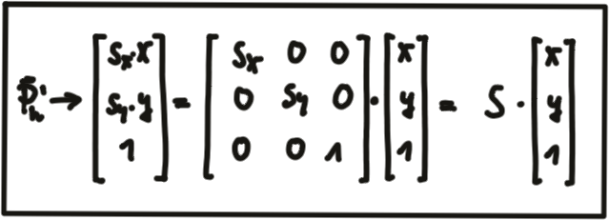](https://classroom.udacity.com/nanodegrees/nd313/parts/1971021c-523b-414c-93a3-2c6297cf4771/modules/0a71c48d-96ab-4d3a-be96-3ea1e64cf773/lessons/fb74bfb2-bfe1-4d86-a997-320ab71c0dbd/concepts/93e3b893-f874-477f-8f02-1ff465c160de)](https://classroom.udacity.com/nanodegrees/nd313/parts/1971021c-523b-414c-93a3-2c6297cf4771/modules/0a71c48d-96ab-4d3a-be96-3ea1e64cf773/lessons/fb74bfb2-bfe1-4d86-a997-320ab71c0dbd/concepts/93e3b893-f874-477f-8f02-1ff465c160de)**

Rotation : A point \vec{P'}*P*′⃗ is rotated in counter-clockwise direction (mathematically positive) by using the following equations for x*x* and y*y*.

**[[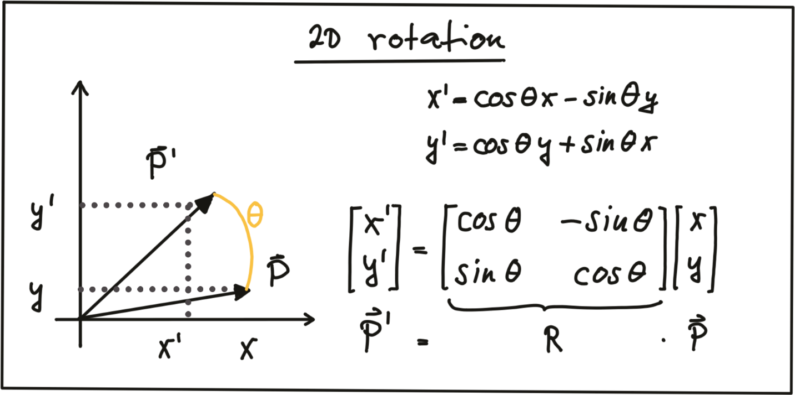](https://classroom.udacity.com/nanodegrees/nd313/parts/1971021c-523b-414c-93a3-2c6297cf4771/modules/0a71c48d-96ab-4d3a-be96-3ea1e64cf773/lessons/fb74bfb2-bfe1-4d86-a997-320ab71c0dbd/concepts/93e3b893-f874-477f-8f02-1ff465c160de)](https://classroom.udacity.com/nanodegrees/nd313/parts/1971021c-523b-414c-93a3-2c6297cf4771/modules/0a71c48d-96ab-4d3a-be96-3ea1e64cf773/lessons/fb74bfb2-bfe1-4d86-a997-320ab71c0dbd/concepts/93e3b893-f874-477f-8f02-1ff465c160de)**

As before, the operation can be expressed as a matrix-vector multiplication with R*R* being called the 'rotation matrix‘. In 3D space, a point P*P* can be rotated around all three axes using the following rotation matrices:

**[[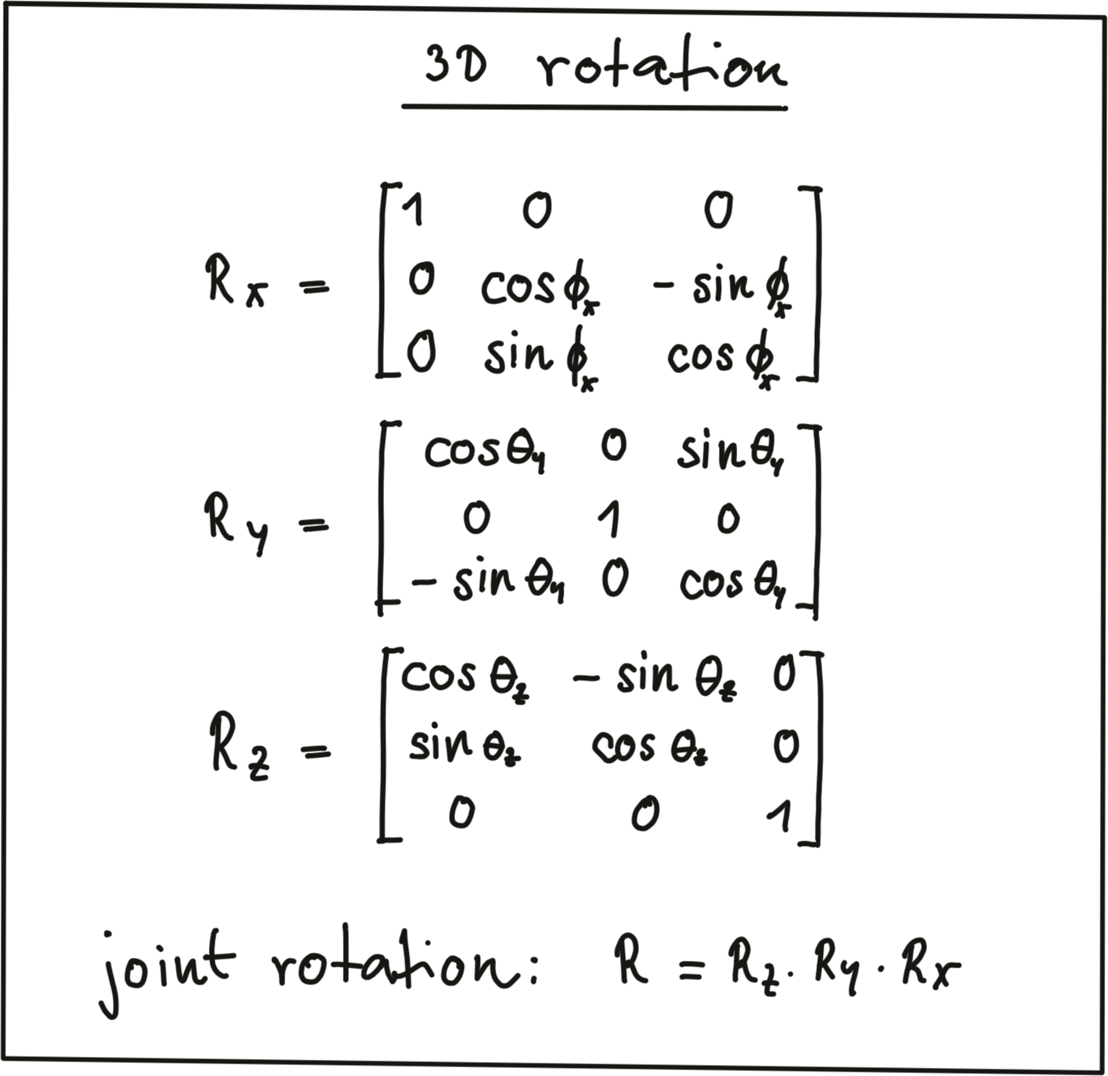](https://classroom.udacity.com/nanodegrees/nd313/parts/1971021c-523b-414c-93a3-2c6297cf4771/modules/0a71c48d-96ab-4d3a-be96-3ea1e64cf773/lessons/fb74bfb2-bfe1-4d86-a997-320ab71c0dbd/concepts/93e3b893-f874-477f-8f02-1ff465c160de)](https://classroom.udacity.com/nanodegrees/nd313/parts/1971021c-523b-414c-93a3-2c6297cf4771/modules/0a71c48d-96ab-4d3a-be96-3ea1e64cf773/lessons/fb74bfb2-bfe1-4d86-a997-320ab71c0dbd/concepts/93e3b893-f874-477f-8f02-1ff465c160de)**

Note that the three individual rotations can be combined into a joint rotation matrix R by successive application in the order R = R\_z \cdot R\_y \cdot R\_x*R*=*Rz*​⋅*Ry*​⋅*Rx*​

One of the advantages of homogeneous coordinates is that they allow for an easy combination of multiple transformations by concatenating several matrix-vector multiplications.

The combined matrix consisting of R*R* and \vec{t}*t*⃗ is also referred to as the extrinsic matrix, as it models how points are transformed between coordinate system. Once a point in the Lidar coordinate system has been expressed in camera coordinates, we need to project it onto the image plane. For this purpose, we need to additionally integrate the intrinsic parameters discussed above. With homogeneous coordinates, we can simply do this by concatenating the individual matrices in the following manner:

**[[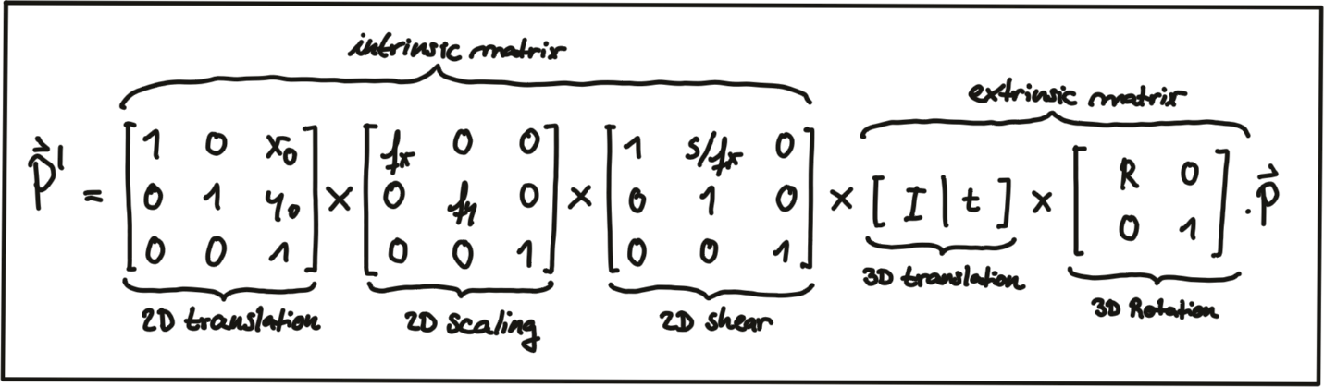](https://classroom.udacity.com/nanodegrees/nd313/parts/1971021c-523b-414c-93a3-2c6297cf4771/modules/0a71c48d-96ab-4d3a-be96-3ea1e64cf773/lessons/fb74bfb2-bfe1-4d86-a997-320ab71c0dbd/concepts/93e3b893-f874-477f-8f02-1ff465c160de)](https://classroom.udacity.com/nanodegrees/nd313/parts/1971021c-523b-414c-93a3-2c6297cf4771/modules/0a71c48d-96ab-4d3a-be96-3ea1e64cf773/lessons/fb74bfb2-bfe1-4d86-a997-320ab71c0dbd/concepts/93e3b893-f874-477f-8f02-1ff465c160de)**

Note that the scale component has been integrated into the intrinsic matrix K*K* (with the focal length being the relevant parameter) and is no longer part of the extrinsic matrix. In the following video, the influence of the extrinsic parameters on the appearance of an object on the image plane is simulated. [**source**: [**http://ksimek.github.io/perspective\_camera\_toy.html**](http://ksimek.github.io/perspective_camera_toy.html)]

## Overview of the KITTI sensor setup

Now that we have an understanding of how points in 3D space can be projected onto the image plane of a camera, let us take a look at the sensor setup of the KITTI vehicle that was used to generate the data sequences. In the following figure, the vehicle is shown, equipped with two forward-facing cameras, a roof-mounted Velodyne Lidar as well as an inertial measurement unit or IMU (which we will not be using in this course).

**[[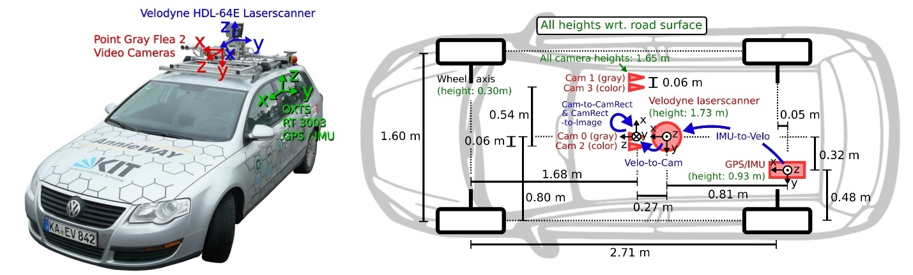](https://classroom.udacity.com/nanodegrees/nd313/parts/1971021c-523b-414c-93a3-2c6297cf4771/modules/0a71c48d-96ab-4d3a-be96-3ea1e64cf773/lessons/fb74bfb2-bfe1-4d86-a997-320ab71c0dbd/concepts/93e3b893-f874-477f-8f02-1ff465c160de)](https://classroom.udacity.com/nanodegrees/nd313/parts/1971021c-523b-414c-93a3-2c6297cf4771/modules/0a71c48d-96ab-4d3a-be96-3ea1e64cf773/lessons/fb74bfb2-bfe1-4d86-a997-320ab71c0dbd/concepts/93e3b893-f874-477f-8f02-1ff465c160de)**

For all datasets, calibration files with intrinsic and extrinsic parameters are available once you download them from the KITTI website. In the following, the content of the file "calib\_velo\_to\_cam.txt“ is shown, which relates the Velodyne sensor and the left camera of the stereo rig (valid for the highway sequence we are using):

calib\_time: 15-Mar-2012 11:37:16

R: 7.533745e-03 -9.999714e-01 -6.166020e-04 1.480249e-02 7.280733e-04 -9.998902e-01 9.998621e-01 7.523790e-03 1.480755e-02

T: -4.069766e-03 -7.631618e-02 -2.717806e-01

…

The matrices R and T provide us with the extrinsic parameters of the sensor setup. As we know, we also need information about the intrinsic parameters in order to perform the projection. These are stored in the file "calib\_cam\_to\_cam.txt", which is given as an excerpt in the following:

calib\_time: 09-Jan-2012 13:57:47

…

R\_rect\_00: 9.999239e-01 9.837760e-03 -7.445048e-03 -9.869795e-03 9.999421e-01 -4.278459e-03 7.402527e-03 4.351614e-03 9.999631e-01

P\_rect\_00: 7.215377e+02 0.000000e+00 6.095593e+02 0.000000e+00 0.000000e+00 7.215377e+02 1.728540e+02 0.000000e+00 0.000000e+00 0.000000e+00 1.000000e+00 0.000000e+00

…

The matrix R\_rect\_00 is the 3x3 rectifying rotation to make image planes co-planar, i.e. to align both cameras of the stereo rig (there are two Point Gray cameras in the KITTI vehicle) in a way that one row of pixels in the left camera directly corresponds to another row of pixels in the right camera (as opposed to a slanted line crossing over the image plane). As we are focussing on the mono camera here, we did not go into details on the underlying concepts - but If you want to learn more about this, research "epipolar geometry". The matrix P\_rect\_00 contains the intrinsic camera parameters as discussed above (we called it K). The following equation shows how to project a 3D Lidar point X in space to a 2D image point Y (using the notation in the Kitti readme file) on the image plane of the left camera using homogeneous coordinates:

**[[](https://classroom.udacity.com/nanodegrees/nd313/parts/1971021c-523b-414c-93a3-2c6297cf4771/modules/0a71c48d-96ab-4d3a-be96-3ea1e64cf773/lessons/fb74bfb2-bfe1-4d86-a997-320ab71c0dbd/concepts/93e3b893-f874-477f-8f02-1ff465c160de)](https://classroom.udacity.com/nanodegrees/nd313/parts/1971021c-523b-414c-93a3-2c6297cf4771/modules/0a71c48d-96ab-4d3a-be96-3ea1e64cf773/lessons/fb74bfb2-bfe1-4d86-a997-320ab71c0dbd/concepts/93e3b893-f874-477f-8f02-1ff465c160de)**

## Exercise: Projecting Lidar Points into the Camera

<https://www.youtube.com/watch?v=B7e3eD7Knl8&feature=emb_logo>

In the code sample in project\_lidar\_to\_camera.cpp of the workspace above, a framework for projecting Lidar points has been prepared. Please use your new knowledge to complete the following exercises:

1. In the loop over all Lidar points, convert each 3D point into homogeneous coordinates and store it in a 4D variable X.
2. Then, apply the projection equation as detailed in lesson 5.1 to map X onto the image plane of the camera. Store the result in Y.
3. Once this is done, transform Y back into Euclidean coordinates and store the result in the variable pt.

Once you have completed all three steps, the output of the code sample should look like the figure below.

**[[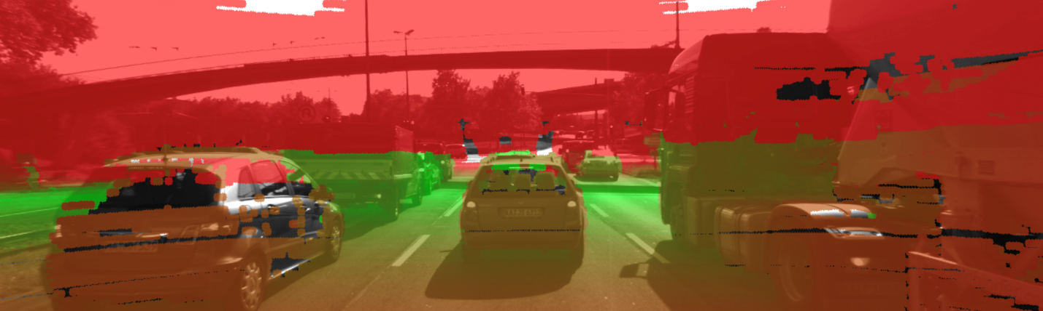](https://classroom.udacity.com/nanodegrees/nd313/parts/1971021c-523b-414c-93a3-2c6297cf4771/modules/0a71c48d-96ab-4d3a-be96-3ea1e64cf773/lessons/fb74bfb2-bfe1-4d86-a997-320ab71c0dbd/concepts/93e3b893-f874-477f-8f02-1ff465c160de)](https://classroom.udacity.com/nanodegrees/nd313/parts/1971021c-523b-414c-93a3-2c6297cf4771/modules/0a71c48d-96ab-4d3a-be96-3ea1e64cf773/lessons/fb74bfb2-bfe1-4d86-a997-320ab71c0dbd/concepts/93e3b893-f874-477f-8f02-1ff465c160de)**

Cleary, something is not working here. The idea of coloring the individual pixels was that red should represent close 3D points while green should be used for far-away points. The image looks good up until the horizon is reached. The bright red sky is not correct though. So let’s take a look at what is wrong here.

## Filtering Lidar Points

Earlier on in this section, you learned how to convert the Lidar point cloud into a top view perspective. The conversion process implicitly assumed that we would only be interested in points directly in front of the vehicle. In the code, the following lines show how the conversion into the top view image was performed:

**int** y = (-xw \* imageSize.height / worldSize.height) + imageSize.height;

**int** x = (-yw \* imageSize.height / worldSize.height) + imageSize.width / 2;

As you now know, the Velodyne Lidar is roof-mounted and spins in a 360° circle at 10 Hz. That means, it also measures 3D points behind the vehicle facing away from the camera. Those points are also contained in the data set but they do not show up in the top view image. But when projected into the camera, they produce a valid image plane coordinate, even though they are not visible to the camera (the projecting line intersects the image plane from behind). The associated Lidar points have a negative x-coordinate which causes the respective pixel color to appear in red on the image plane. So in order to avoid this from happening, let’s take a look at some filtering options we have to thin out the point cloud.

The code below shows how a filter can be applied to remove Lidar points that do not satisfy a set of constraints, i.e. they are …

1. … positioned behind the Lidar sensor and thus have a negative x coordinate.
2. … too far away in x-direction and thus exceeding an upper distance limit.
3. … too far off to the sides in y-direction and thus not relevant for collision detection
4. … too close to the road surface in negative z-direction.
5. … showing a reflectivity close to zero, which might indicate low reliability.

**for**(**auto** it=lidarPoints.begin(); it!=lidarPoints.end(); ++it) {

**float** maxX = 25.0, maxY = 6.0, minZ = -1.4;

**if**(it->x > maxX || it->x < 0.0 || abs(it->y) > maxY || it->z < minZ || it->r<0.01 )

{

**continue**; *// skip to next point*

}

After applying these filters to the Lidar point cloud, the resulting overlay image shows a significantly reduced number of points. From the perspective of collision detection, measurement quality is of highest importance and the filtering step, aside from increasing the processing speed further down the pipeline, can help improve reliability. Try this now in your project\_lidar\_to\_camera.cpp file in the workspace above!

**[[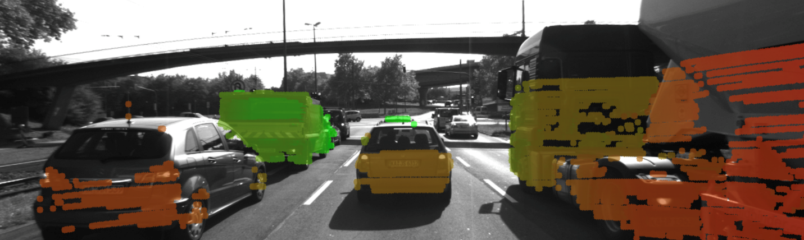](https://classroom.udacity.com/nanodegrees/nd313/parts/1971021c-523b-414c-93a3-2c6297cf4771/modules/0a71c48d-96ab-4d3a-be96-3ea1e64cf773/lessons/fb74bfb2-bfe1-4d86-a997-320ab71c0dbd/concepts/93e3b893-f874-477f-8f02-1ff465c160de)](https://classroom.udacity.com/nanodegrees/nd313/parts/1971021c-523b-414c-93a3-2c6297cf4771/modules/0a71c48d-96ab-4d3a-be96-3ea1e64cf773/lessons/fb74bfb2-bfe1-4d86-a997-320ab71c0dbd/concepts/93e3b893-f874-477f-8f02-1ff465c160de)**

# Object Detection with YOLO

## Why Object Detection?

As mentioned in the introductory video, we need a way to detect vehicles in our images so that we can isolate matched keypoints as well as projected Lidar points and associate them to a specific object. Let us take a look at the program flow schematic we already discussed in the lesson on engineering a collision detection system.

<https://www.youtube.com/watch?v=ZpyEq_U4pRY&feature=emb_logo>

**[[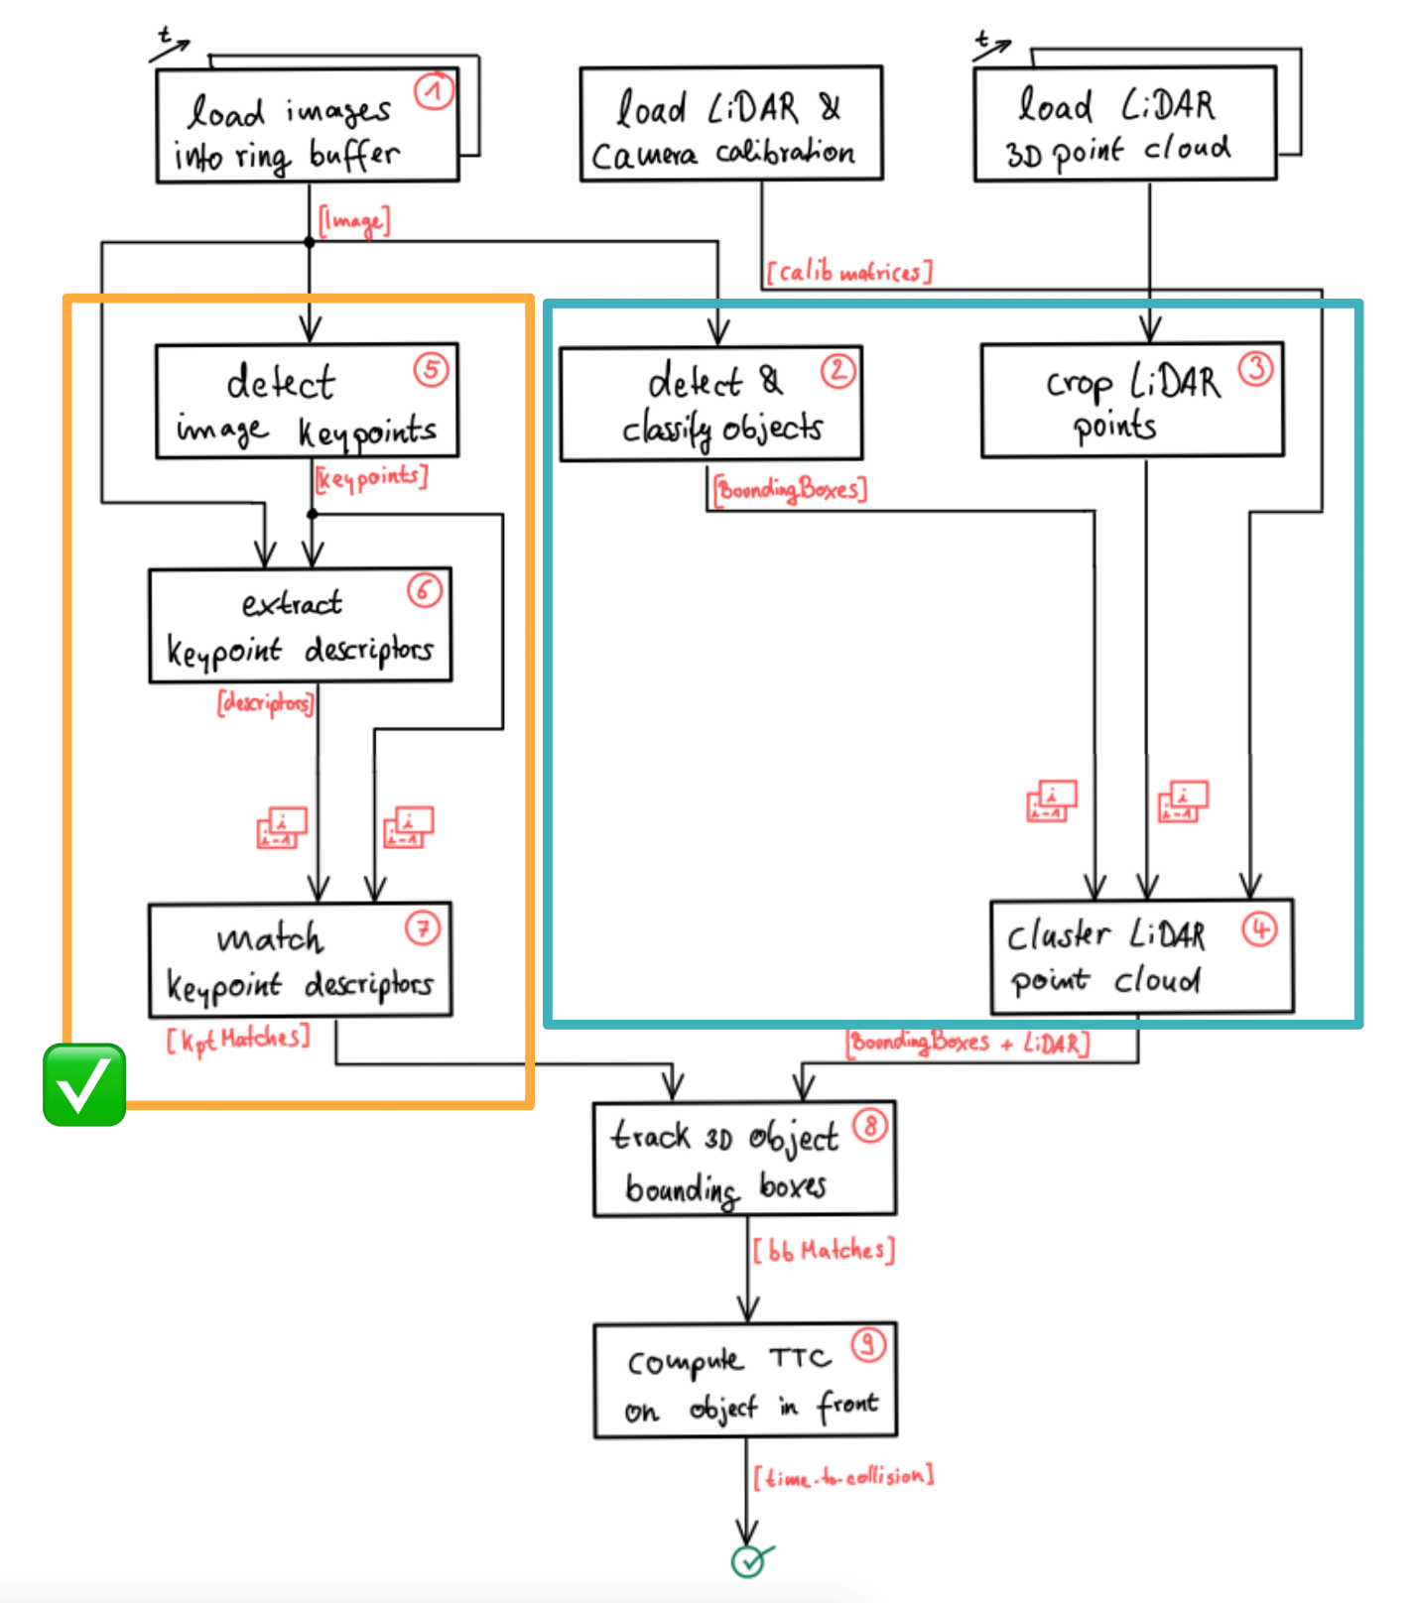](https://classroom.udacity.com/nanodegrees/nd313/parts/1971021c-523b-414c-93a3-2c6297cf4771/modules/0a71c48d-96ab-4d3a-be96-3ea1e64cf773/lessons/fb74bfb2-bfe1-4d86-a997-320ab71c0dbd/concepts/77657b72-080f-4d93-b9d7-a6abf3b2e92b)](https://classroom.udacity.com/nanodegrees/nd313/parts/1971021c-523b-414c-93a3-2c6297cf4771/modules/0a71c48d-96ab-4d3a-be96-3ea1e64cf773/lessons/fb74bfb2-bfe1-4d86-a997-320ab71c0dbd/concepts/77657b72-080f-4d93-b9d7-a6abf3b2e92b)**

Based on what you learned in the previous lesson, you are now able to detect and match keypoints using a variety of detectors and descriptors. In order to compute the time-to-collision for a specific vehicle however, we need to isolate the keypoints on that vehicle so that TTC estimation is not distorted due to the inclusion of matches on e.g. the road surface, stationary objects or other vehicles in the scene. One way to achieve this is to automatically identify the vehicles in the scene using object detection. The output of such an algorithm would (ideally) be a set of 2D bounding boxes around all objects in the scene. Based on these bounding boxes, we could then easily associate keypoint matches to objects and achieve a stable TTC estimate.

<https://www.youtube.com/watch?v=AvGh3pFQKJQ&feature=emb_logo>

For the Lidar measurements, the same rationale can be applied. As you have learned in the previous course on Lidar, you already know that 3D points can be successfully clustered into individual objects, e.g. by using algorithms from the Point Cloud Library (PCL), which can be seen as an equivalent to the OpenCV library for 3D applications. In this section, let us look at yet another approach to group Lidar points into objects. Based on what you learned in the previous section, you now know how to project Lidar points onto the image plane. Given a set of bounding boxes from object detection, we could thus easily associate a 3D Lidar point to a specific object in a scene by simply checking wether it is enclosed by a bounding box when projected into the camera.

We will look in detail at both of the described approaches later in this section but for now, let us look at a way to detect objects in camera images - which is a prerequisite for grouping keypoint matches as well as Lidar points. in the schematic shown above, the content of the current lesson is highlighted by a blue rectangle and in this section we will be focussing on 'detecting & classifying objects‘.

## Introduction into YOLO

The aim of this section is to enable you to quickly leverage a powerful and state-of-the-art tool for object detection. It is not the purpose to perform a theoretical deep-dive into the inner workings of such algorithms, but rather you should be enabled to integrate object detection into the code framework of this course quickly and seamlessly. The following image shows the an example output of the code we will be developing in this section.

**[[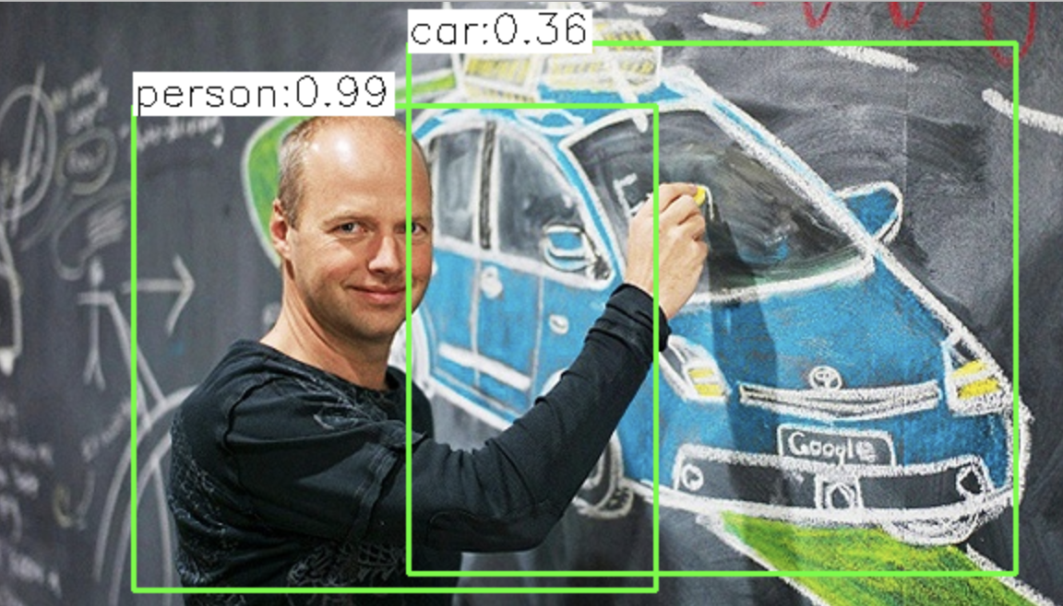](https://classroom.udacity.com/nanodegrees/nd313/parts/1971021c-523b-414c-93a3-2c6297cf4771/modules/0a71c48d-96ab-4d3a-be96-3ea1e64cf773/lessons/fb74bfb2-bfe1-4d86-a997-320ab71c0dbd/concepts/77657b72-080f-4d93-b9d7-a6abf3b2e92b)](https://classroom.udacity.com/nanodegrees/nd313/parts/1971021c-523b-414c-93a3-2c6297cf4771/modules/0a71c48d-96ab-4d3a-be96-3ea1e64cf773/lessons/fb74bfb2-bfe1-4d86-a997-320ab71c0dbd/concepts/77657b72-080f-4d93-b9d7-a6abf3b2e92b)**

In the past, methods for object detection were often based on histograms of oriented gradients (HOG) and support vector machines (SVM). Until the advent of deep-learning, the HOG/SVM approach was long considered the state-of-the-art approach to detection. While the results of HOG/SVM are still acceptable for a large variety of problems, its use on platforms with limited processing speed is limited. As with SIFT, one of the major issues is the methods reliance on the intensity gradient - which is a costly operation.

Another approach to object detection is the use of deep-learning frameworks such as TensorFlow or Caffe. However, the learning curve for both is very steep and would warrant an entire course on its own. An easy-to-use alternative that works right out of the box and is also based on similar underlying concepts is YOLO, a very fast detection framework that is shipped with the OpenCV library. Developed by Joseph Redmon, Santosh Divvala, Ross Girshick, and Ali Farhadi at Cornell University, YOLO uses a different approach than most other methods: Here, a single neural network is applied to the full image. This network divides the image into regions and predicts bounding boxes and probabilities for each region. These bounding boxes are weighted by the predicted probabilities. The following figure illustrates the principle:

**[[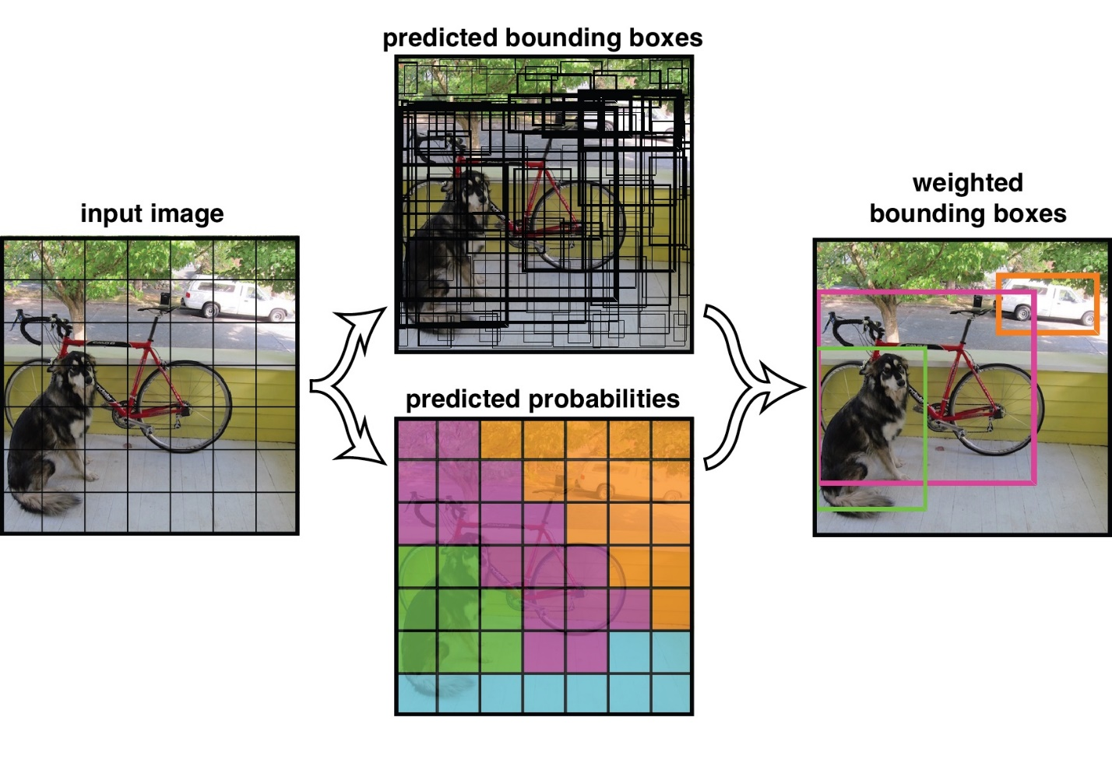](https://classroom.udacity.com/nanodegrees/nd313/parts/1971021c-523b-414c-93a3-2c6297cf4771/modules/0a71c48d-96ab-4d3a-be96-3ea1e64cf773/lessons/fb74bfb2-bfe1-4d86-a997-320ab71c0dbd/concepts/77657b72-080f-4d93-b9d7-a6abf3b2e92b)](https://classroom.udacity.com/nanodegrees/nd313/parts/1971021c-523b-414c-93a3-2c6297cf4771/modules/0a71c48d-96ab-4d3a-be96-3ea1e64cf773/lessons/fb74bfb2-bfe1-4d86-a997-320ab71c0dbd/concepts/77657b72-080f-4d93-b9d7-a6abf3b2e92b)**

**[[adapted from this](https://classroom.udacity.com/nanodegrees/nd313/parts/1971021c-523b-414c-93a3-2c6297cf4771/modules/0a71c48d-96ab-4d3a-be96-3ea1e64cf773/lessons/fb74bfb2-bfe1-4d86-a997-320ab71c0dbd/concepts/77657b72-080f-4d93-b9d7-a6abf3b2e92b)**[**source**](https://github.com/pjreddie/darknet/wiki/YOLO:-Real-Time-Object-Detection)]

Other than classifier-based systems such as HOG/SVM, YOLO looks at the whole image so its predictions are informed by global context in the image. It also makes predictions with a single network pass unlike systems like R-CNN which require thousands of passes for a single image. This makes it extremely fast while at the same time generating similar results as other state-of-the-art methods such as the Single Shot MultiBox Detector (SSD).

The makers of YOLO have also made available a set of pre-trained weights that enable the current version YOLOv3 to recognize 80 different objects in images and videos based on COCO ([**http://cocodataset.org/#home**](http://cocodataset.org/#home)) , which is a is large-scale object detection, segmentation, and captioning dataset. In the context of this course this means, that we can use YOLOv3 as an out-of-the-box classifier which is able to detect vehicles (and many other obstacles) with reasonable accuracy.

## The YOLOv3 Workflow

In this section, we will take a look at the different steps involved to execute YOLO on the course image set. The parameters used below are mainly the ones suggested by the authors. In the following, a short overview of the main algorithmic steps is given:

* First, the image is divided into a 13x13 grid of cells. Based on the size of the input image, the size of these cells in pixels varies. In the code below, a size of 416 x 416 pixels was used, leading to a cell size of 32 x 32 pixels.
* As seen in the schematic above, each cell is then used for predicting a set of bounding boxes. For each bounding box, the network also predicts the confidence that the bounding box encloses a particular object as well as the probability of the object belonging to a particular class (taken from the COCO dataset).
* Lastly, a non-maximum suppression is used to eliminate bounding boxes with a low confidence level as well as redundant bounding boxes enclosing the same object.

In the following, the main workflow as well as the respective code is presented.

Step 1: Initialize the Parameters

Every bounding box predicted by YOLOv3 is associated with a confidence score. The parameter 'confThreshold' is used to remove all bounding boxes with a lower score value.

Then, a non-maximum suppression is applied to the remaining bounding boxes. The NMS procedure is controlled by the parameter ‚nmsThreshold‘.

The size of the input image is controlled by the parameters ‚inpWidth‘ and ‚inpHeight‘, which is set to 416 as proposed by the YOLO authors. Other values could e.g. be 320 (faster) or 608 (more accurate).

Step 2: Prepare the Model

The file 'yolov3.weights' contains the pre-trained network’s weights and has been made available by the authors of YOLO [**here**](https://pjreddie.com/media/files/yolov3.weights).

The file 'yolov3.cfg' containing the network configuration is available [**here**](https://github.com/pjreddie/darknet/blob/master/cfg/yolov3.cfg) and the coco.names file which contains the 80 different class names used in the COCO dataset can be downloaded [**here**](https://github.com/pjreddie/darknet/blob/master/data/coco.names).

The following code shows how to load the model weights as well as the associated model configuration:

// load image from file

cv::Mat img = cv::imread("./images/img1.png");

// load class names from file

string yoloBasePath = "./dat/yolo/";

string yoloClassesFile = yoloBasePath + "coco.names";

string yoloModelConfiguration = yoloBasePath + "yolov3.cfg";

string yoloModelWeights = yoloBasePath + "yolov3.weights";

vector<string> classes;

ifstream ifs(yoloClassesFile.c\_str());

string line;

while (getline(ifs, line)) classes.push\_back(line);

// load neural network

cv::dnn::Net net = cv::dnn::readNetFromDarknet(yoloModelConfiguration, yoloModelWeights);

net.setPreferableBackend(cv::dnn::DNN\_BACKEND\_OPENCV);

net.setPreferableTarget(cv::dnn::DNN\_TARGET\_CPU);

After loading the network, the DNN backend is set to DNN\_BACKEND\_OPENCV. If OpenCV is built with Intel’s Inference Engine, DNN\_BACKEND\_INFERENCE\_ENGINE should be used instead. The target is set to CPU in the code, as opposed to using DNN\_TARGET\_OPENCL, which would be the method of choice if a (Intel) GPU was available.

Step 3: Generate 4D Blob from Input Image

As data flows through the network, YOLO stores, communicates, and manipulates the information as "blobs": the blob is the standard array and unified memory interface for many frameworks, including Caffe. A blob is a wrapper over the actual data being processed and passed along and also provides synchronization capability between the CPU and the GPU. Mathematically, a blob is an N-dimensional array stored in a C-contiguous fashion. The conventional blob dimensions for batches of image data are number N x channel C x height H x width W. In this nomenclature, N is the batch size of the data. Batch processing achieves better throughput for communication and device processing. For a training batch of 256 images, N would be 256. The parameter C represents the feature dimension, e.g. for RGB images C = 3. In OpenCV, blobs are stored as 4-dimensional cv::Mat array with NCHW dimensions order. More details on blobs can be found here: [**http://caffe.berkeleyvision.org/tutorial/net\_layer\_blob.html**](http://caffe.berkeleyvision.org/tutorial/net_layer_blob.html)

The following example illustrates the memory structure of a blob with N=2, C=16 channels and height H=5 / width W=4.

**[[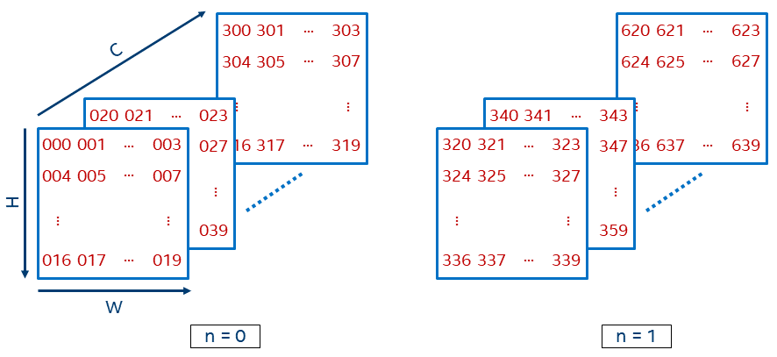](https://classroom.udacity.com/nanodegrees/nd313/parts/1971021c-523b-414c-93a3-2c6297cf4771/modules/0a71c48d-96ab-4d3a-be96-3ea1e64cf773/lessons/fb74bfb2-bfe1-4d86-a997-320ab71c0dbd/concepts/77657b72-080f-4d93-b9d7-a6abf3b2e92b)](https://classroom.udacity.com/nanodegrees/nd313/parts/1971021c-523b-414c-93a3-2c6297cf4771/modules/0a71c48d-96ab-4d3a-be96-3ea1e64cf773/lessons/fb74bfb2-bfe1-4d86-a997-320ab71c0dbd/concepts/77657b72-080f-4d93-b9d7-a6abf3b2e92b)**

**[[](https://classroom.udacity.com/nanodegrees/nd313/parts/1971021c-523b-414c-93a3-2c6297cf4771/modules/0a71c48d-96ab-4d3a-be96-3ea1e64cf773/lessons/fb74bfb2-bfe1-4d86-a997-320ab71c0dbd/concepts/77657b72-080f-4d93-b9d7-a6abf3b2e92b)**[**source**](https://intel.github.io/mkl-dnn/understanding_memory_formats.html)]

In a blob data structure, a value at position (n, c, h, w) can be accessed (if needed) using the following formula: b (n, c, h, w) = ((n C + c) H + h) \* W + w.

The code below shows how an image loaded from the file is passed through the blobFromImage function to be converted into an input block for the neural network. The pixel values are scaled with a scaling factor of 1/255 to a target range of 0 to 1. It also adjusts the size of the image to the specified size of (416, 416, 416) without cropping.

*// generate 4D blob from input image*

cv::Mat blob;

**double** scalefactor = 1/255.0;

cv::Size size = cv::Size(416, 416);

cv::Scalar mean = cv::Scalar(0,0,0);

**bool** swapRB = false;

**bool** crop = false;

cv::dnn::blobFromImage(img, blob, scalefactor, size, mean, swapRB, crop);

Later in the code, the output blob will be passed as input to the network. Then, a forward pass will be executed to obtain a list of predicted bounding boxes as output from the network. These boxes go through a post-processing step to filter out those with low confidence values. Let’s look at those steps in more detail.

Step 4: Run Forward Pass Through the Network

As the next step, we have to pass the blob we just created to the network as its input. Then, we run the forward-function of OpenCV to perform a single forward-pass through the network. In order to do that, we need to identify the last layer of the network and provide the associated internal names to the function. This can be done by using the OpenCV function 'getUnconnectedOutLayers', which gives the names of all unconnected output layers, which are in fact the last layers of the network. The following code shows how this can be achieved:

*// Get names of output layers*

vector<cv::String> names;

vector<**int**> outLayers = net.getUnconnectedOutLayers(); *// get indices of output layers, i.e. layers with unconnected outputs*

vector<cv::String> layersNames = net.getLayerNames(); *// get names of all layers in the network*

names.resize(outLayers.size());

**for** (**size\_t** i = 0; i < outLayers.size(); ++i) *// Get the names of the output layers in names*

{

names[i] = layersNames[outLayers[i] - 1];

}

*// invoke forward propagation through network*

vector<cv::Mat> netOutput;

net.setInput(blob);

net.forward(netOutput, names);

The result of the forward pass and thus the output of the network is a vector of size C (the number of blob classes) with the first four elements in each class representing the center in x, the center in y as well as the width and height of the associated bounding box. The fifth element represents the trust or confidence that the respective bounding box actually encloses an object. The remaining elements of the matrix are the confidence associated with each of the classes contained in the coco.cfg file. Further on in the code, each box is assigned to the class corresponding to the highest confidence.

The following code shows how to scan through the network results and assemble the bounding boxes with a sufficiently high confidence score into a vector. The function cv::minMaxLoc finds the minimum and maximum element values and their positions with extremums searched across the whole array.

*// Scan through all bounding boxes and keep only the ones with high confidence*

**float** confThreshold = 0.20;

vector<**int**> classIds;

vector<**float**> confidences;

vector<cv::Rect> boxes;

**for** (**size\_t** i = 0; i < netOutput.size(); ++i)

{

**float**\* data = (**float**\*)netOutput[i].data;

**for** (**int** j = 0; j < netOutput[i].rows; ++j, data += netOutput[i].cols)

{

cv::Mat scores = netOutput[i].row(j).colRange(5, netOutput[i].cols);

cv::Point classId;

**double** confidence;

*// Get the value and location of the maximum score*

cv::minMaxLoc(scores, 0, &confidence, 0, &classId);

**if** (confidence > confThreshold)

{

cv::Rect box; **int** cx, cy;

cx = (**int**)(data[0] \* img.cols);

cy = (**int**)(data[1] \* img.rows);

box.width = (**int**)(data[2] \* img.cols);

box.height = (**int**)(data[3] \* img.rows);

box.x = cx - box.width/2; *// left*

box.y = cy - box.height/2; *// top*

boxes.push\_back(box);

classIds.push\_back(classId.x);

confidences.push\_back((**float**)confidence);

}

}

}

Applying the YOLOv3 algorithm to our highway image provides the following result:

**[[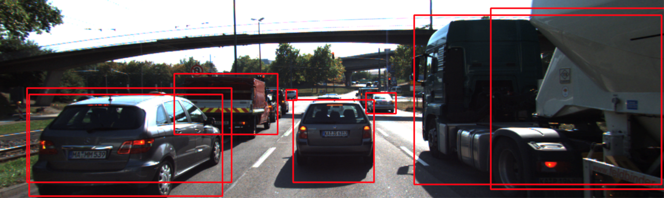](https://classroom.udacity.com/nanodegrees/nd313/parts/1971021c-523b-414c-93a3-2c6297cf4771/modules/0a71c48d-96ab-4d3a-be96-3ea1e64cf773/lessons/fb74bfb2-bfe1-4d86-a997-320ab71c0dbd/concepts/77657b72-080f-4d93-b9d7-a6abf3b2e92b)](https://classroom.udacity.com/nanodegrees/nd313/parts/1971021c-523b-414c-93a3-2c6297cf4771/modules/0a71c48d-96ab-4d3a-be96-3ea1e64cf773/lessons/fb74bfb2-bfe1-4d86-a997-320ab71c0dbd/concepts/77657b72-080f-4d93-b9d7-a6abf3b2e92b)**

As can be seen, the car in the left lane is covered by two bounding boxes of similar size. To avoid the occurrence of redundant boxes, the last step performs a non-maximum suppression which aims at keeping only the bounding box with the highest confidence score.

Step 5: Post-Processing of Network Output

The OpenCV library offers a ready-made function for the suppression of overlapping bounding boxes. This function is called NMSBoxes and it can be used as illustrated by the following short code sample:

*// perform non-maxima suppression*

**float** nmsThreshold = 0.4; *// Non-maximum suppression threshold*

vector<**int**> indices;

cv::dnn::NMSBoxes(boxes, confidences, confThreshold, nmsThreshold, indices);

After applying non-maximum suppression, redundant bounding boxes will have been successfully removed. The following figure shows the results, where green indicates preserved bounding boxes while red bounding boxes have been removed during NMS.

## Exercise

In this exercise, please conduct the following experiments with the code given below:

1. Look at the coco.cfg file and find out which object classes the YOLO network is able to detect. Then, find some interesting images containing some of those objects and load them into the framework. Share some of the results with us if you like.
2. Experiment with the size of the blob image and use some other settings instead of 416 x 416. Measure the execution time for varying sizes of the blob image.
3. Experiment with the confidence threshold and the NMS threshold. How do the detection results change for different settings of both variables?

Note that we are now using a proprietary structure called 'BoundingBoxes' to store the results of the object detection step. In the course of this lesson, further information will be added to this structure, such as Lidar points or image keypoints associated with the respective object.

<https://www.youtube.com/watch?v=jh75oLxSfo0&feature=emb_logo>

# Creating 3D-Objects

<https://www.youtube.com/watch?v=FcXzpiuDogk&feature=emb_logo>

## Grouping Lidar Points Using a Region of Interest

The goal of this section is to group Lidar points that belong to the same physical object in the scene. To do this, we will make use of the camera-based object detection method we investigated in the last section. By using the YOLOv3 framework, we can extract a set of objects from a camera image that are represented by an enclosing rectangle (a "region of interest" or ROI) as well as a class label that identifies the type of object, e.g. a vehicle.

In the following, we will make use of the ROI to associate 3D Lidar points in space with 2D objects in the camera image. As can be seen in the following image, the idea is to project all Lidar points onto the image plane using calibration data and camera view geometry. By cycling through all Lidar points contained in the current data buffer in an outer loop and through all ROI in an inner loop, a test can be performed to check whether a Lidar point belongs to a specific bounding box.

**[[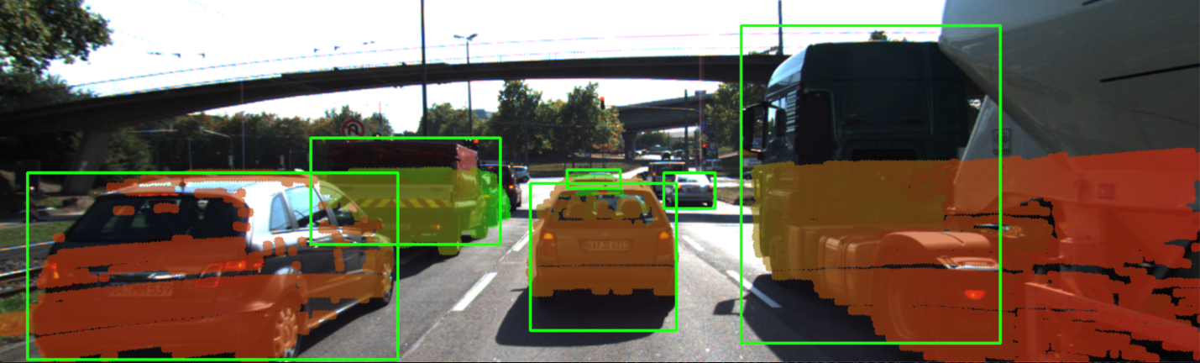](https://classroom.udacity.com/nanodegrees/nd313/parts/1971021c-523b-414c-93a3-2c6297cf4771/modules/0a71c48d-96ab-4d3a-be96-3ea1e64cf773/lessons/fb74bfb2-bfe1-4d86-a997-320ab71c0dbd/concepts/287ac53f-9169-411d-b125-41e500aa4043)](https://classroom.udacity.com/nanodegrees/nd313/parts/1971021c-523b-414c-93a3-2c6297cf4771/modules/0a71c48d-96ab-4d3a-be96-3ea1e64cf773/lessons/fb74bfb2-bfe1-4d86-a997-320ab71c0dbd/concepts/287ac53f-9169-411d-b125-41e500aa4043)**

If a Lidar point has been found to be within a ROI, it is added to the BoundingBox data structure we have seen in the previous section on object detection with YOLO. The BoundingBox structure introduced there now contains the following elements:

**struct** BoundingBox { *// bounding box around a classified object (contains both 2D and 3D data)*

**int** boxID; *// unique identifier for this bounding box*

**int** trackID; *// unique identifier for the track to which this bounding box belongs*

cv::Rect roi; *// 2D region-of-interest in image coordinates*

**int** classID; *// ID based on class file provided to YOLO framework*

**double** confidence; *// classification trust*

std::vector<LidarPoint> lidarPoints; *// Lidar 3D points which project into 2D image roi*

std::vector<cv::KeyPoint> keypoints; *// keypoints enclosed by 2D roi*

std::vector<cv::DMatch> kptMatches; *// keypoint matches enclosed by 2D roi*

};

During object detection, the members "boxID", "roi", "classID" and "confidence" have been filled with data. During Lidar point grouping in this section, the member "lidarPoints" is filled with all points within the boundaries of the respective ROI rectangle. In terms of the image shown above, this means that all colored Lidar points which have been projected into the camera image are associated with the green rectangle which encloses them. Lidar points not enclosed by a rectangle are ignored.

In some cases, object detection returns ROI that are too large and thus overlap into parts of the scene that are not a part of the enclosed object (e.g. a neighboring vehicle or the road surface). It is therefore advisable to adjust the size of the ROI slightly so that the number of Lidar points which are not physically located on the object is reduced. The following code shows how this can be achieved without much effort.

vector<vector<BoundingBox>::iterator> enclosingBoxes; *// pointers to all bounding boxes which enclose the current Lidar point*

**for** (vector<BoundingBox>::iterator it2 = boundingBoxes.begin(); it2 != boundingBoxes.end(); ++it2)

{

*// shrink current bounding box slightly to avoid having too many outlier points around the edges*

cv::Rect smallerBox;

smallerBox.x = (\*it2).roi.x + shrinkFactor \* (\*it2).roi.width / 2.0;

smallerBox.y = (\*it2).roi.y + shrinkFactor \* (\*it2).roi.height / 2.0;

smallerBox.width = (\*it2).roi.width \* (1 - shrinkFactor);

smallerBox.height = (\*it2).roi.height \* (1 - shrinkFactor);

By providing a factor "shrinkFactor" which denotes the amount of resizing in [% ], a smaller box is created from the original bounding box. Further down in the code (see final project student code for details), a check is performed for each keypoint wether it belongs to the smaller bounding box. The figure below shows two different settings for "shrinkFactor". It can be seen that for second figure, the projected Lidar points are concentrated on the central area of the preceding vehicle whereas Lidar points close to the edges are ignored.

**[[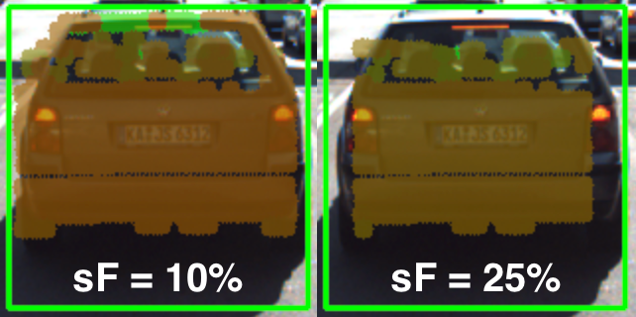](https://classroom.udacity.com/nanodegrees/nd313/parts/1971021c-523b-414c-93a3-2c6297cf4771/modules/0a71c48d-96ab-4d3a-be96-3ea1e64cf773/lessons/fb74bfb2-bfe1-4d86-a997-320ab71c0dbd/concepts/287ac53f-9169-411d-b125-41e500aa4043)](https://classroom.udacity.com/nanodegrees/nd313/parts/1971021c-523b-414c-93a3-2c6297cf4771/modules/0a71c48d-96ab-4d3a-be96-3ea1e64cf773/lessons/fb74bfb2-bfe1-4d86-a997-320ab71c0dbd/concepts/287ac53f-9169-411d-b125-41e500aa4043)**

In practice, a moderate setting of 5-10% should be used to avoid discarding too much data. In some cases, when the bounding boxes returned by object detection are severely oversized, this process of boundary frame shrinkage can be an important tool to improve the quality of the associated Lidar point group.

## Exercise: Avoiding Grouping Errors

Another potential problem in addition to oversized regions of interest is their strictly rectangular shape, which rarely fits the physical outline of the enclosed objects. As can be seen in the figure at the very top of this section, the two vehicles in the left lane exhibit a significant overlap in their regions of interest.

During point cloud association, Lidar points located on one vehicle might inadvertently be associated to another other vehicle. In the example illustrated in the figure below, a set of Lidar points in the upper right corner of the green ROI that actually belong to the red truck are associated with the blue vehicle. In the top view perspective on the left, this error becomes clearly visible.

**[[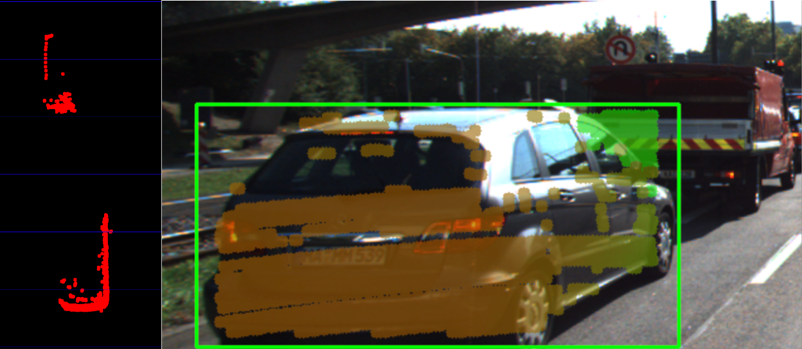](https://classroom.udacity.com/nanodegrees/nd313/parts/1971021c-523b-414c-93a3-2c6297cf4771/modules/0a71c48d-96ab-4d3a-be96-3ea1e64cf773/lessons/fb74bfb2-bfe1-4d86-a997-320ab71c0dbd/concepts/287ac53f-9169-411d-b125-41e500aa4043)](https://classroom.udacity.com/nanodegrees/nd313/parts/1971021c-523b-414c-93a3-2c6297cf4771/modules/0a71c48d-96ab-4d3a-be96-3ea1e64cf773/lessons/fb74bfb2-bfe1-4d86-a997-320ab71c0dbd/concepts/287ac53f-9169-411d-b125-41e500aa4043)**

In the following code example you will find the algorithm that is responsible for this incorrect behavior.

Your task now is to make changes to this code in such a way that Lidar points enclosed within multiple bounding boxes are excluded from further processing. Visualize your result to ensure that everything works correctly before you proceed to the next section.

You can find the code in the workspace below in cluster\_with\_roi.cpp, and after making, you can run the code using the executable cluster\_with\_roi.

<https://www.youtube.com/watch?v=kX5W8Gud7So&feature=emb_logo>

As you can see in the resulting top-view image below, Lidar points have been grouped together into several distinct 3D objects.

**[[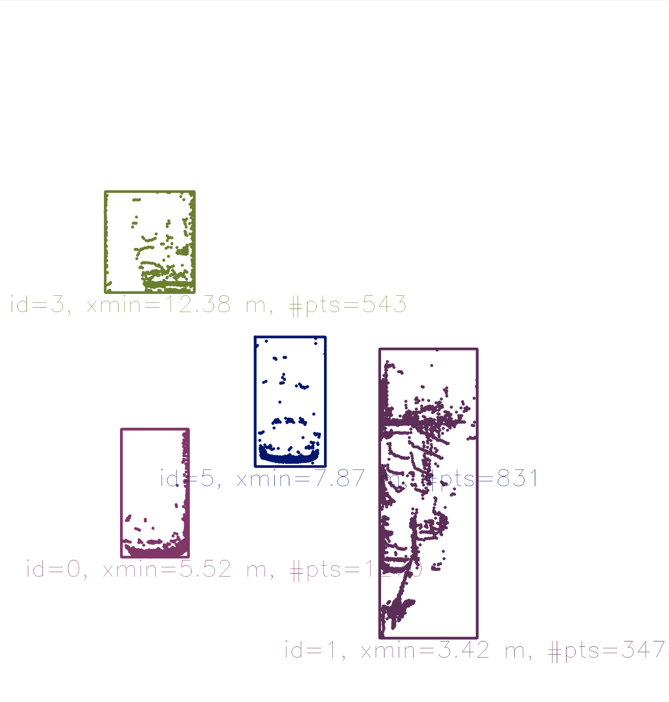](https://classroom.udacity.com/nanodegrees/nd313/parts/1971021c-523b-414c-93a3-2c6297cf4771/modules/0a71c48d-96ab-4d3a-be96-3ea1e64cf773/lessons/fb74bfb2-bfe1-4d86-a997-320ab71c0dbd/concepts/287ac53f-9169-411d-b125-41e500aa4043)](https://classroom.udacity.com/nanodegrees/nd313/parts/1971021c-523b-414c-93a3-2c6297cf4771/modules/0a71c48d-96ab-4d3a-be96-3ea1e64cf773/lessons/fb74bfb2-bfe1-4d86-a997-320ab71c0dbd/concepts/287ac53f-9169-411d-b125-41e500aa4043)**

So by combining Lidar and camera information, an augmented view on the objects in the observed scene can be obtained. However, a computation of the time-to-collision is not yet possible as there is currently no link in time between 3D objects. It will be your task in the upcoming final project to implement this link and to finally compute TTC measurements based on both Lidar and camera.

<https://www.youtube.com/watch?v=ID_zxQ37V3s&feature=emb_logo>

Track an Object in 3D Space

<https://www.youtube.com/watch?v=ghUqSPmPuZA&feature=emb_logo>

<https://github.com/udacity/SFND_3D_Object_Tracking>

<https://www.youtube.com/watch?time_continue=9&v=0yJ7gE2JMcw&feature=emb_logo>

# Match 3D Objects

## FP.1 : Match 3D Objects

In this task, please implement the method "matchBoundingBoxes", which takes as input both the previous and the current data frames and provides as output the ids of the matched regions of interest (i.e. the boxID property)“. Matches must be the ones with the highest number of keypoint correspondences.

The task is complete once the code is functional and returns the specified output, where each bounding box is assigned the match candidate with the highest number of occurrences.

<https://www.youtube.com/watch?v=UqaC-d8vhyY&feature=emb_logo>

# Compute Lidar-based TTC

## FP.2 : Compute Lidar-based TTC

In this part of the final project, your task is to compute the time-to-collision for all matched 3D objects based on Lidar measurements alone. Please take a look at the second lesson of this course to revisit the theory behind TTC estimation. Also, please implement the estimation in a way that makes it robust against outliers which might be way too close and thus lead to faulty estimates of the TTC. Please return your TCC to the main function at the end of computeTTCLidar.

The task is complete once the code is functional and returns the specified output. Also, the code is able to deal with outlier Lidar points in a statistically robust way to avoid severe estimation errors.

<https://www.youtube.com/watch?v=YAauGTeSilA&feature=emb_logo>

## FP.3 : Associate Keypoint Correspondences with Bounding Boxes

Before a TTC estimate can be computed in the next exercise, you need to find all keypoint matches that belong to each 3D object. You can do this by simply checking wether the corresponding keypoints are within the region of interest in the camera image. All matches which satisfy this condition should be added to a vector. The problem you will find is that there will be outliers among your matches. To eliminate those, I recommend that you compute a robust mean of all the euclidean distances between keypoint matches and then remove those that are too far away from the mean.

The task is complete once the code performs as described and adds the keypoint correspondences to the "kptMatches" property of the respective bounding boxes. Also, outlier matches have been removed based on the euclidean distance between them in relation to all the matches in the bounding box.

## FP.4 : Compute Camera-based TTC

Once keypoint matches have been added to the bounding boxes, the next step is to compute the TTC estimate. As with Lidar, we already looked into this in the second lesson of this course, so you please revisit the respective section and use the code sample there as a starting point for this task here. Once you have your estimate of the TTC, please return it to the main function at the end of computeTTCCamera.

The task is complete once the code is functional and returns the specified output. Also, the code must be able to deal with outlier correspondences in a statistically robust way to avoid severe estimation errors.

<https://www.youtube.com/watch?v=_gn3yqpzKmU&feature=emb_logo>

# Performance Evaluation

## [https://www.youtube.com/wat FP.5 : Performance Evaluation 1](https://www.youtube.com/watch?v=bozht0VBXvA&feature=emb_logo)

[This exercise is about conducting tests with the final project code, especially with regard to the Lidar part. Look for several examples where you have the impression that the Lidar-based TTC estimate is way off. Once you have found those, describe your observations and provide a sound argumentation why you think this happened.](https://www.youtube.com/watch?v=bozht0VBXvA&feature=emb_logo)

[The task is complete once several examples (2-3) have been identified and described in detail. The assertion that the TTC is off should be based on manually estimating the distance to the rear of the preceding vehicle from a top view perspective of the Lidar points.](https://www.youtube.com/watch?v=bozht0VBXvA&feature=emb_logo)

## [FP.6 : Performance Evaluation 2](https://www.youtube.com/watch?v=bozht0VBXvA&feature=emb_logo)

[This last exercise is about running the different detector / descriptor combinations and looking at the differences in TTC estimation. Find out which methods perform best and also include several examples where camera-based TTC estimation is way off. As with Lidar, describe your observations again and also look into potential reasons. This is the last task in the final project.](https://www.youtube.com/watch?v=bozht0VBXvA&feature=emb_logo)

[The task is complete once all detector / descriptor combinations implemented in previous chapters have been compared with regard to the TTC estimate on a frame-by-frame basis. To facilitate the comparison, a spreadsheet and graph should be used to represent the different TTCs.](https://www.youtube.com/watch?v=bozht0VBXvA&feature=emb_logo)

[We are super-excited to receive your submission as soon as possible.](https://www.youtube.com/watch?v=bozht0VBXvA&feature=emb_logo)

[ch?v=bozht0VBXvA&feature=emb\_logo](https://www.youtube.com/watch?v=bozht0VBXvA&feature=emb_logo)

Unscented Kalman Filter Highway Project

Below is a workspace with the SFND\_Unscented\_Kalman project repository cloned over. In this project you will be filling in the function code for ukf.cpp and ukf.h by using the previous lessons as reference. The results of completing the UKF code can be seen in the animation above, where each of the three traffic cars are tracked using a CTRV motion model. Although the cars have variable acceleration and turning rates the UKF is still able to track the objects quite well with the CTRV model. The accuracy is being calculated by the RMSE, root mean squared error over each time step and for each car. The RMSE is looking at the error difference between the ground truth and estimated position and velocities. All the cars are considered in the RMSE value so if one car is particularly inaccurate it would affect the overall RMSE in this case. In the animation above the 4 RMSE values are X, Y, Vx, Vy from top to bottom. To pass the project the RMSE values should not exceed the rmse threshold values in the project rubric after the simulator has ran for more than 1 second.

**[[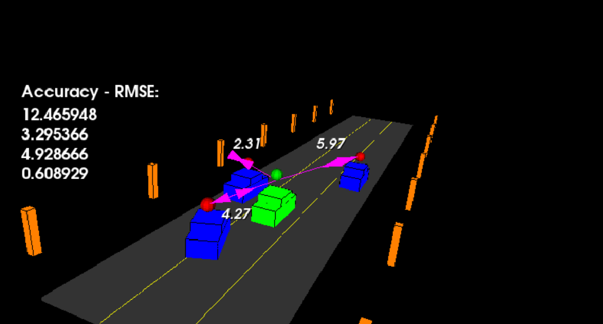](https://classroom.udacity.com/nanodegrees/nd313/parts/da5e72fc-972d-42ae-bb76-fca3d3b2db06/modules/c32eb575-0080-4a25-a087-98ab84cb3092/lessons/493be691-f4f2-43bb-a412-3454656b48ab/concepts/fb9d4925-ba9d-4008-949a-096a8fabed50)](https://classroom.udacity.com/nanodegrees/nd313/parts/da5e72fc-972d-42ae-bb76-fca3d3b2db06/modules/c32eb575-0080-4a25-a087-98ab84cb3092/lessons/493be691-f4f2-43bb-a412-3454656b48ab/concepts/fb9d4925-ba9d-4008-949a-096a8fabed50)**

**[cars without tracking, lidar pings are red spheres and radar is purple lines.](https://classroom.udacity.com/nanodegrees/nd313/parts/da5e72fc-972d-42ae-bb76-fca3d3b2db06/modules/c32eb575-0080-4a25-a087-98ab84cb3092/lessons/493be691-f4f2-43bb-a412-3454656b48ab/concepts/fb9d4925-ba9d-4008-949a-096a8fabed50)**

main.cpp is using highway.h to create a straight 3 lane highway environment with 3 traffic cars and the main ego car at the center. The viewer scene is centered around the ego car and the coordinate system is relative to the ego car as well. The ego car is green while the other traffic cars are blue. The traffic cars will be accelerating and altering their steering to change lanes. Each of the traffic car's has it's own UKF object generated for it in highway.h , and will update each individual one during every time step.

The red spheres above cars represent the (x,y) lidar detection and the purple lines show the radar measurements with the velocity magnitude along the detected angle. The Z axis is not taken into account for tracking, so you are only tracking along the X/Y axis.

### Working on the Project Locally

The **[Github repository](https://github.com/udacity/SFND_Unscented_Kalman_Filter" \t "_blank)** can be used to clone over the project locally instead of working on it in the work space. In that situation a zip file containing the root of the compiled project would be uploaded and submitted directly.

## Testing Your Project Before Submission

Before you submit the project, compile and run the project once more to ensure that everything is working correctly. You should see results that are similar to the .gif above: each of the three vehicles should be tracked with green spheres indicating estimated position and green magnitude arrows showing estimated velocity value and direction. The RMSE values should also look reasonable.

## Checking the Rubric

If your project works correctly and you are happy with the results, carefully look at the [**project rubric**](https://review.udacity.com/#!/rubrics/2551/view). If you feel like all the criteria from the rubric are met, you are ready to submit!

## Submitting the Project

You can submit your project using the "SUBMIT PROJECT" button in the terminal below. If you are developing the project locally, and you would prefer to submit using a .zip file or Github repo, proceed to the next concept.

# Additional Project Details

## Highway Parameters

In highway.h there are a number of parameters that can be modified to help with testing and understanding.

*// Parameters*

*// --------------------------------*

*// Set which cars to track with UKF*

std::vector<**bool**> trackCars = {true,true,true};

*// Visualize sensor measurements*

**bool** visualize\_lidar = true;

**bool** visualize\_radar = true;

**bool** visualize\_pcd = false;

*// Predict path in the future using UKF*

**double** projectedTime = 0;

**int** projectedSteps = 0;

*// --------------------------------*

The trackCars list can be used to toggle on/off cars for the UKF objects to track. The default is to track all three cars on the road, but for testing it can be nice to toggle to only track one at a time. For instance to only track the first car {true,false,false}.

The animation above shows what it looks like if the projectedTime and projectedSteps variables are used. Also in the animation above the visualization for lidar and radar has been set to false and projectedTime = 2 and projectedSteps = 6. The green spheres then show the predicted position for the car in the future over a 2 second interval. The number of steps increases the number of positions to interpolate the time interval.

It's interesting to see the predicted path which is constrained by the motion model. In this project the motion model used is CTRV, which assumes constant velocity and turning rate. Since our cars do not have constant turning rates you can see the predicted paths swing around and take a while to correct after the car begins moving straight again.



The visualize\_pcd parameter can be set to true to visualize the cars from the lidar's perspective from point clouds. The traffic pcd data is available in src/sensors/data/pcd directory. As a bonus assignment this data could be used to cluster the individual cars using techniques from Lidar Obstacle Detection and then bounding boxes could be fitted around the car clusters. The bounding box center (x,y) point could then be used to represent the lidar marker that would be fed into the UKF instead of the project pre-generated lidar marker from tools.cpp lidarSense function.